Table of Contents

1 Sensitivity Analysis 2

1.1 Sensitivity Analysis for Raltegravir 10 mg (lactose formulation) 2

1.2 Sensitivity Analysis for Raltegravir 25 mg (lactose formulation) 11

1.3 Sensitivity Analysis for Raltegravir 100 mg filmcoated tablet md 21

2 PK parameters 37

2.1 PK parameters for Raltegravir 10 mg (lactose formulation) 37

2.2 PK parameters for Raltegravir 25 mg (lactose formulation) 38

2.3 PK parameters for Raltegravir 100 mg filmcoated tablet md 39

3 Absorption 41

3.1 Absorption for Raltegravir 10 mg (lactose formulation) 41

3.2 Absorption for Raltegravir 25 mg (lactose formulation) 42

3.3 Absorption for Raltegravir 100 mg filmcoated tablet md 43

4 Mass Balance 45

4.1 Mass Balance for Raltegravir 10 mg (lactose formulation) 45

4.2 Mass Balance for Raltegravir 25 mg (lactose formulation) 50

4.3 Mass Balance for Raltegravir 100 mg filmcoated tablet md 55

5 Time profiles and residual plots 61

5.1 Time profiles and residual plots for Raltegravir 10 mg (lactose formulation) 61

5.2 Time profiles and residual plots for Raltegravir 25 mg (lactose formulation) 69

5.3 Time profiles and residual plots for Raltegravir 100 mg filmcoated tablet md 77

5.3.1 For total simulation time range 77

5.3.2 For first application range 85

5.3.3 For last application range 87

5.4 Residuals across all simulations 95

# Sensitivity Analysis

## Sensitivity Analysis for Raltegravir 10 mg (lactose formulation)

**Figure 1-1: Most sensitive parameters for C_max of Raltegravir.**

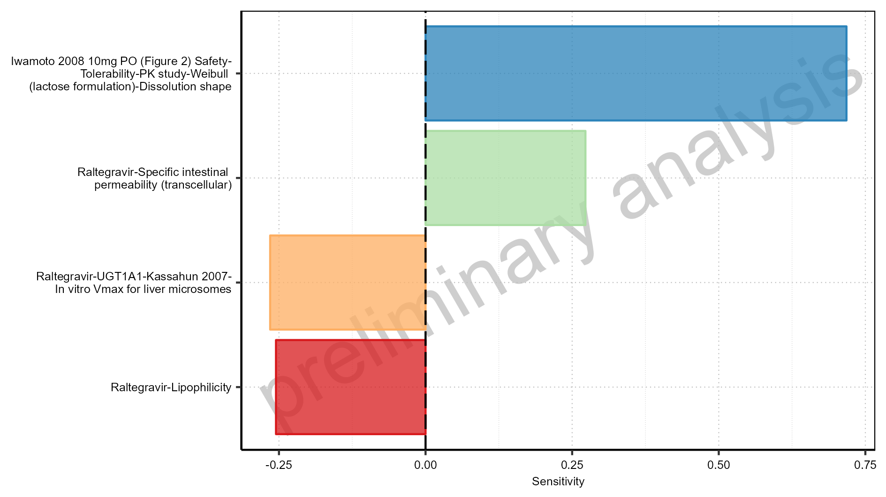

Figure 1-2: Most sensitive parameters for t_max of Raltegravir.

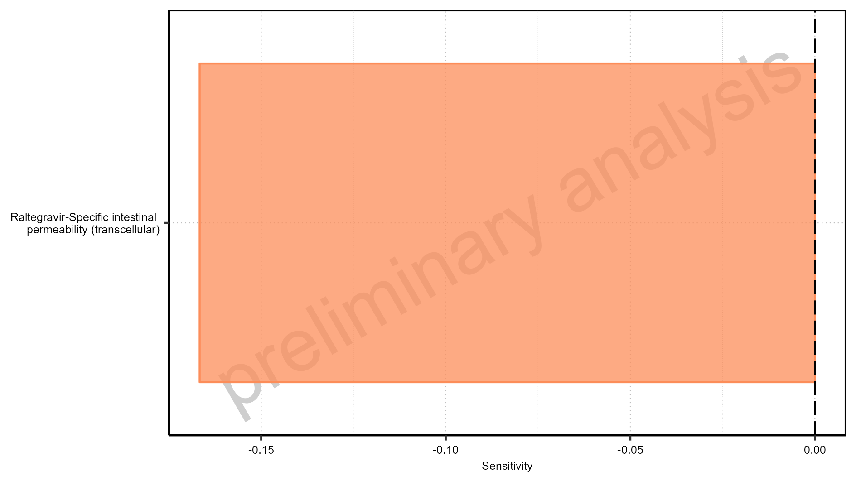

Figure 1-3: Most sensitive parameters for C_tEnd of Raltegravir.

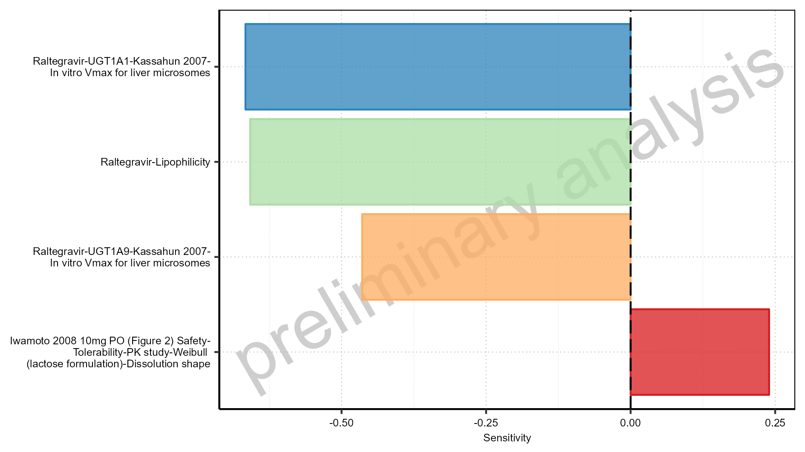

Figure 1-4: Most sensitive parameters for AUC of Raltegravir.

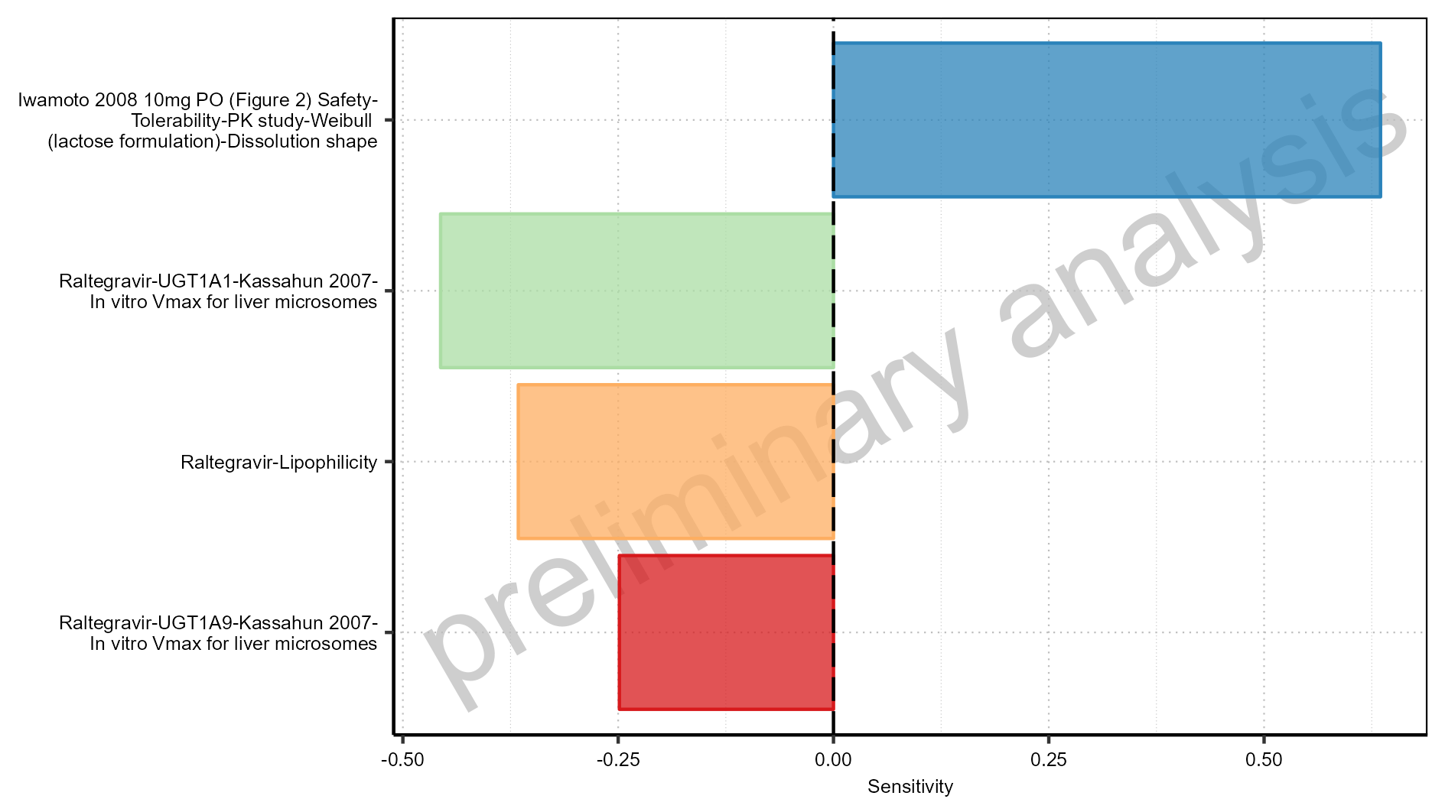

Figure 1-5: Most sensitive parameters for AUC_inf of Raltegravir.

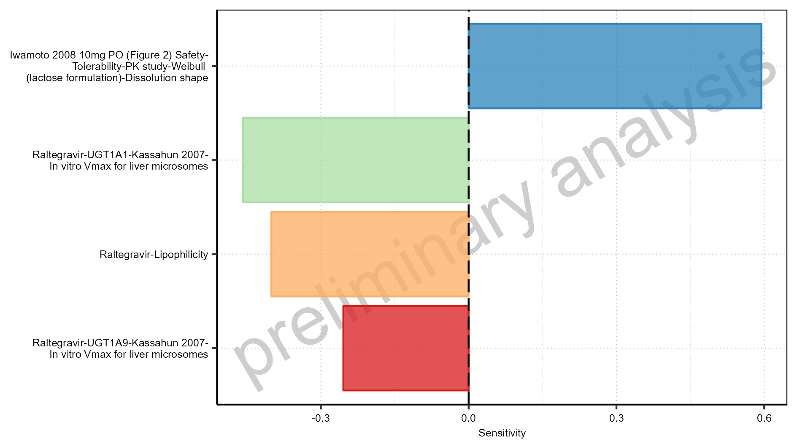

Figure 1-6: Most sensitive parameters for MRT of Raltegravir.

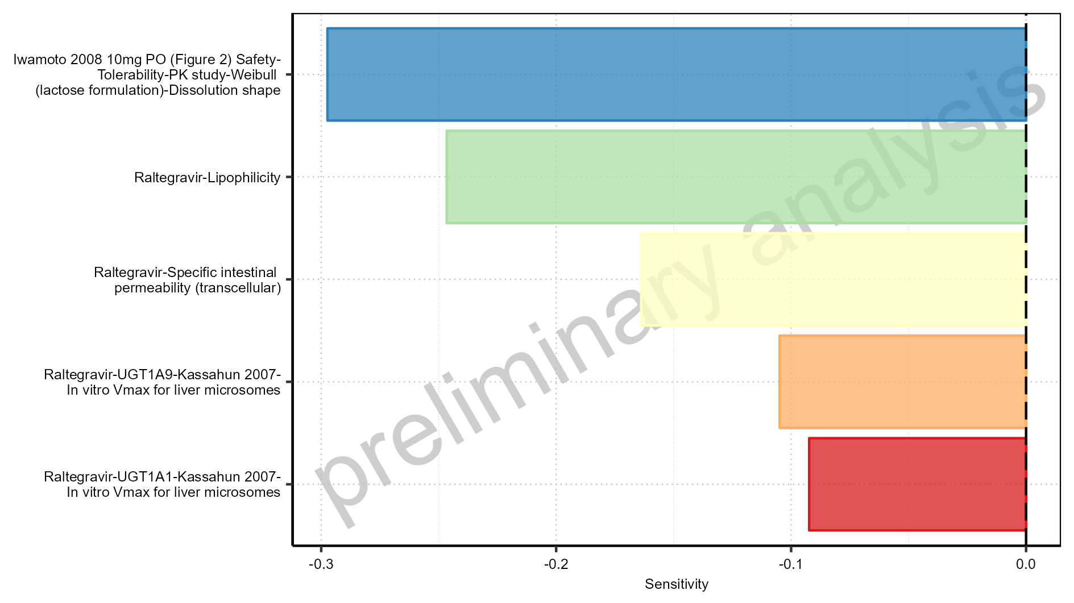

Figure 1-7: Most sensitive parameters for Thalf of Raltegravir.

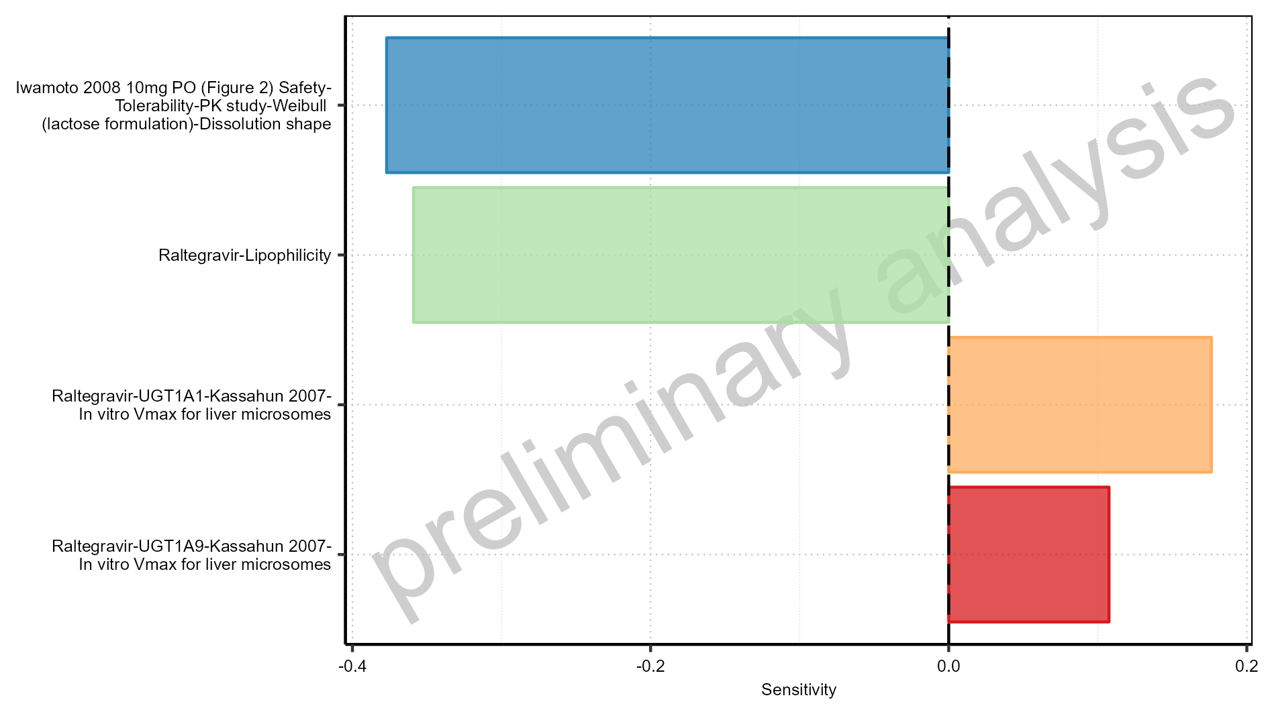

Figure 1-8: Most sensitive parameters for CL of Raltegravir.

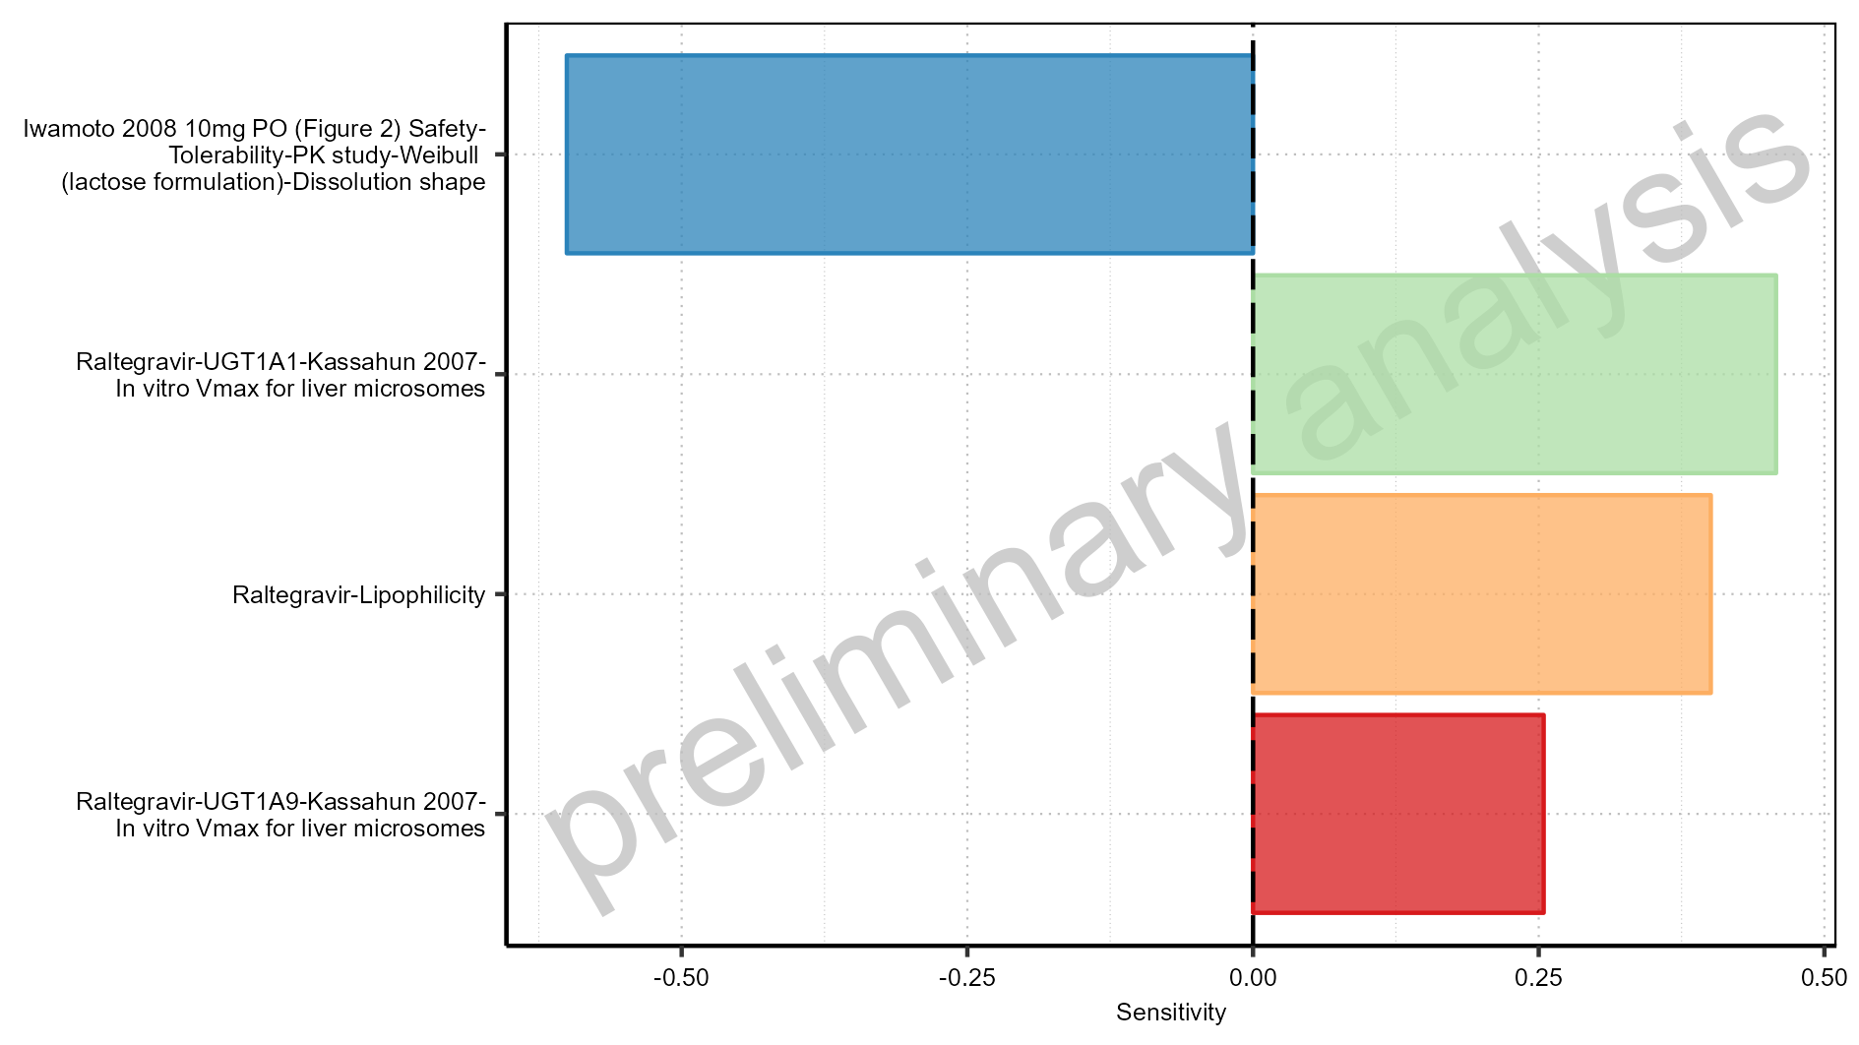

Figure 1-9: Most sensitive parameters for Vss of Raltegravir.

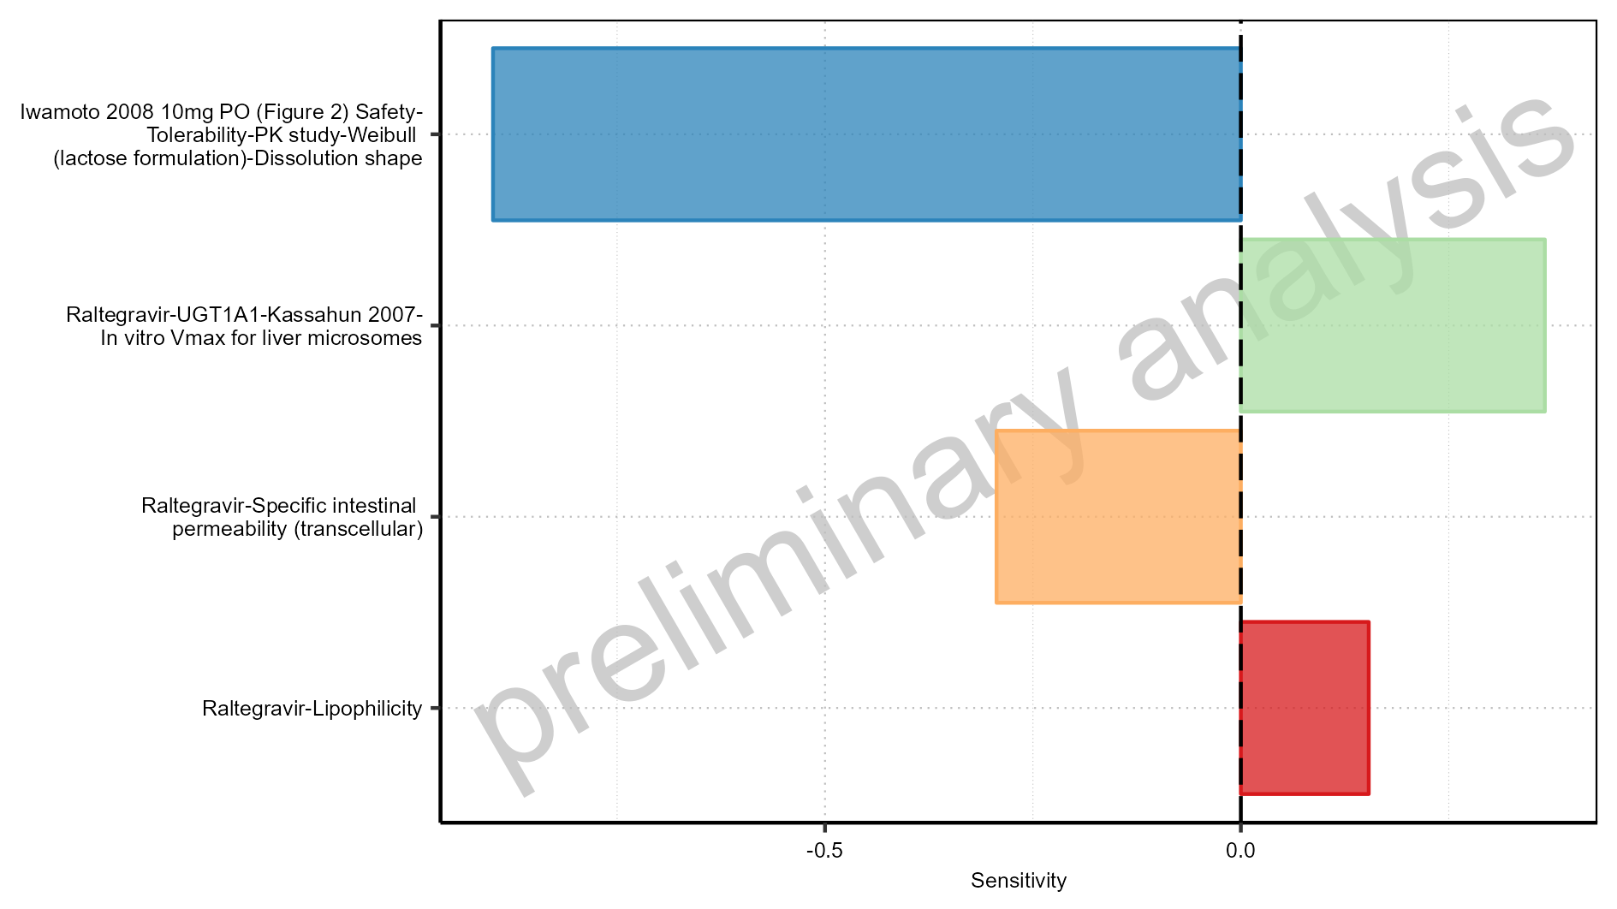

Figure 1-10: Most sensitive parameters for Vd of Raltegravir.

## Sensitivity Analysis for Raltegravir 25 mg (lactose formulation)

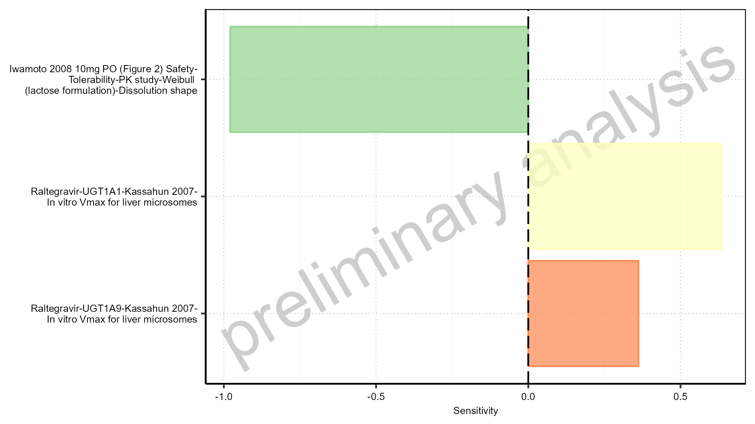

Figure 1-11: Most sensitive parameters for C_max of Raltegravir.

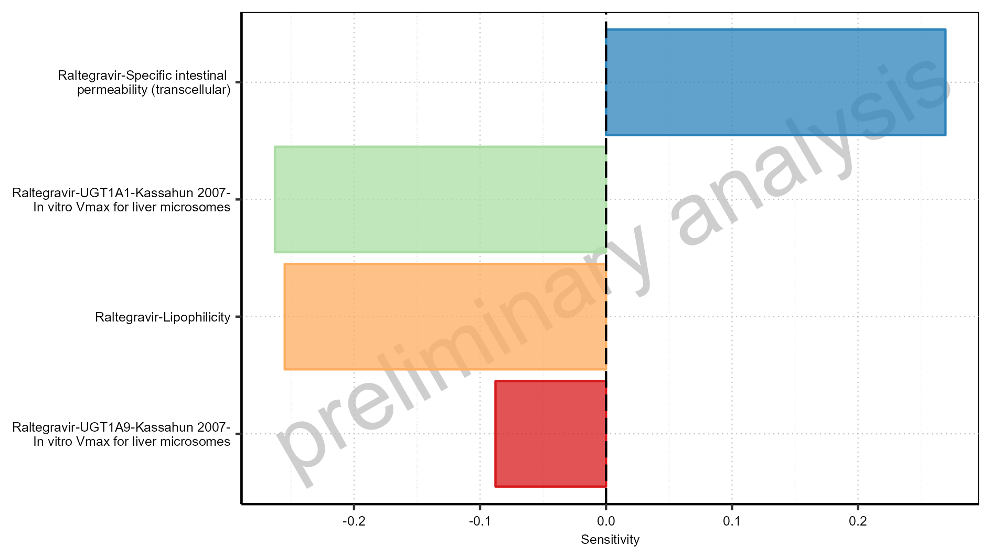

Figure 1-12: Most sensitive parameters for t_max of Raltegravir.



Figure 1-13: Most sensitive parameters for C_tEnd of Raltegravir.

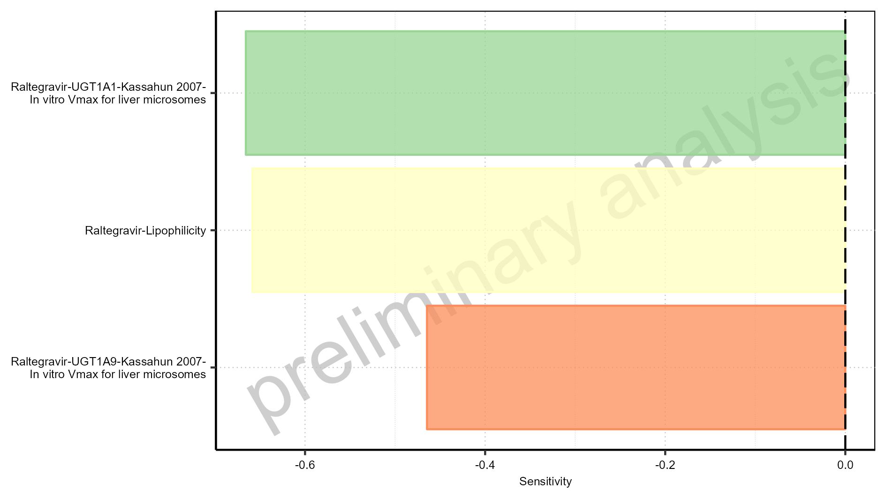

Figure 1-14: Most sensitive parameters for AUC of Raltegravir.

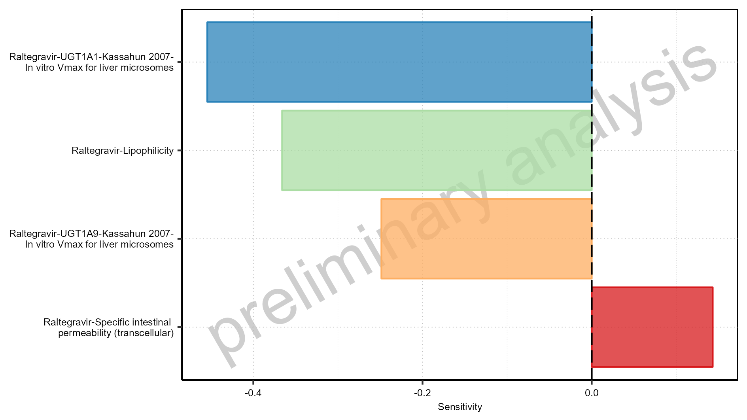

Figure 1-15: Most sensitive parameters for AUC_inf of Raltegravir.

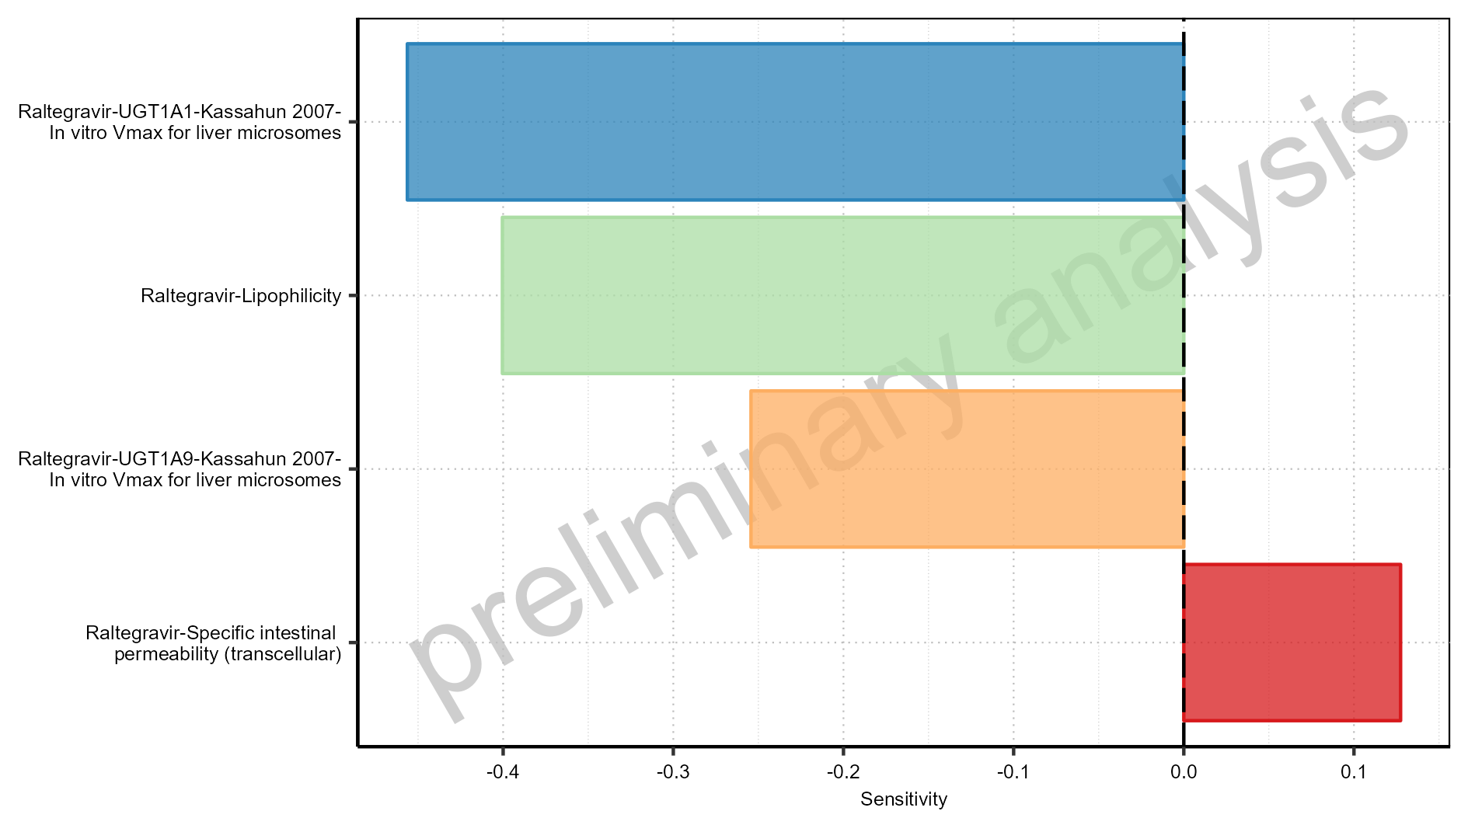

Figure 1-16: Most sensitive parameters for MRT of Raltegravir.

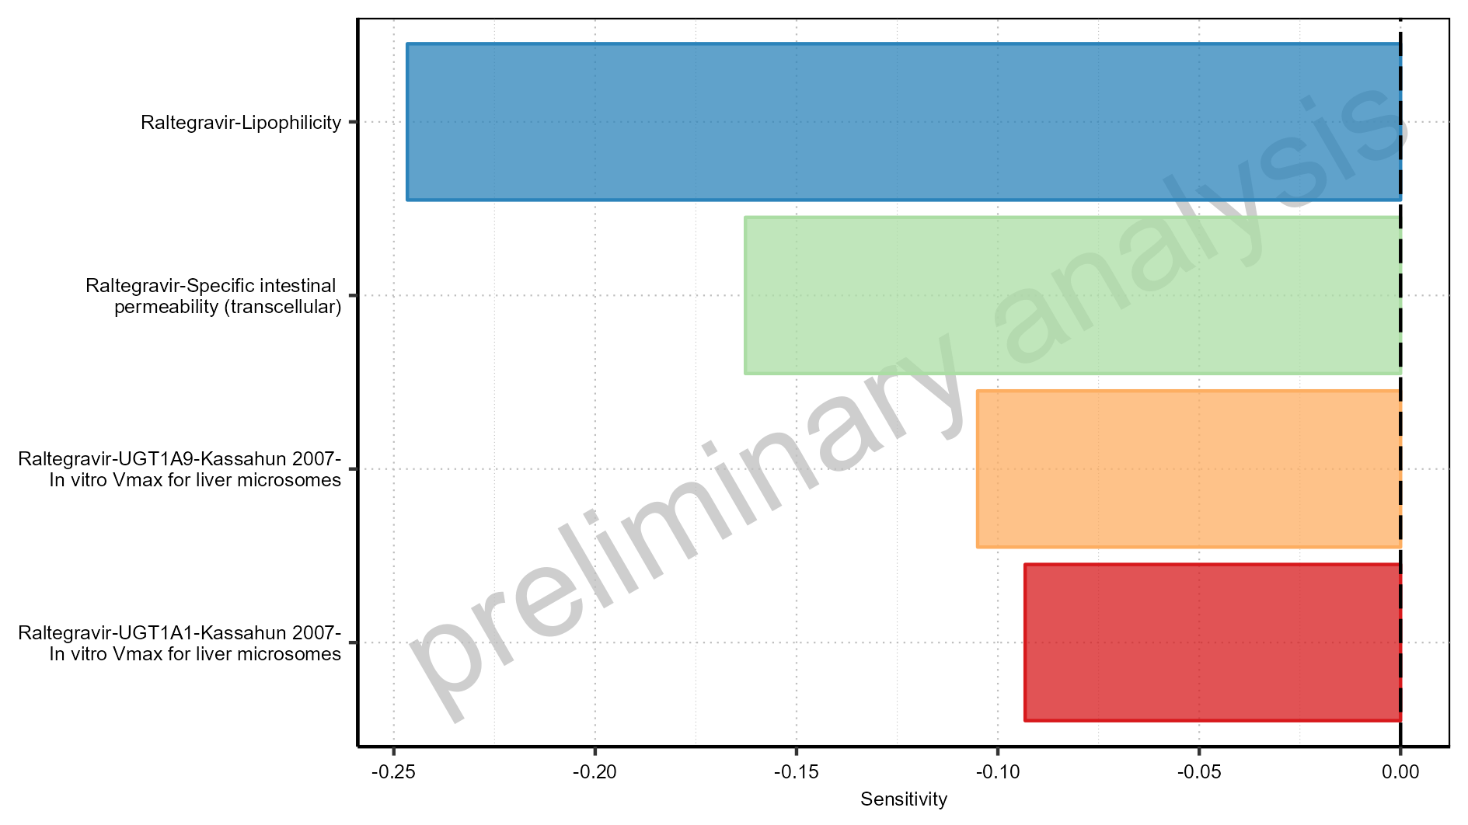

Figure 1-17: Most sensitive parameters for Thalf of Raltegravir.

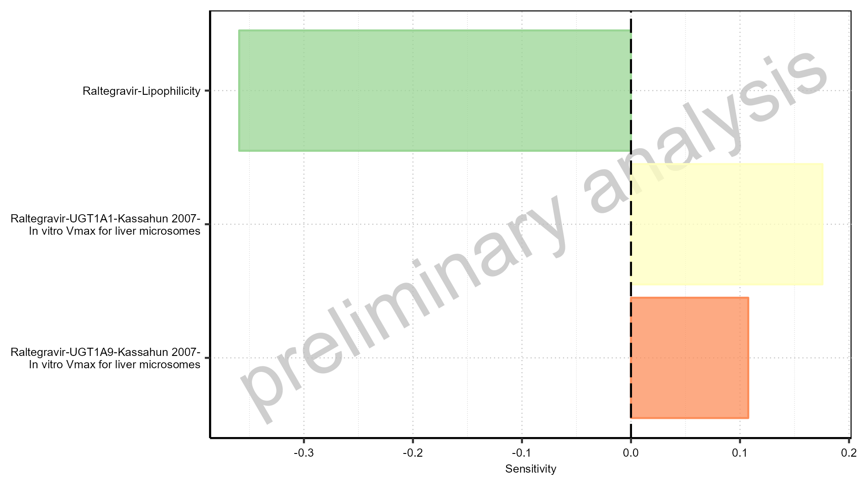

Figure 1-18: Most sensitive parameters for CL of Raltegravir.

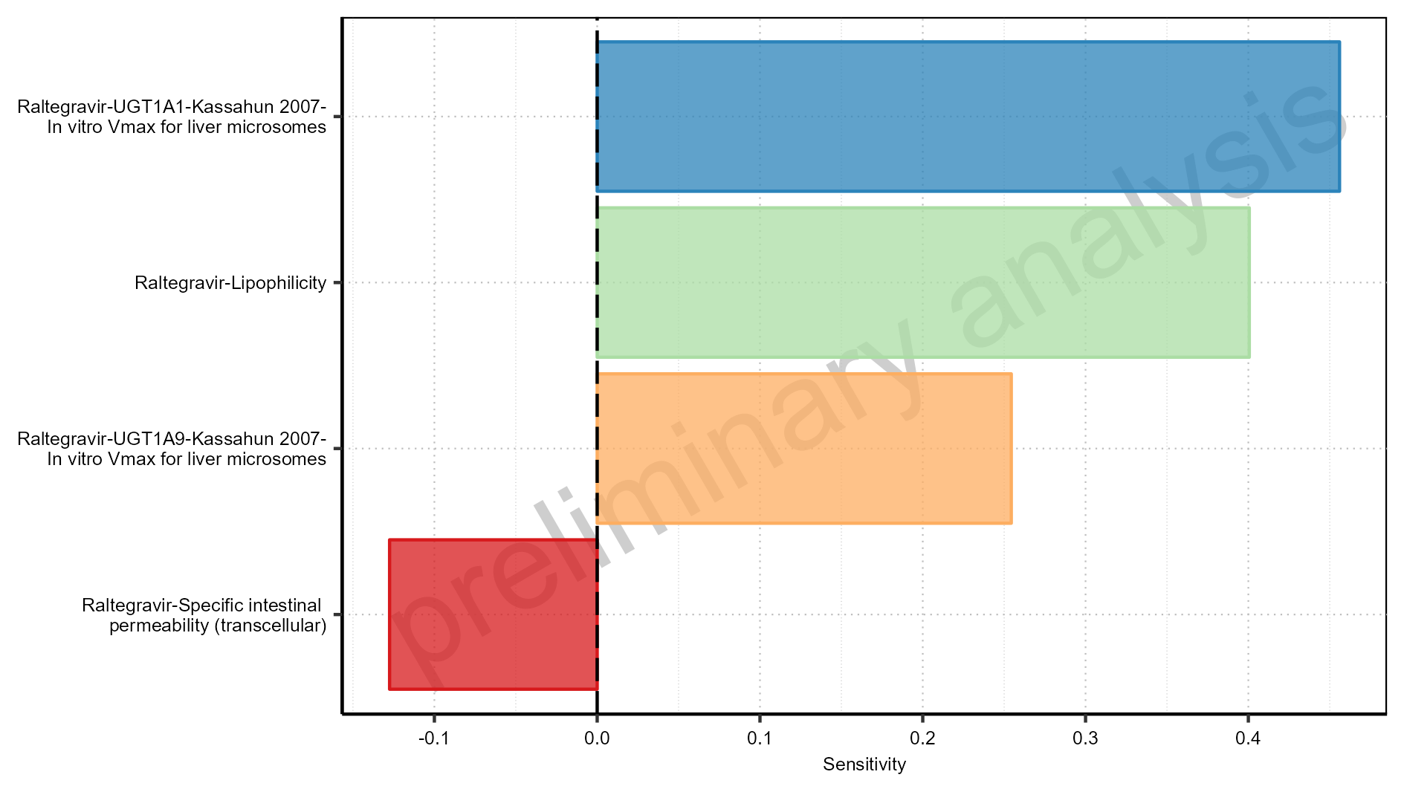

Figure 1-19: Most sensitive parameters for Vss of Raltegravir.

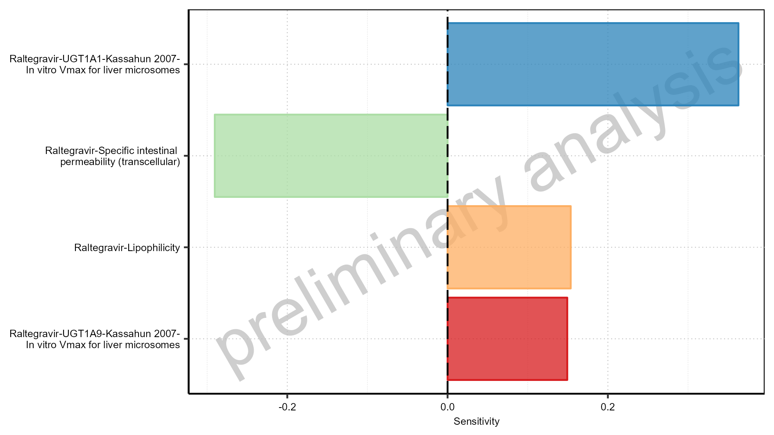

Figure 1-20: Most sensitive parameters for Vd of Raltegravir.

## Sensitivity Analysis for Raltegravir 100 mg filmcoated tablet md

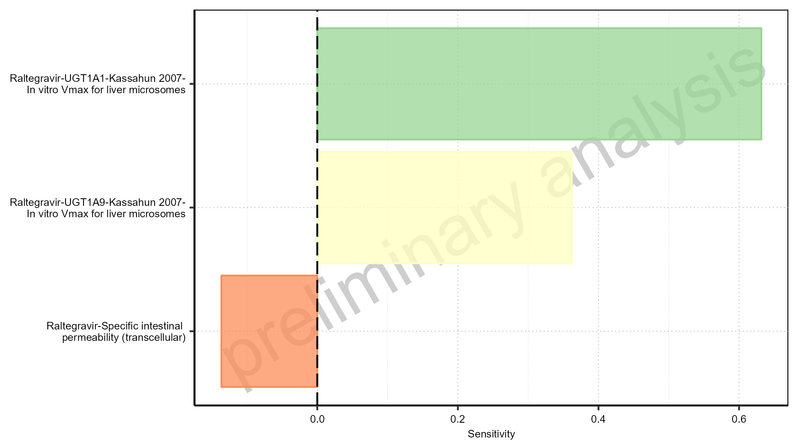

Figure 1-21: Most sensitive parameters for C_max of Raltegravir.

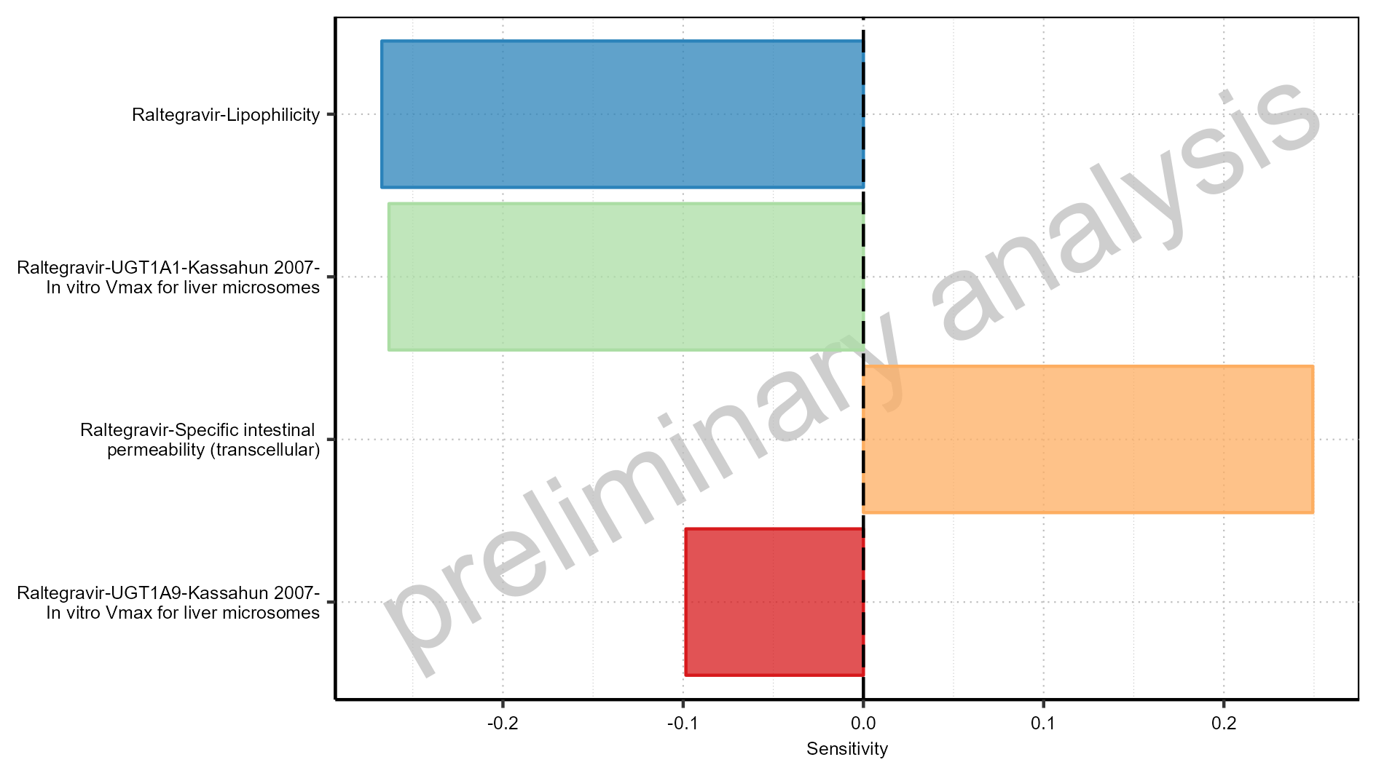

Figure 1-22: Most sensitive parameters for C_max_t1_t2 of Raltegravir.

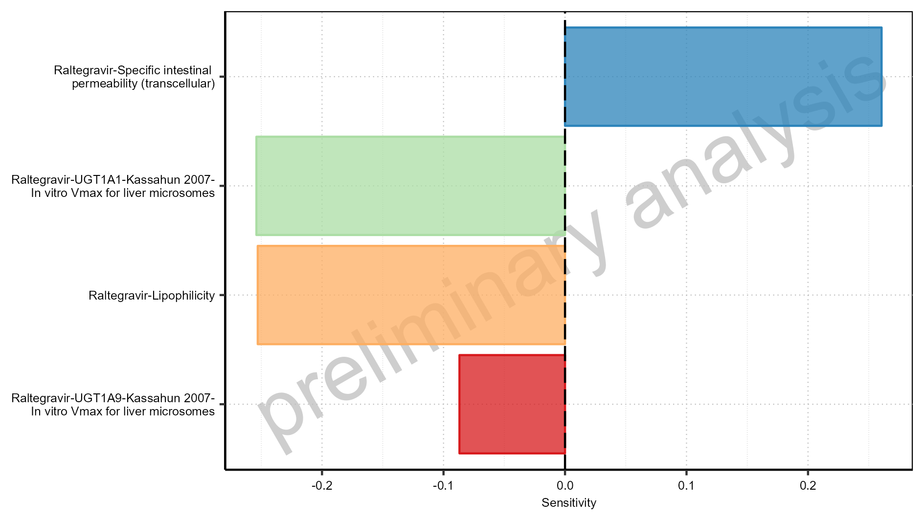

Figure 1-23: Most sensitive parameters for C_max_tLast_tEnd of Raltegravir.

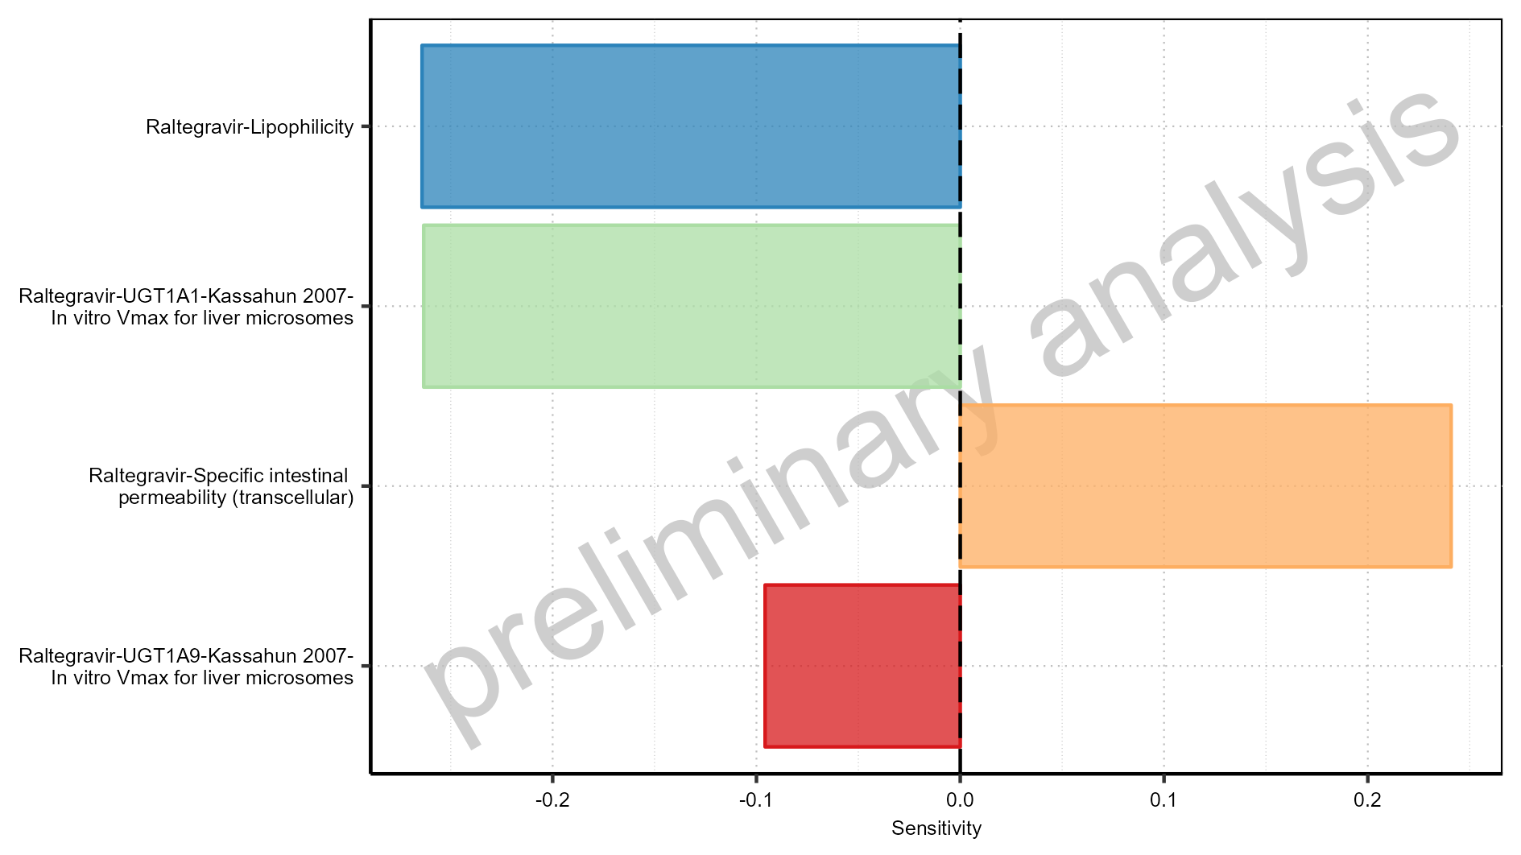

Figure 1-24: Most sensitive parameters for t_max of Raltegravir.

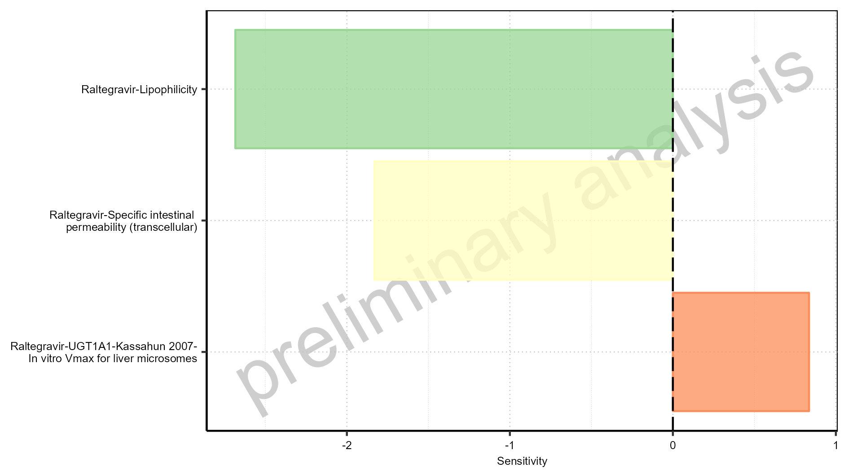

Figure 1-25: Most sensitive parameters for t_max_t1_t2 of Raltegravir.

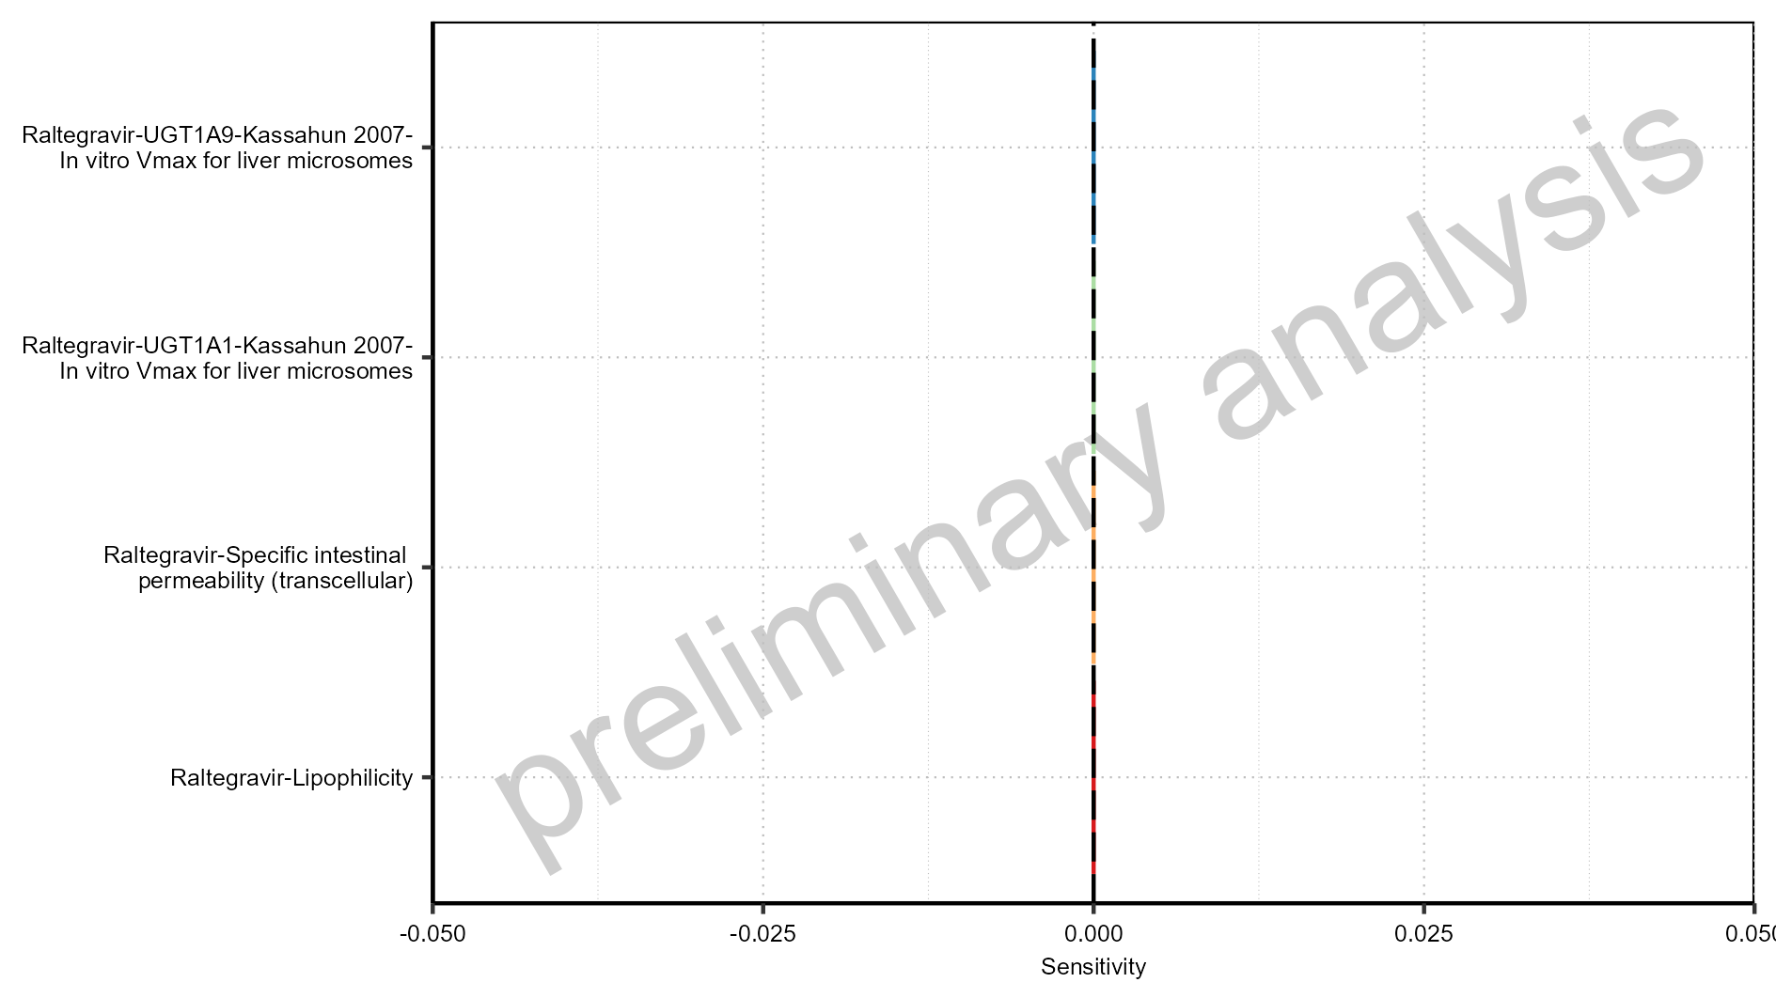

Figure 1-26: Most sensitive parameters for t_max_tLast_tEnd of Raltegravir.



Figure 1-27: Most sensitive parameters for C_trough_t2 of Raltegravir.

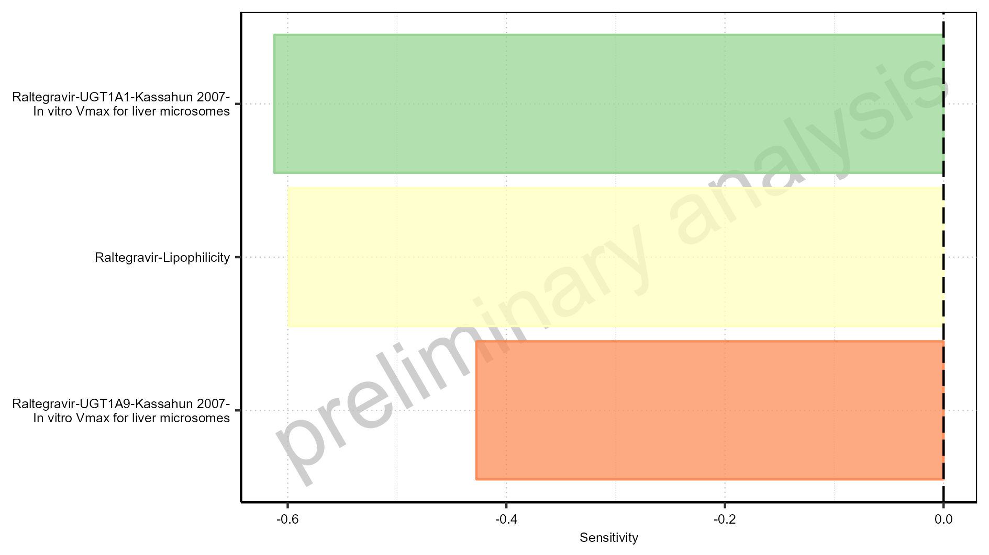

Figure 1-28: Most sensitive parameters for C_trough_tLast of Raltegravir.

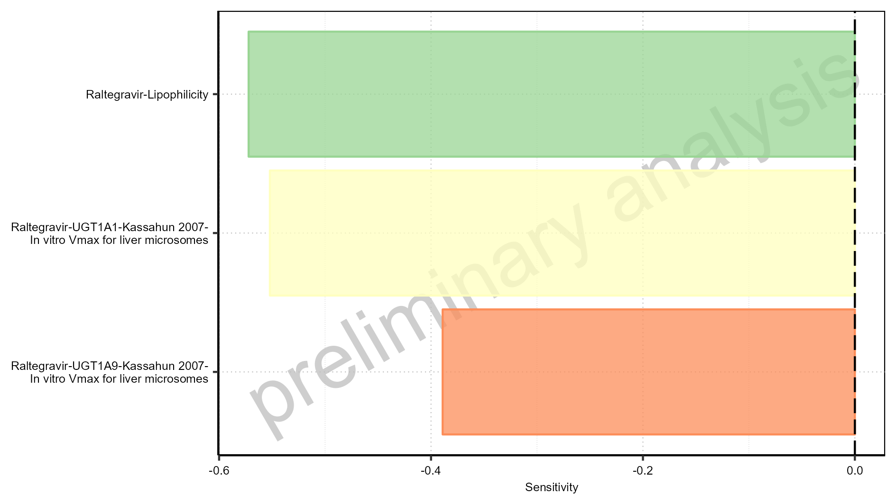

Figure 1-29: Most sensitive parameters for AUC_t1_t2 of Raltegravir.

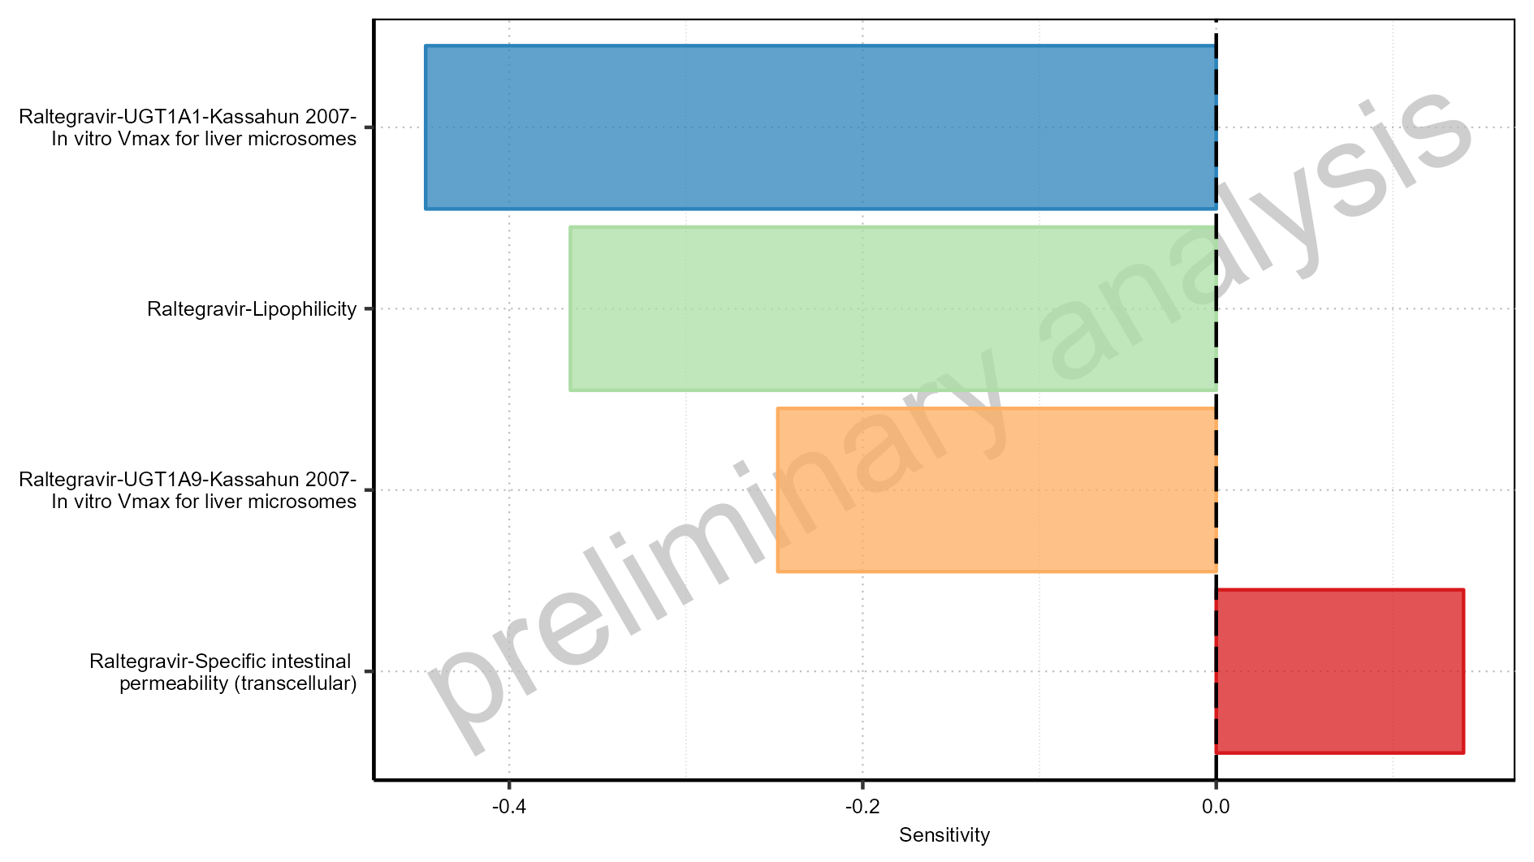

Figure 1-30: Most sensitive parameters for AUC_tLast_minus_1_tLast of Raltegravir.

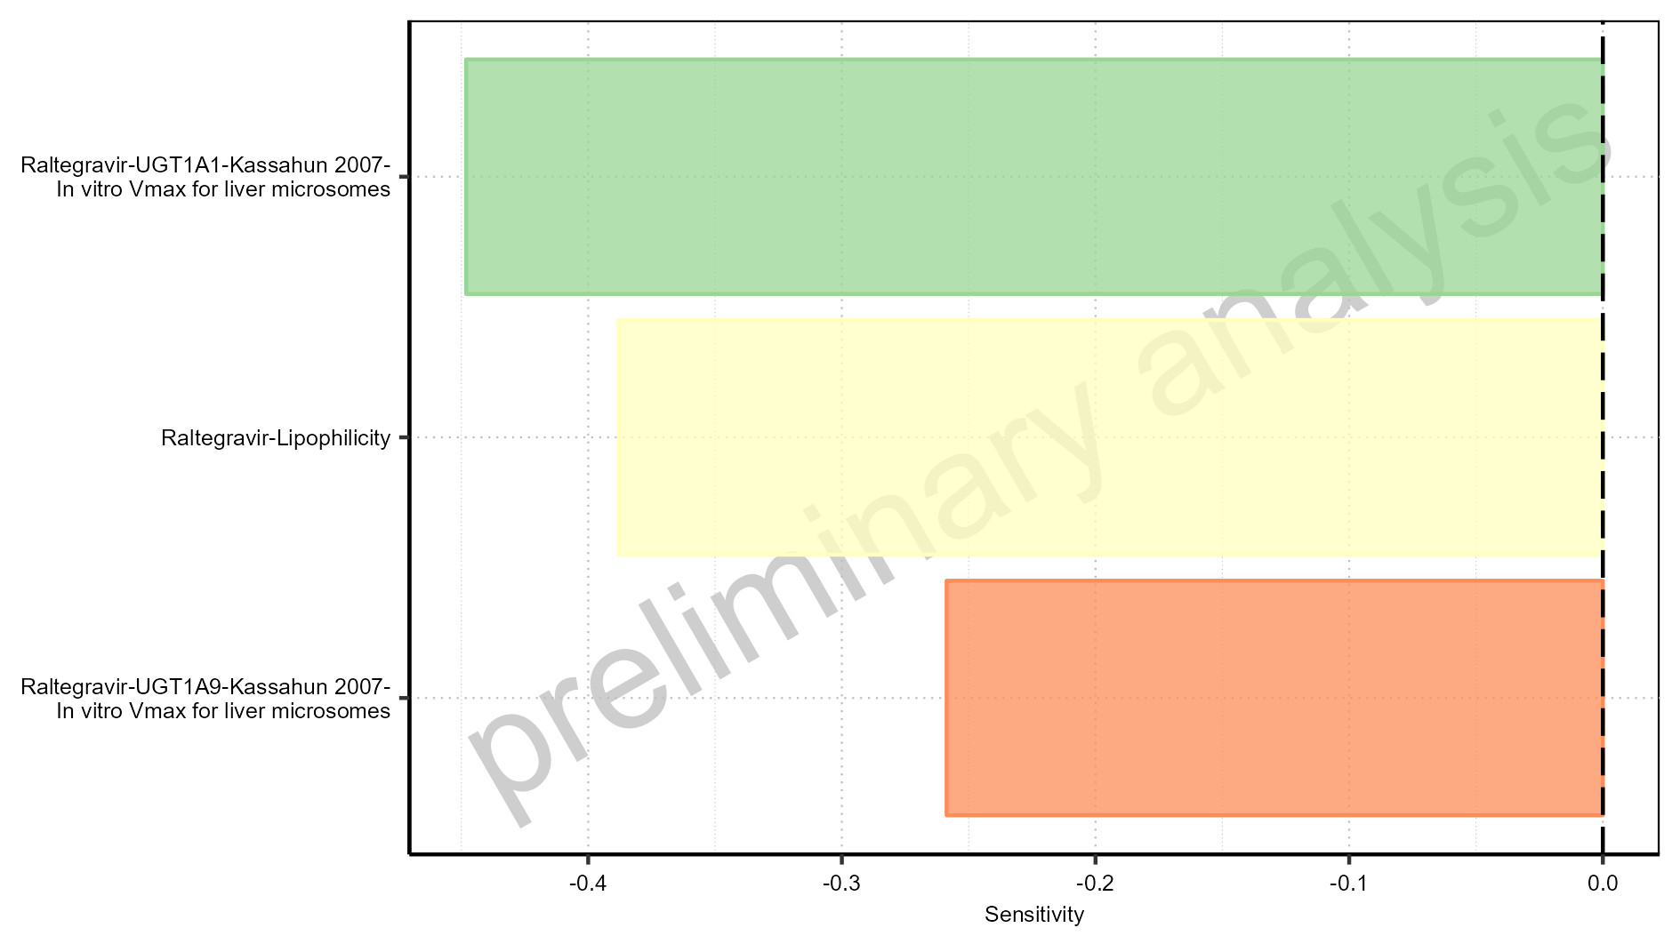

Figure 1-31: Most sensitive parameters for AUC_inf_t1 of Raltegravir.

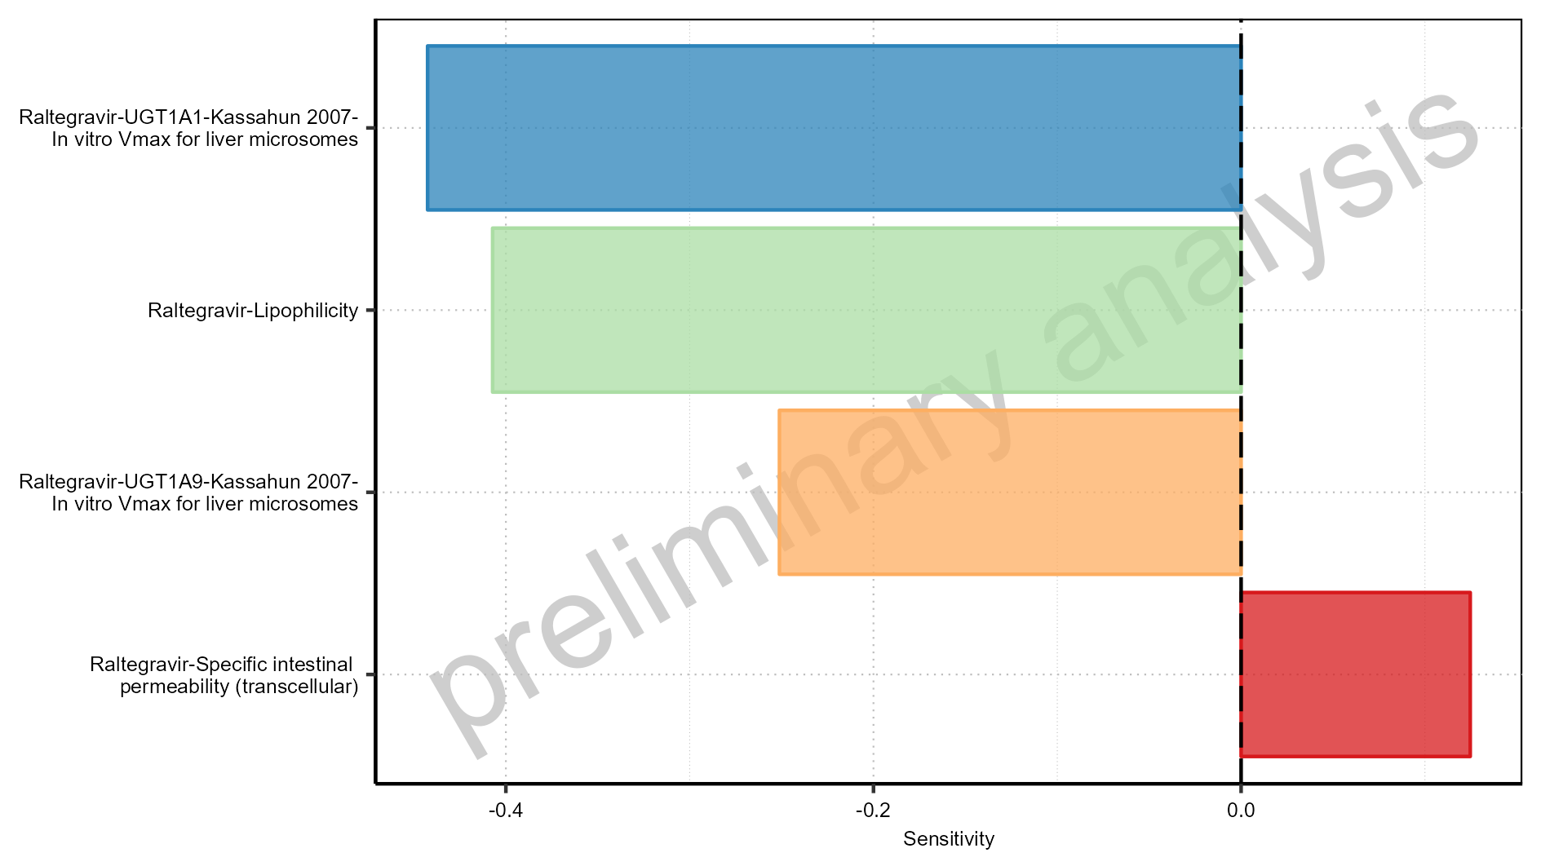

Figure 1-32: Most sensitive parameters for AUC_inf_tLast of Raltegravir.

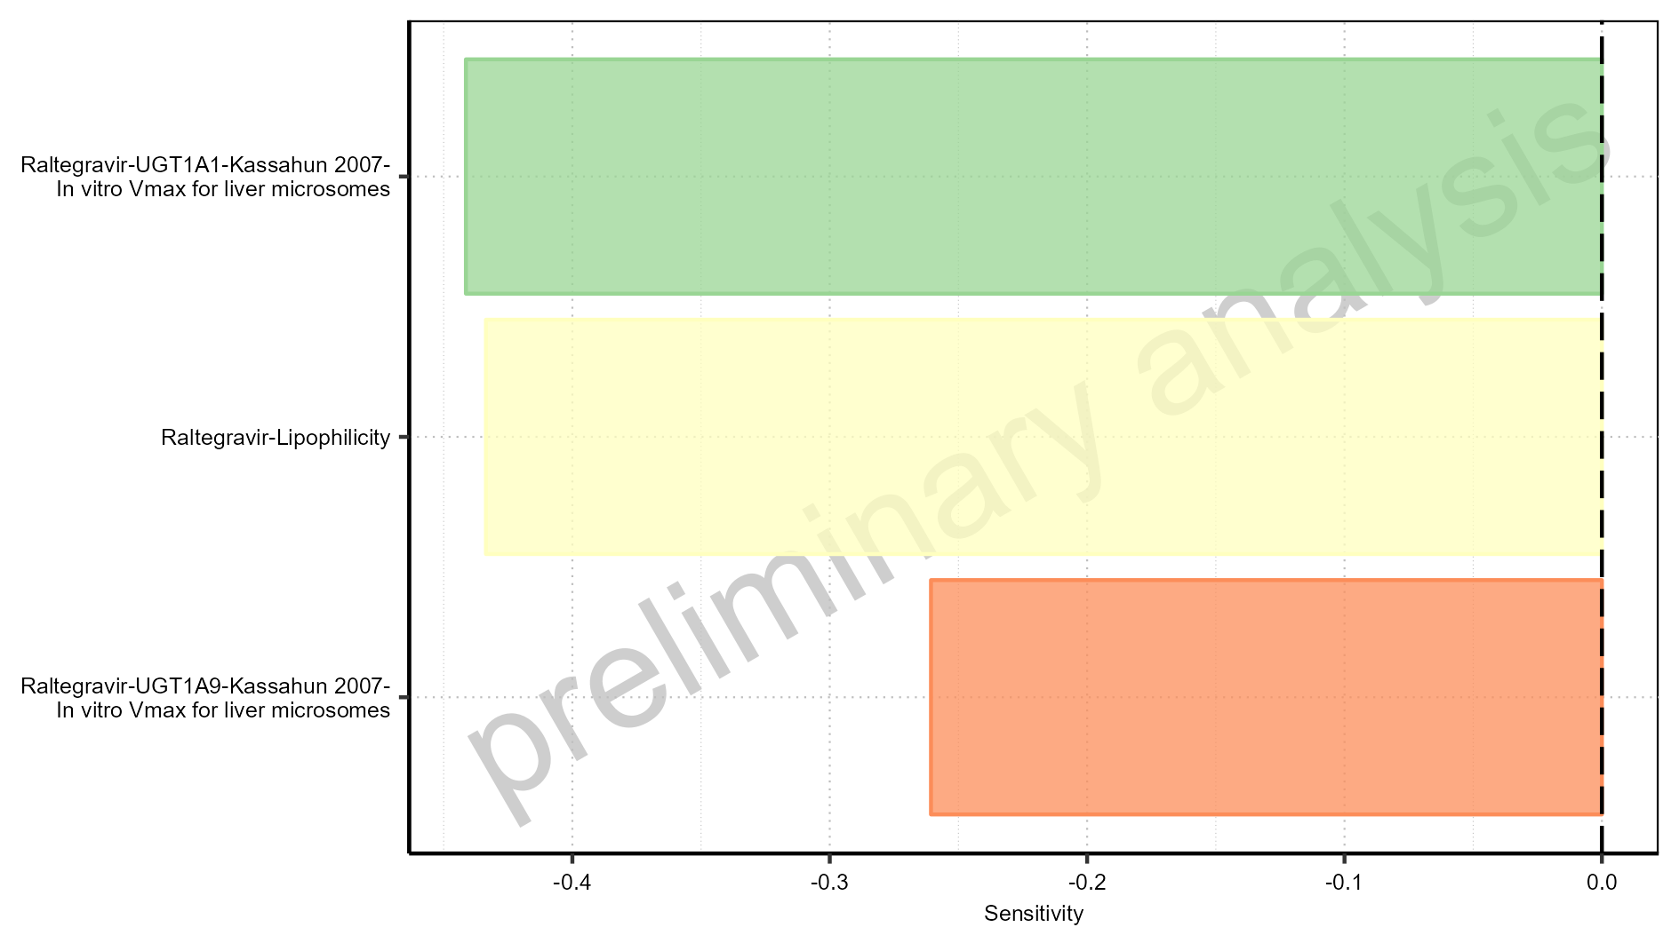

Figure 1-33: Most sensitive parameters for MRT of Raltegravir.

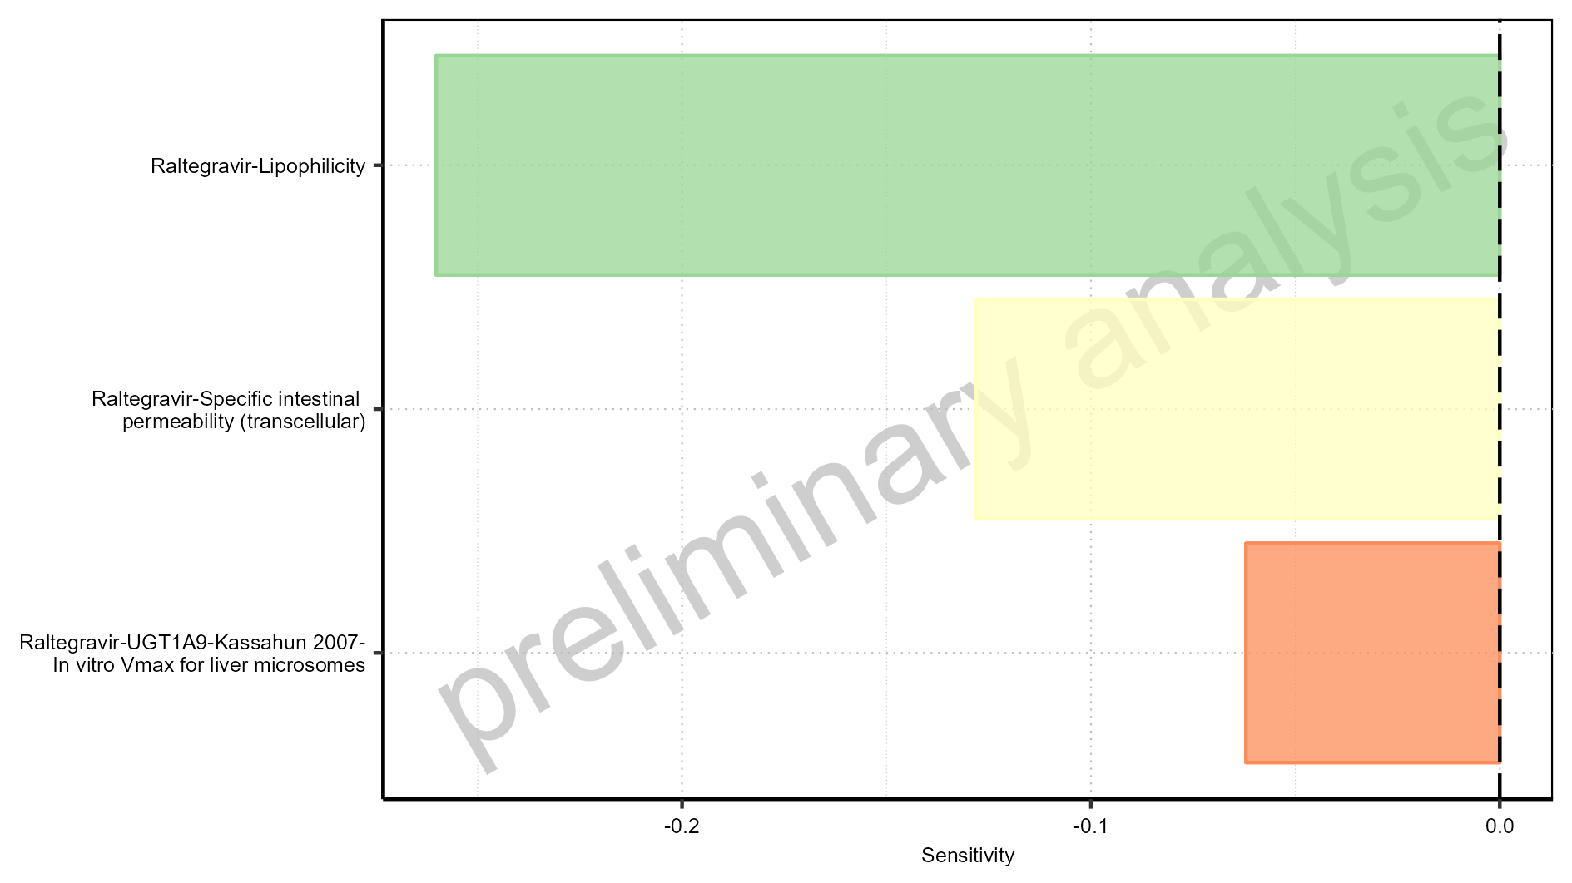

Figure 1-34: Most sensitive parameters for Thalf of Raltegravir.

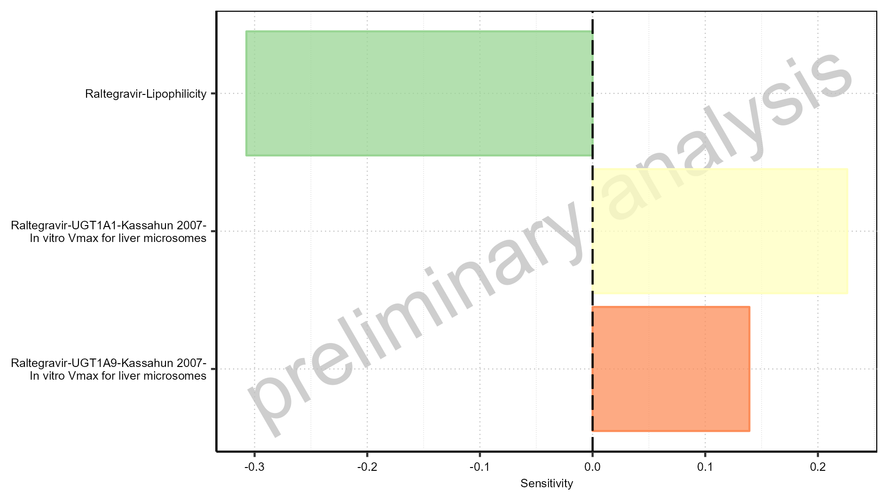

Figure 1-35: Most sensitive parameters for Thalf_tLast_tEnd of Raltegravir.

# PK parameters

## PK parameters for Raltegravir 10 mg (lactose formulation)

**Table 2-1: PK parameters for Raltegravir 10 mg (lactose formulation)**

|  |  |  |  |
| --- | --- | --- | --- |
| Path | Parameter | Value | Unit |
| Raltegravir | C_max | 110.49 | µg/l |
| Raltegravir | C_max_norm | 0.81 | kg/l |
| Raltegravir | t_max | 0.75 | h |
| Raltegravir | C_tEnd | 1.96 | µg/l |
| Raltegravir | AUC | 241.61 | µg*h/l |
| Raltegravir | AUC_norm | 1.76 | kg*h/l |
| Raltegravir | AUC_inf | 255.14 | µg*h/l |
| Raltegravir | AUC_inf_norm | 1.86 | kg*h/l |
| Raltegravir | MRT | 3.33 | h |
| Raltegravir | Thalf | 4.79 | h |
| Raltegravir | CL | 8.95 | ml/min/kg |
| Raltegravir | Vss | 1787.57 | ml/kg |
| Raltegravir | Vd | 3713.90 | ml/kg |

## PK parameters for Raltegravir 25 mg (lactose formulation)

**Table 2-2: PK parameters for Raltegravir 25 mg (lactose formulation)**

|  |  |  |  |
| --- | --- | --- | --- |
| Path | Parameter | Value | Unit |
| Raltegravir | C_max | 276.85 | µg/l |
| Raltegravir | C_max_norm | 0.81 | kg/l |
| Raltegravir | t_max | 0.75 | h |
| Raltegravir | C_tEnd | 4.89 | µg/l |
| Raltegravir | AUC | 605.06 | µg*h/l |
| Raltegravir | AUC_norm | 1.77 | kg*h/l |
| Raltegravir | AUC_inf | 638.90 | µg*h/l |
| Raltegravir | AUC_inf_norm | 1.87 | kg*h/l |
| Raltegravir | MRT | 3.33 | h |
| Raltegravir | Thalf | 4.79 | h |
| Raltegravir | CL | 8.93 | ml/min/kg |
| Raltegravir | Vss | 1783.40 | ml/kg |
| Raltegravir | Vd | 3705.77 | ml/kg |

## PK parameters for Raltegravir 100 mg filmcoated tablet md

**Table 2-3: PK parameters for Raltegravir 100 mg filmcoated tablet md**

|  |  |  |  |
| --- | --- | --- | --- |
| Path | Parameter | Value | Unit |
| Raltegravir | C_max | 893.50 | µg/l |
| Raltegravir | C_max_norm | 0.03 | kg/l |
| Raltegravir | C_max_t1_t2 | 863.16 | µg/l |
| Raltegravir | C_max_t1_t2_norm | 0.63 | kg/l |
| Raltegravir | C_max_tLast_tEnd | 892.65 | µg/l |
| Raltegravir | C_max_tLast_tEnd_norm | 0.65 | kg/l |
| Raltegravir | t_max | 168.75 | h |
| Raltegravir | t_max_t1_t2 | 0.75 | h |
| Raltegravir | t_max_tLast_tEnd | 228.75 | h |
| Raltegravir | C_trough_t2 | 19.66 | µg/l |
| Raltegravir | C_trough_tLast | 31.92 | µg/l |
| Raltegravir | AUC_t1_t2 | 1978.76 | µg*h/l |
| Raltegravir | AUC_t1_t2_norm | 1.44 | kg*h/l |
| Raltegravir | AUC_tLast_minus_1_tLast | 2218.73 | µg*h/l |
| Raltegravir | AUC_tLast_minus_1_tLast_norm | 1.62 | kg*h/l |
| Raltegravir | AUC_inf_t1 | 2144.35 | µg*h/l |
| Raltegravir | AUC_inf_t1_norm | 1.57 | kg*h/l |
| Raltegravir | AUC_inf_tLast | 2536.55 | µg*h/l |
| Raltegravir | AUC_inf_tLast_norm | 1.85 | kg*h/l |
| Raltegravir | MRT | 3.96 | h |
| Raltegravir | Thalf | 5.84 | h |
| Raltegravir | Thalf_tLast_tEnd | 6.90 | h |

# Absorption

## Absorption for Raltegravir 10 mg (lactose formulation)

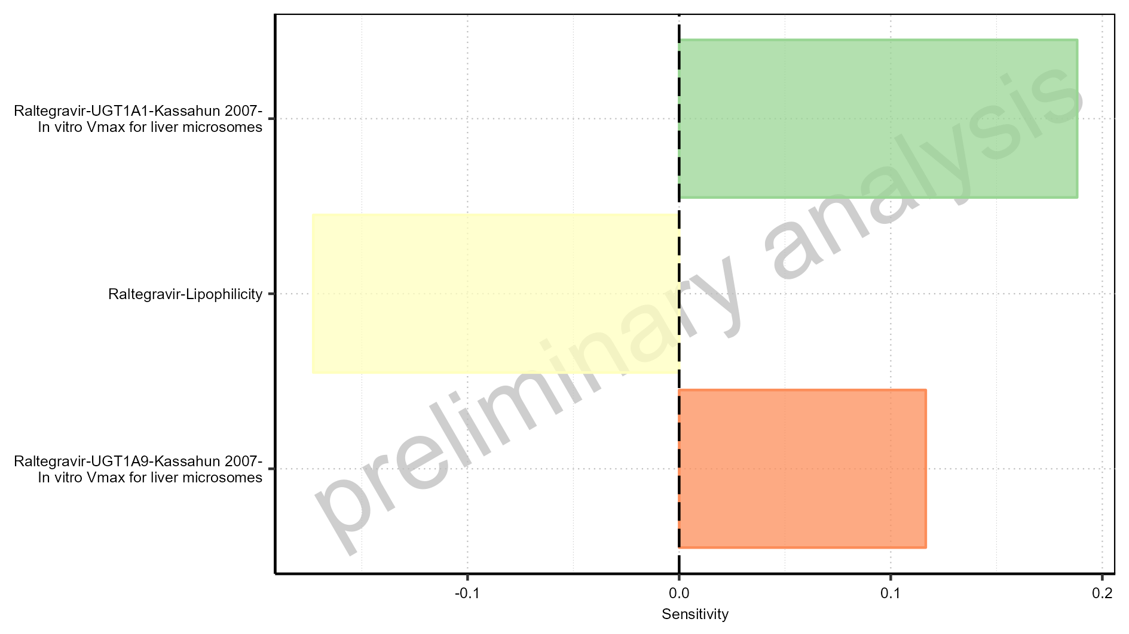

Figure 3-1: Absorption of Raltegravir

## Absorption for Raltegravir 25 mg (lactose formulation)

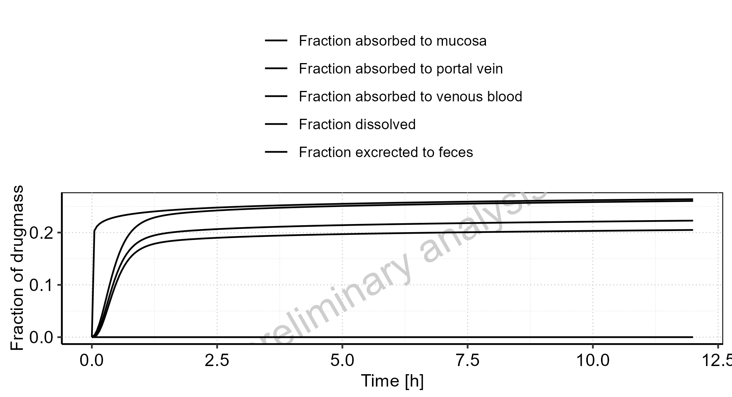

Figure 3-2: Absorption of Raltegravir

## Absorption for Raltegravir 100 mg filmcoated tablet md

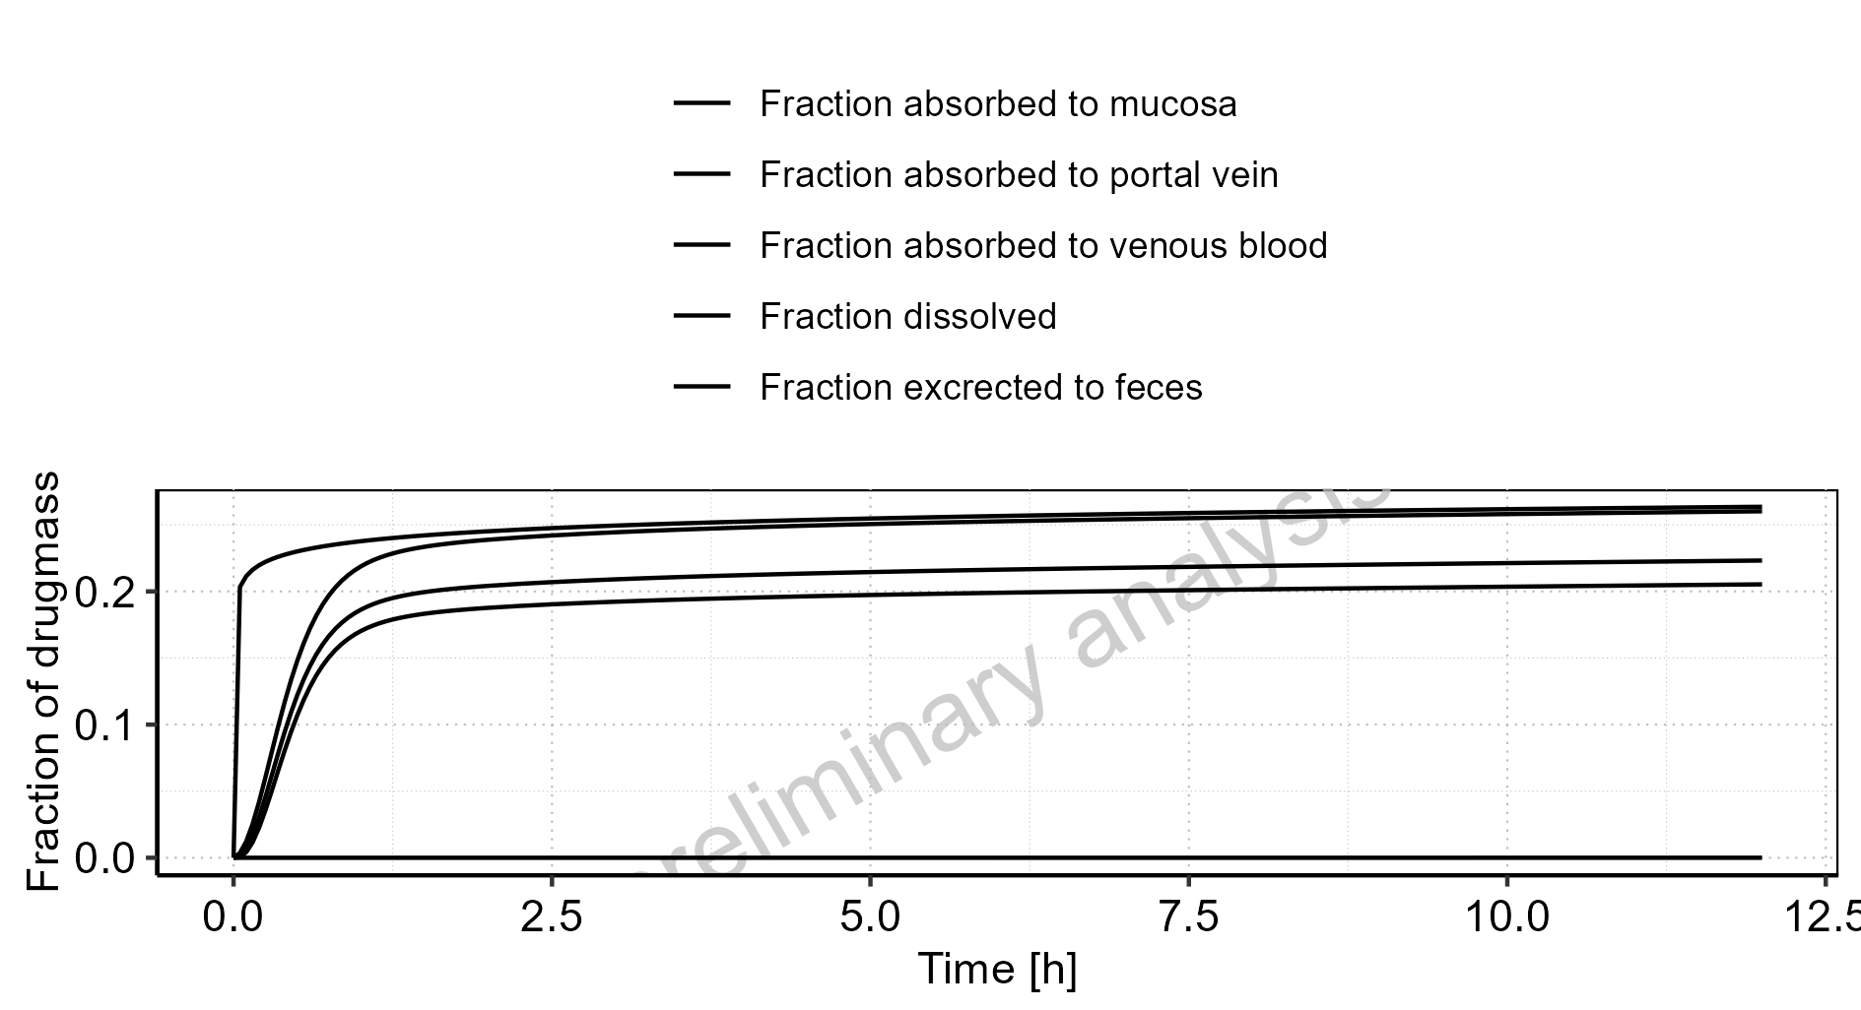

Figure 3-3: Absorption of Raltegravir

# Mass Balance

## Mass Balance for Raltegravir 10 mg (lactose formulation)

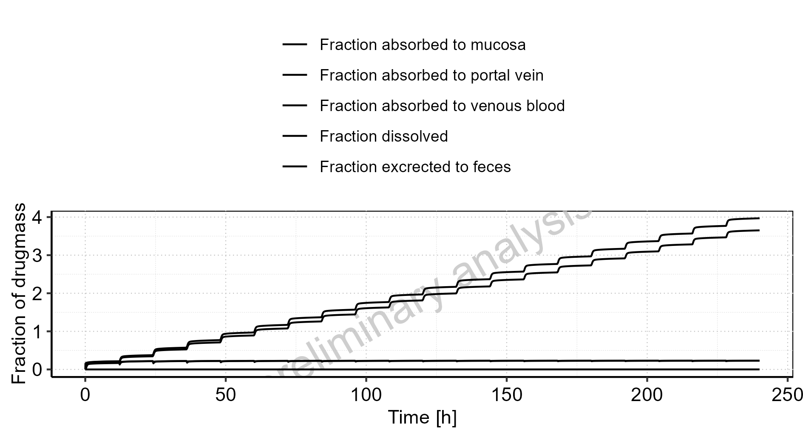

Figure 4-1: Amount of drug vs time within the different compartments

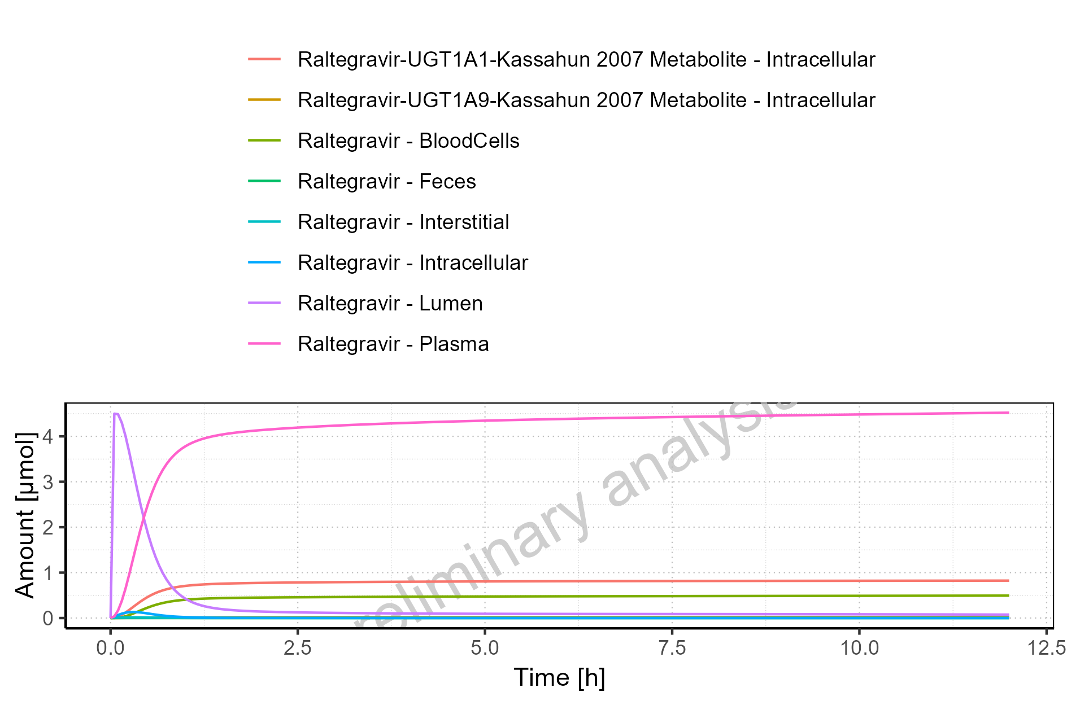

Figure 4-2: Cumulated amount of drug vs time within the different compartments

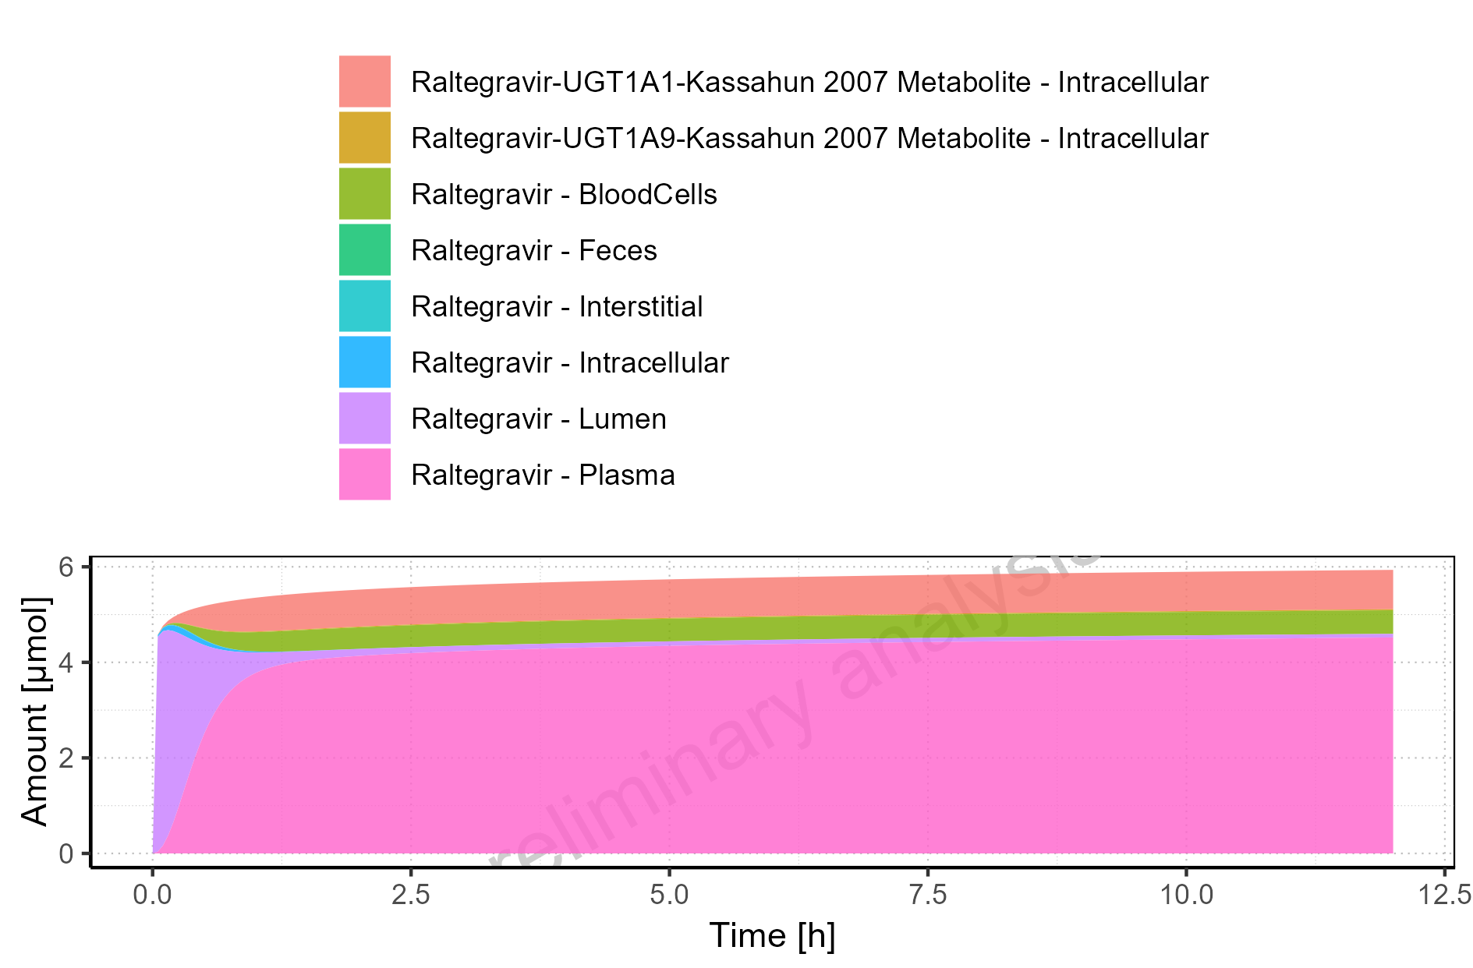

Figure 4-3: Amount of drug vs time within the different compartments normalized to applicated drugmass

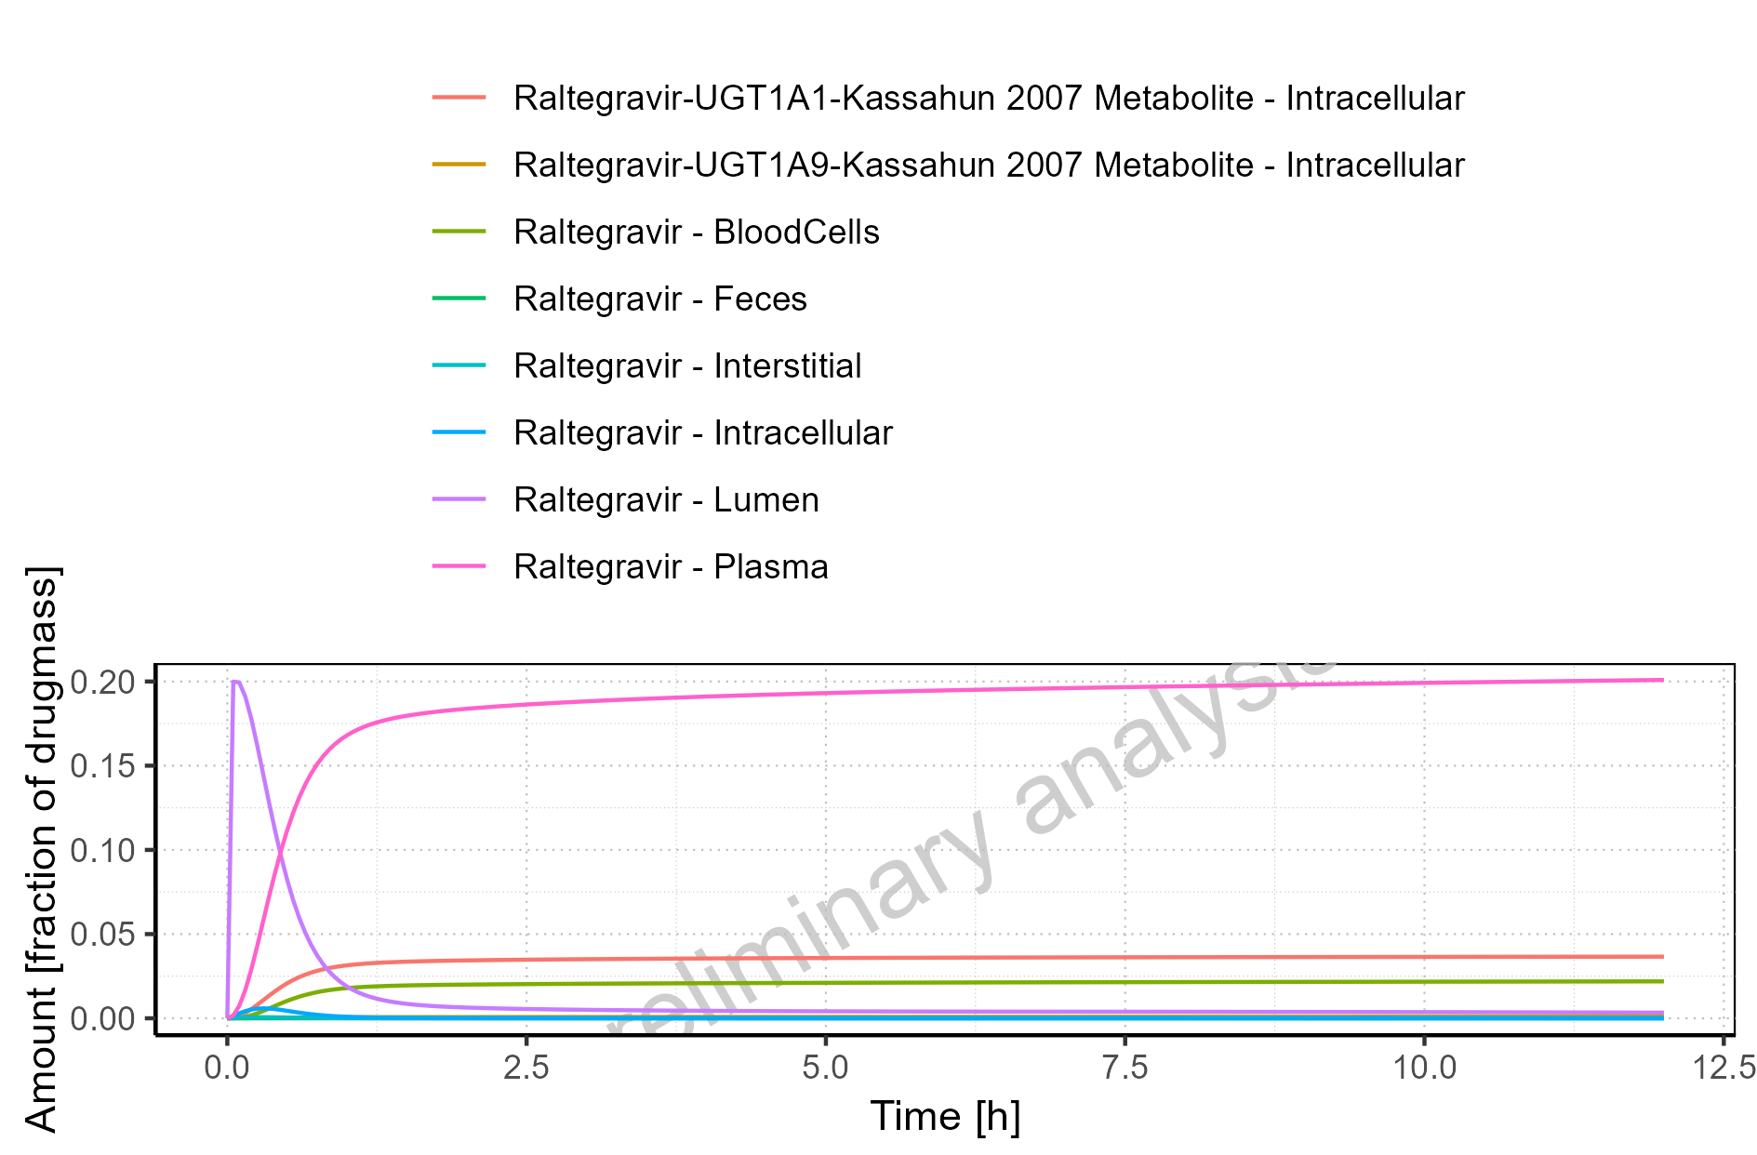

Figure 4-4: Cumulated amount of drug vs time within the different compartments normalized to applicated drugmass

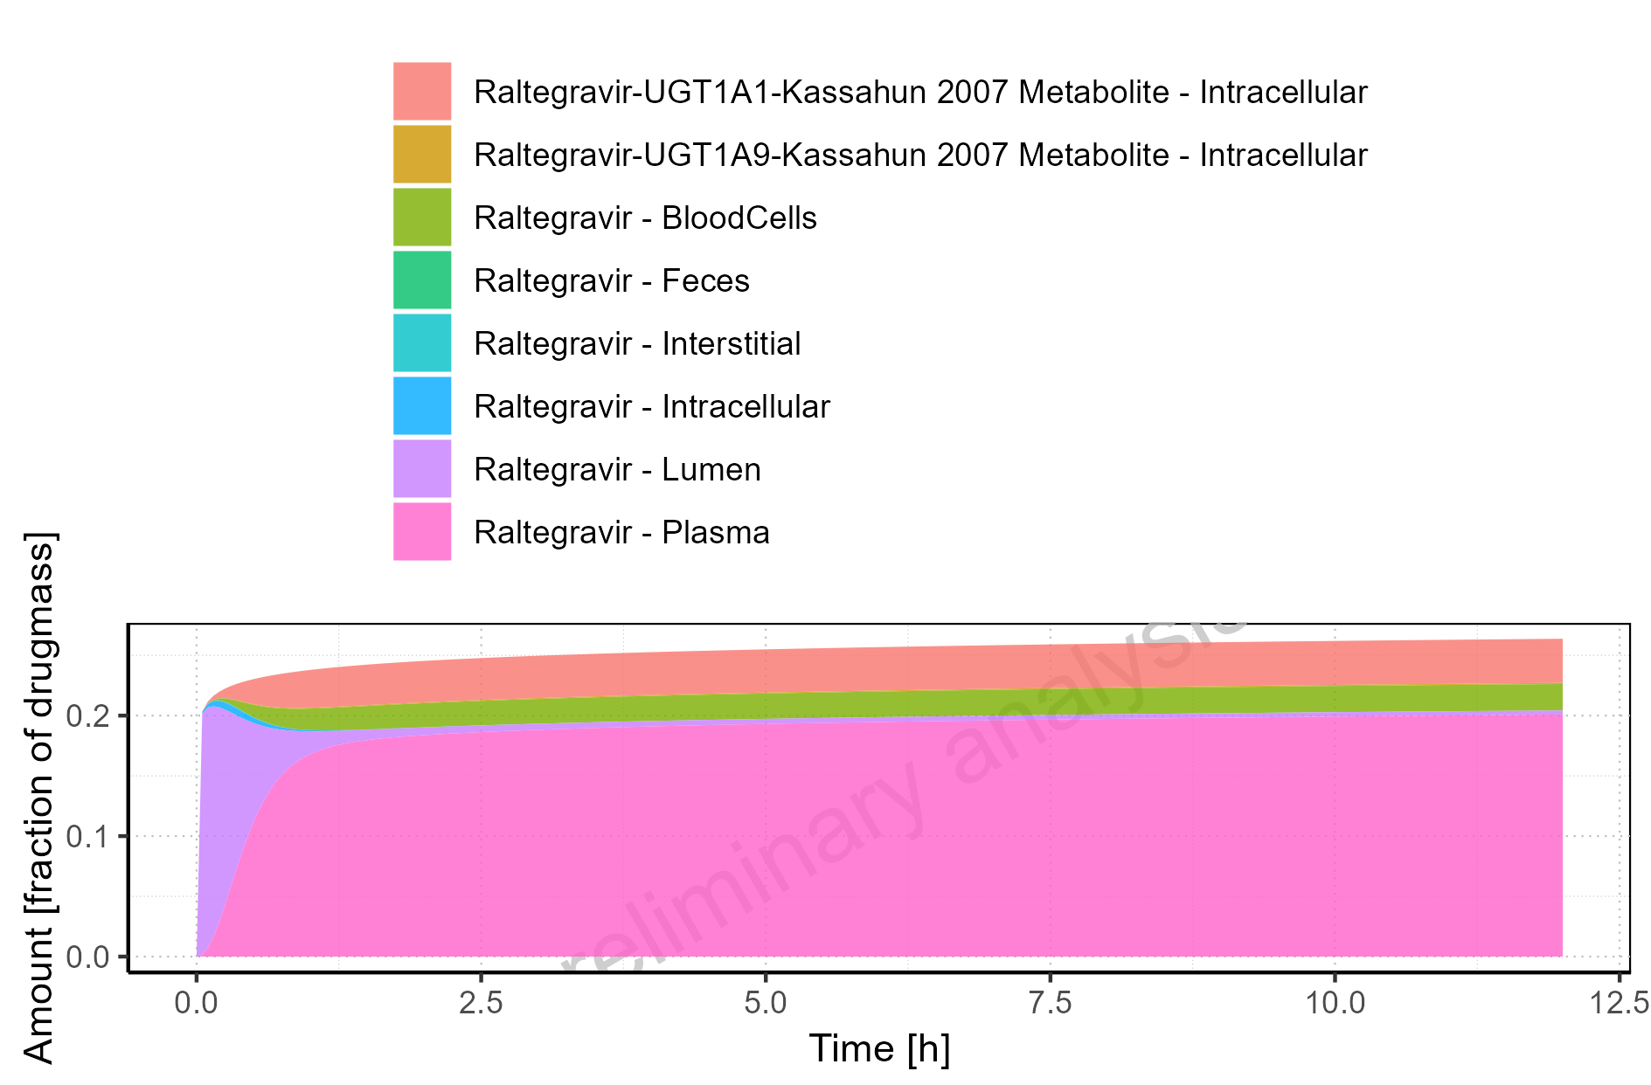

Figure 4-5: Fraction of drug within the different compartments at 12.00h

## Mass Balance for Raltegravir 25 mg (lactose formulation)

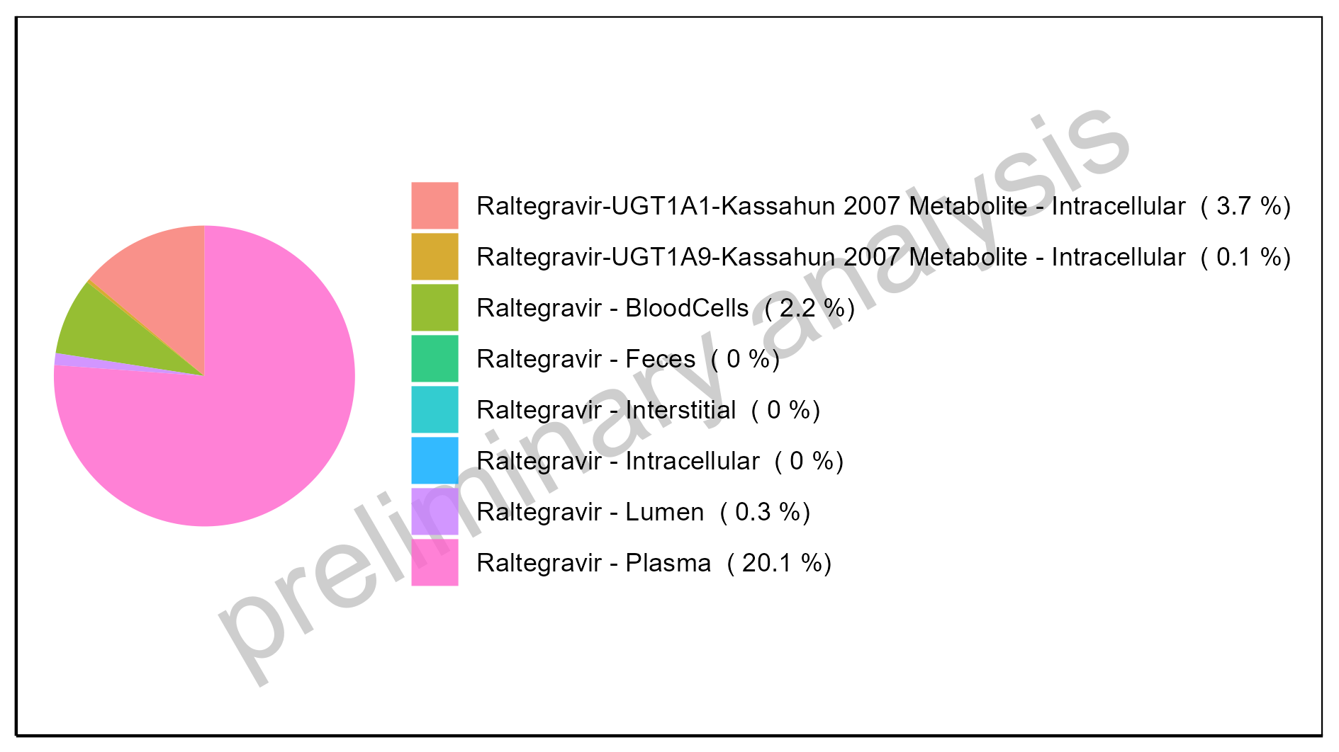

Figure 4-6: Amount of drug vs time within the different compartments

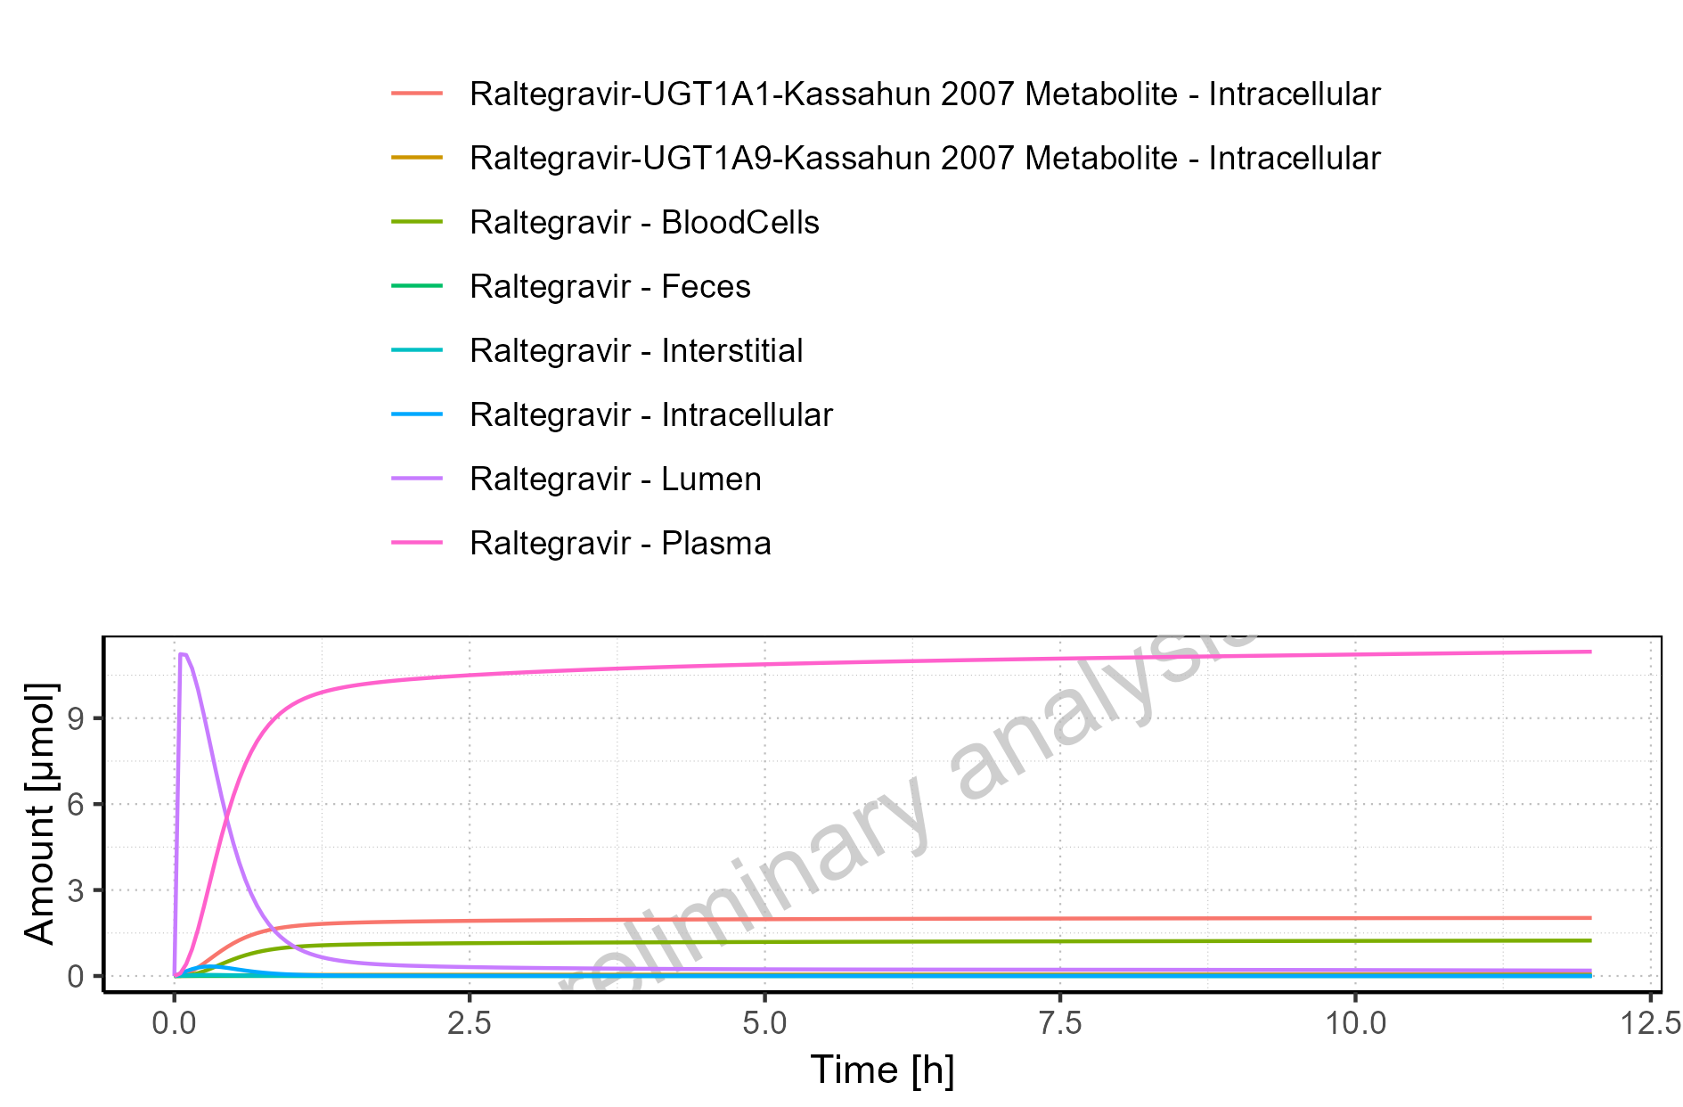

Figure 4-7: Cumulated amount of drug vs time within the different compartments

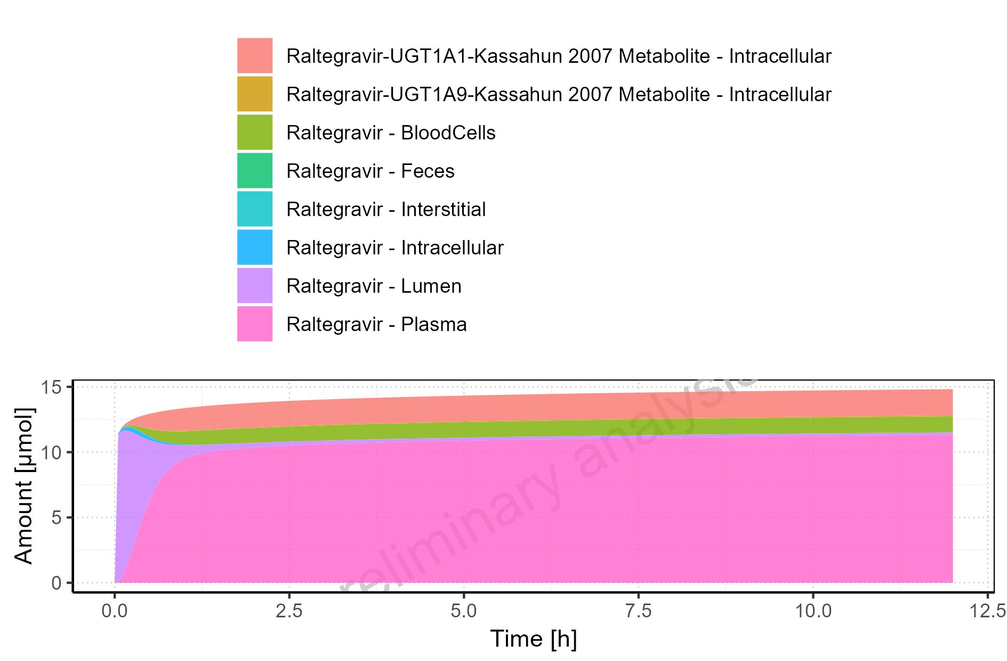

Figure 4-8: Amount of drug vs time within the different compartments normalized to applicated drugmass

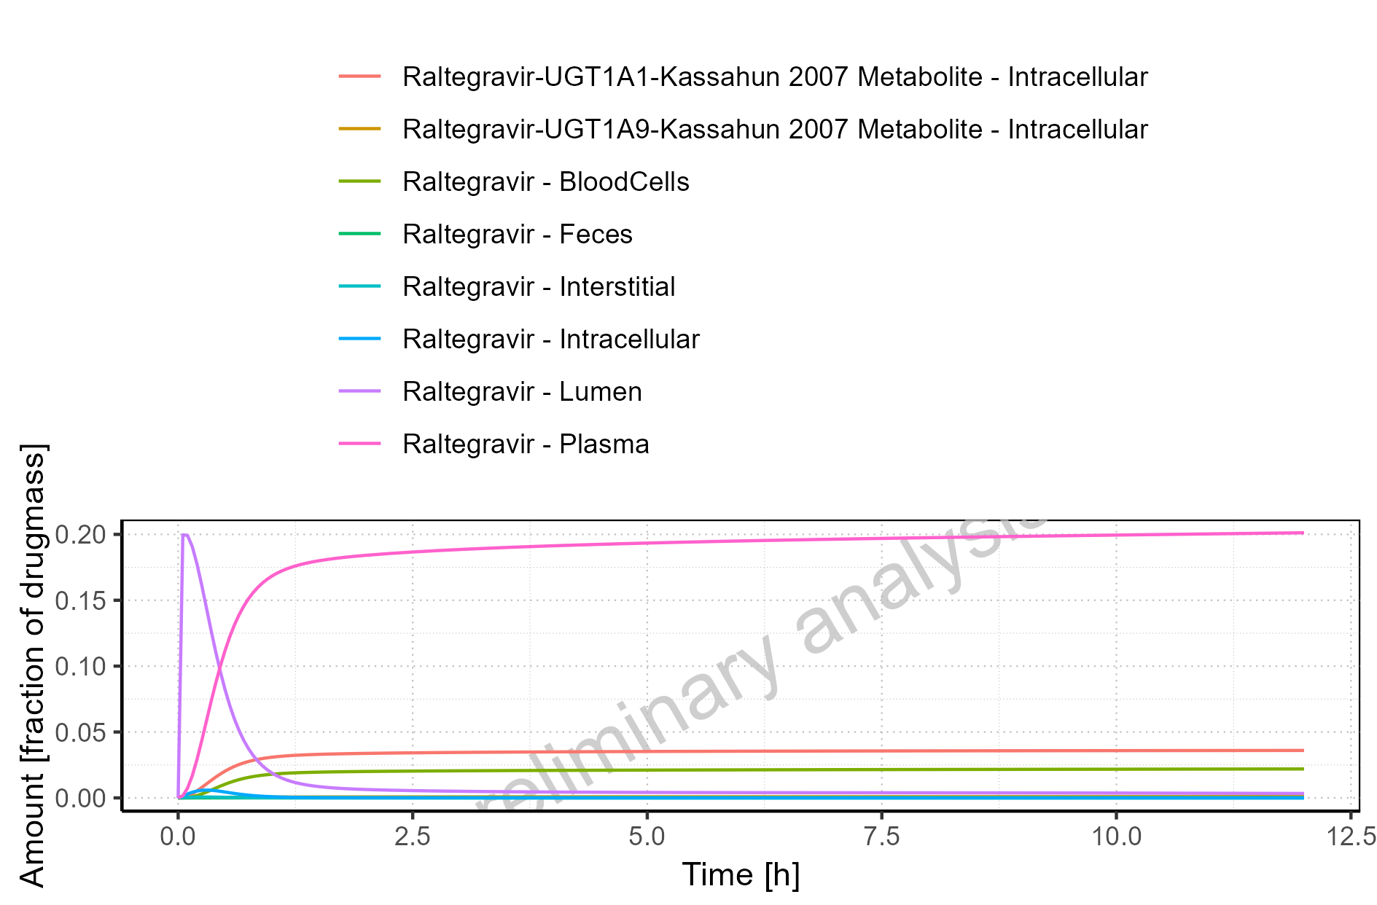

Figure 4-9: Cumulated amount of drug vs time within the different compartments normalized to applicated drugmass

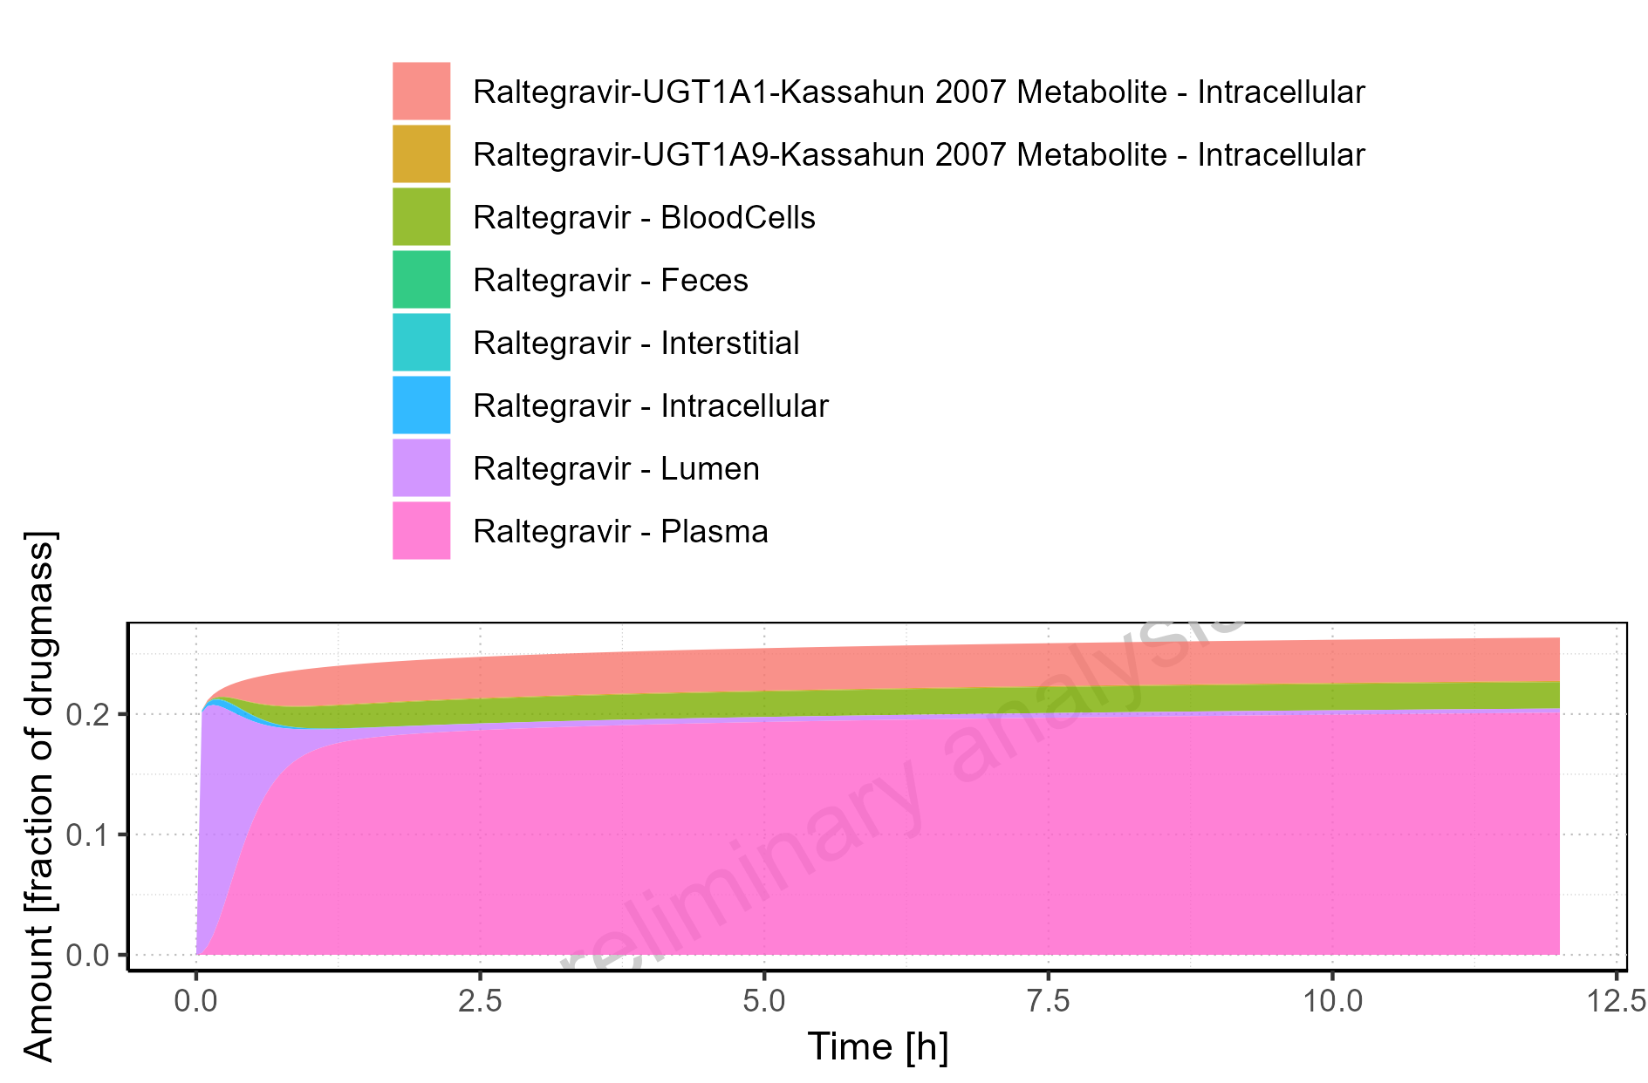

Figure 4-10: Fraction of drug within the different compartments at 12.00h

## Mass Balance for Raltegravir 100 mg filmcoated tablet md

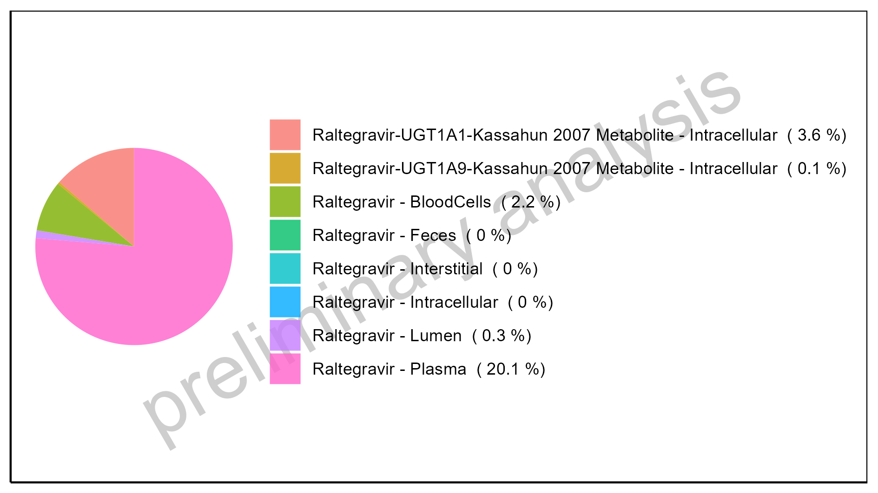

Figure 4-11: Amount of drug vs time within the different compartments

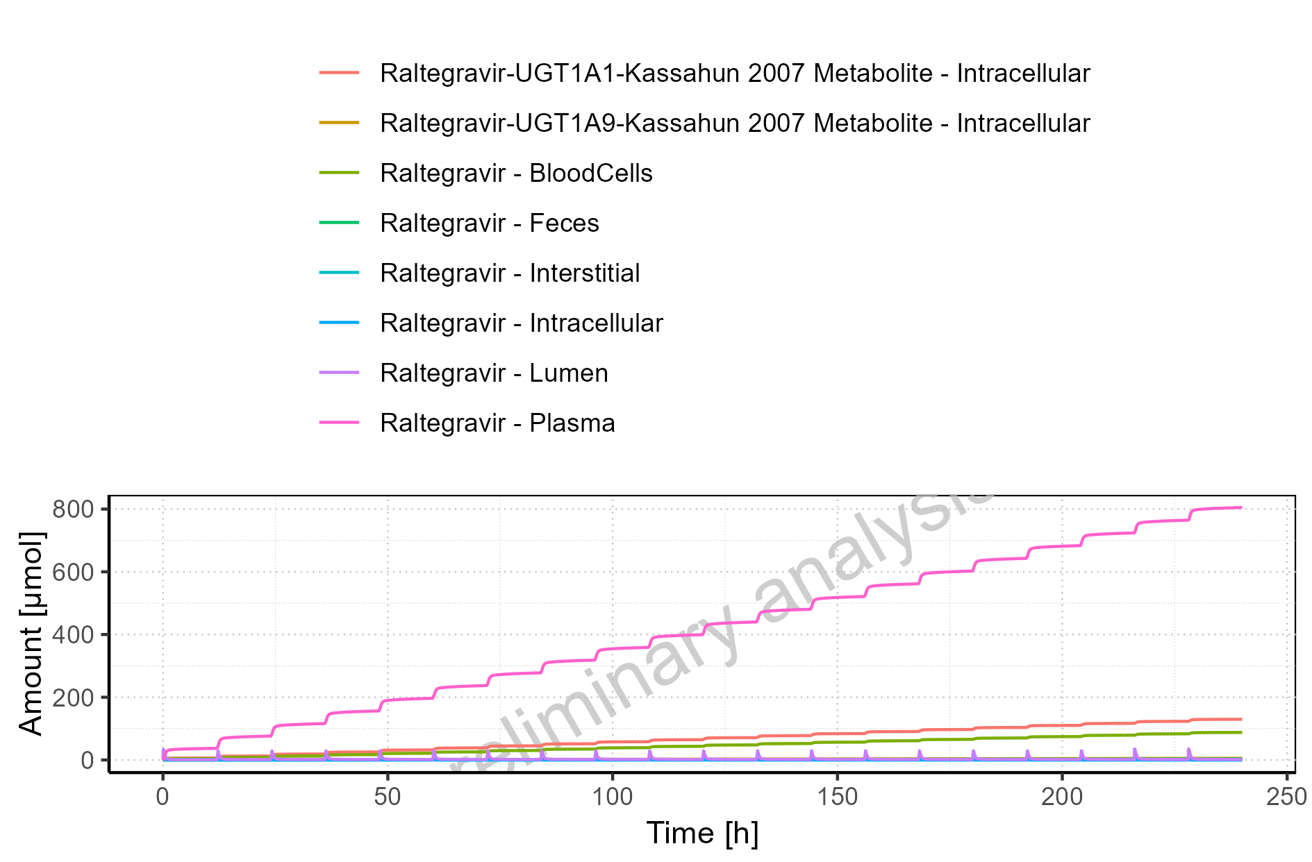

Figure 4-12: Cumulated amount of drug vs time within the different compartments

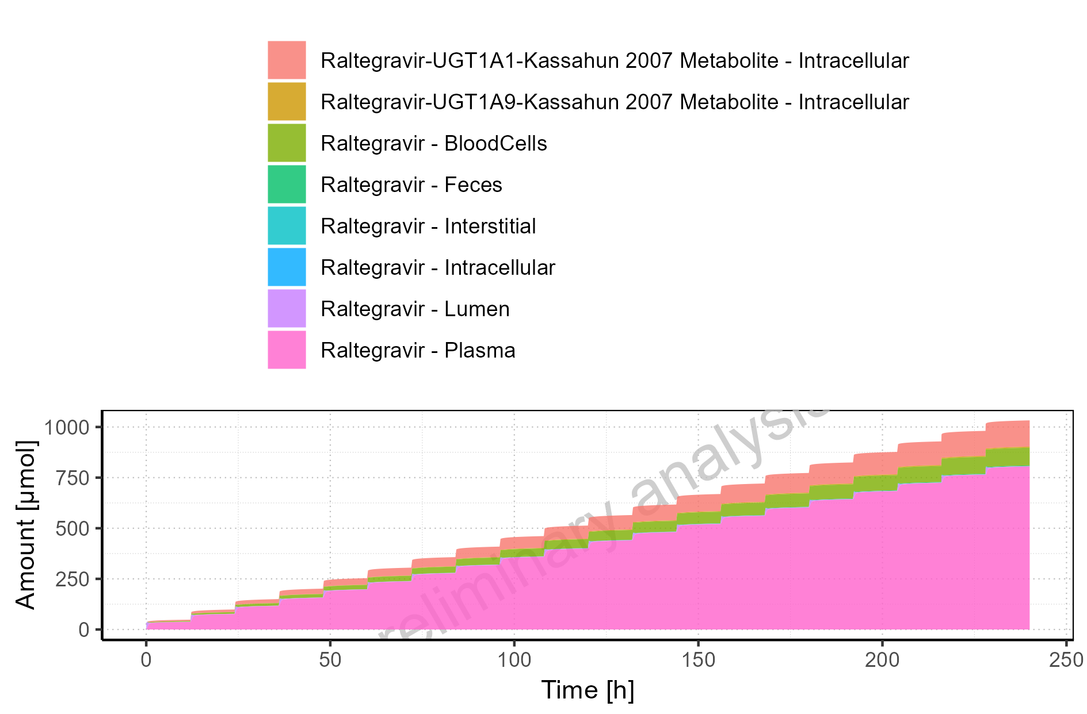

Figure 4-13: Amount of drug vs time within the different compartments normalized to applicated drugmass

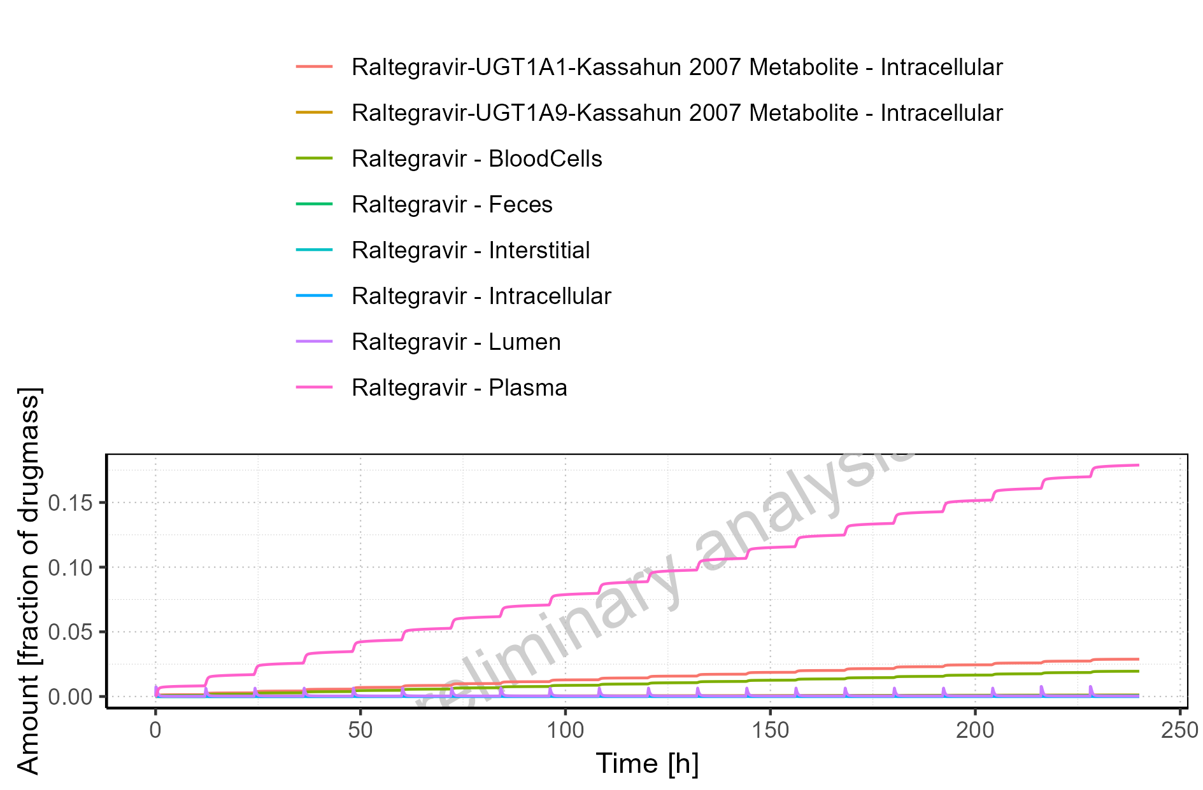

Figure 4-14: Cumulated amount of drug vs time within the different compartments normalized to applicated drugmass

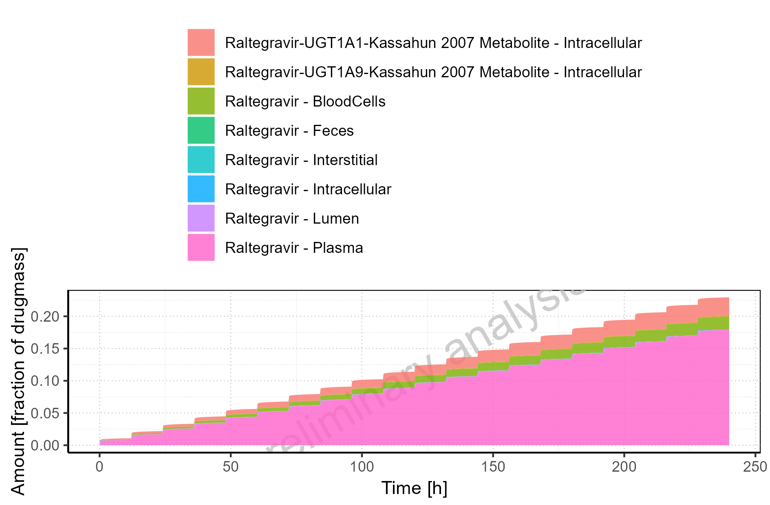

Figure 4-15: Fraction of drug within the different compartments at 240.00h

# Time profiles and residual plots

## Time profiles and residual plots for Raltegravir 10 mg (lactose formulation)

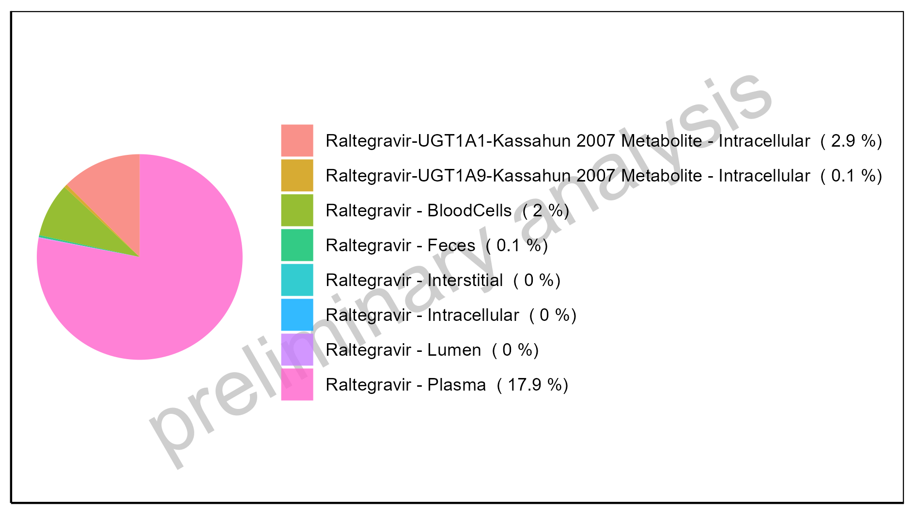

Figure 5-1: Time profiles for Raltegravir 10 mg (lactose formulation). Data source: Data/Raltegravir_PK.txt .. Time profiles are plotted in a linear scale.

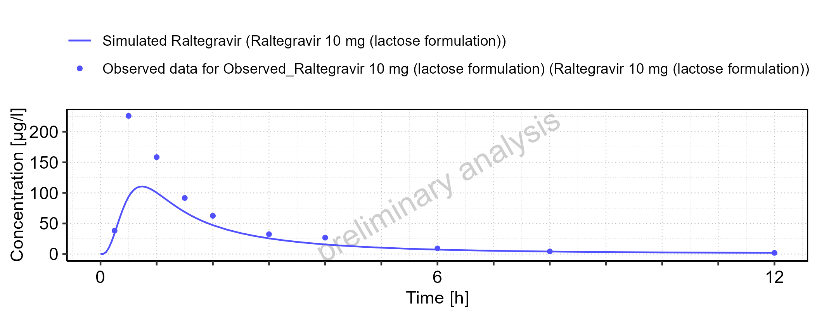

Figure 5-2: Time profiles for Raltegravir 10 mg (lactose formulation). Data source: Data/Raltegravir_PK.txt .. Time profiles are plotted in a logarithmic scale.

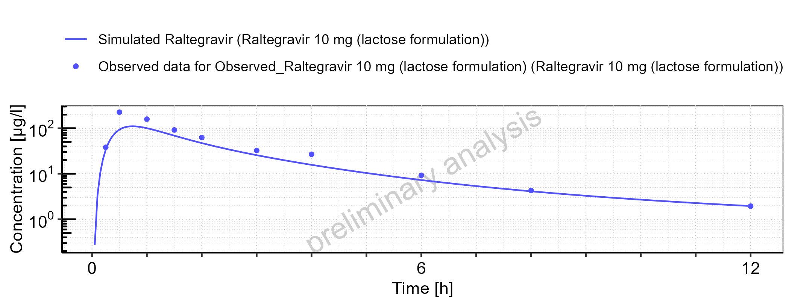

Figure 5-3: Predicted vs observed for Raltegravir 10 mg (lactose formulation). Data source: Data/Raltegravir_PK.txt .. Predictions and observations are plotted in a linear scale.

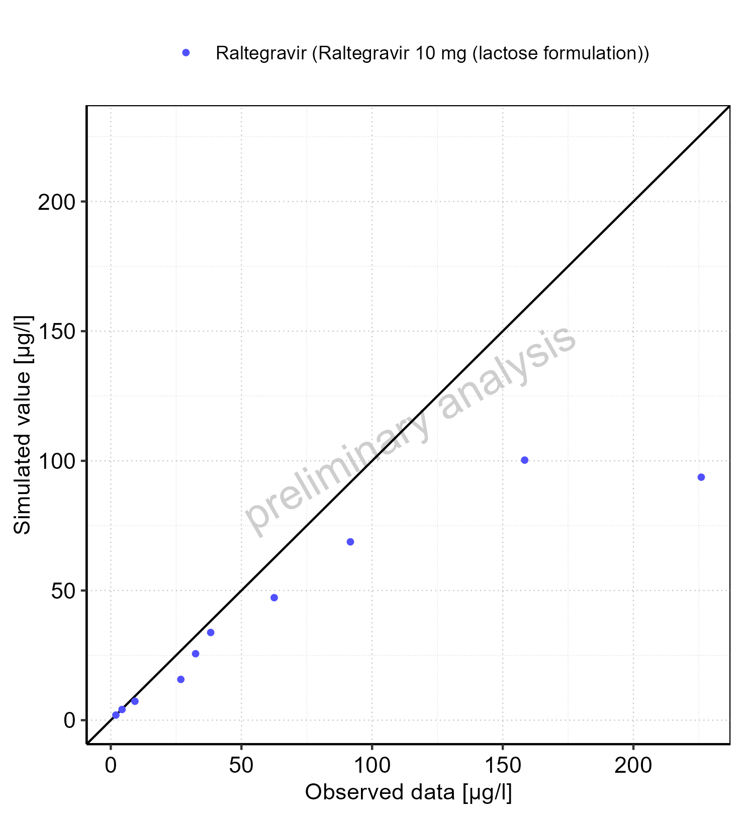

Figure 5-4: Predicted vs observed for Raltegravir 10 mg (lactose formulation). Data source: Data/Raltegravir_PK.txt .. Predictions and observations are plotted in a logarithmic scale.

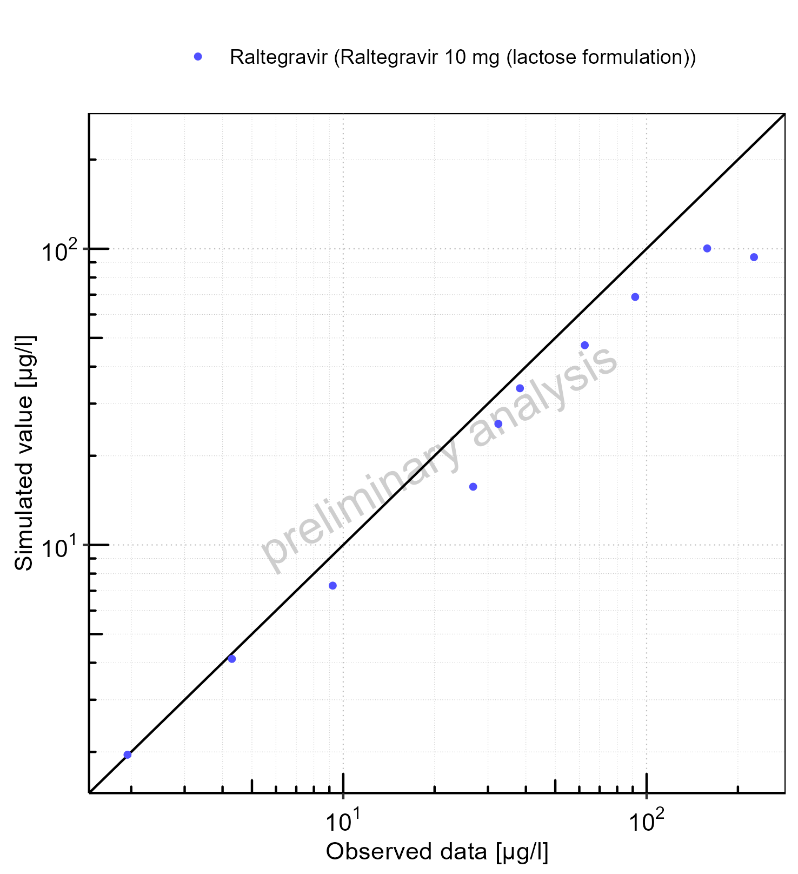

Figure 5-5: Logarithmic residuals vs predicted values for Raltegravir 10 mg (lactose formulation). Data source: Data/Raltegravir_PK.txt .

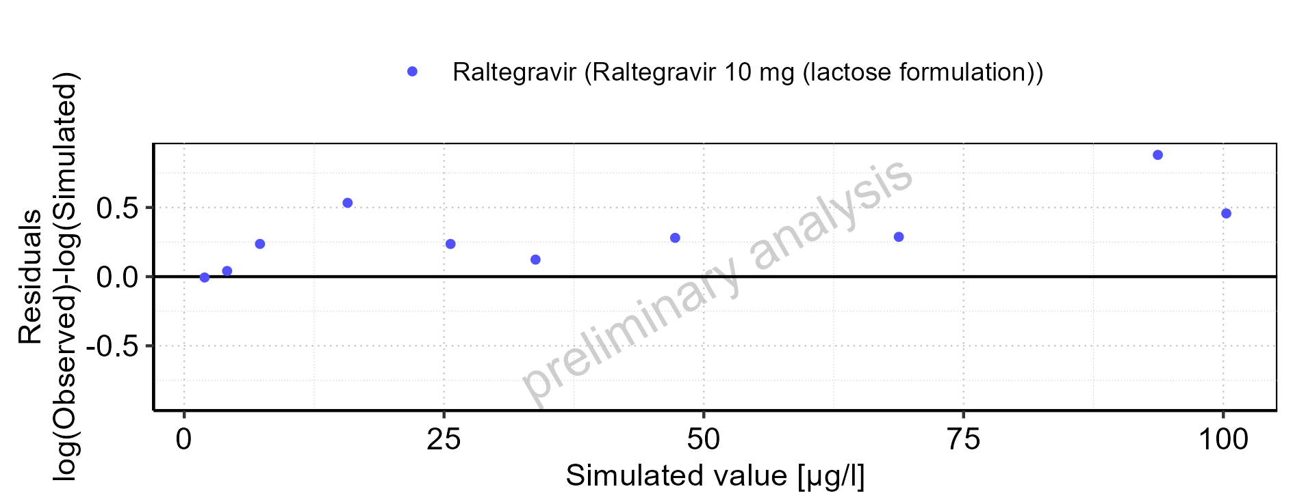

Figure 5-6: Logarithmic residuals vs time values for Raltegravir 10 mg (lactose formulation). Data source: Data/Raltegravir_PK.txt .

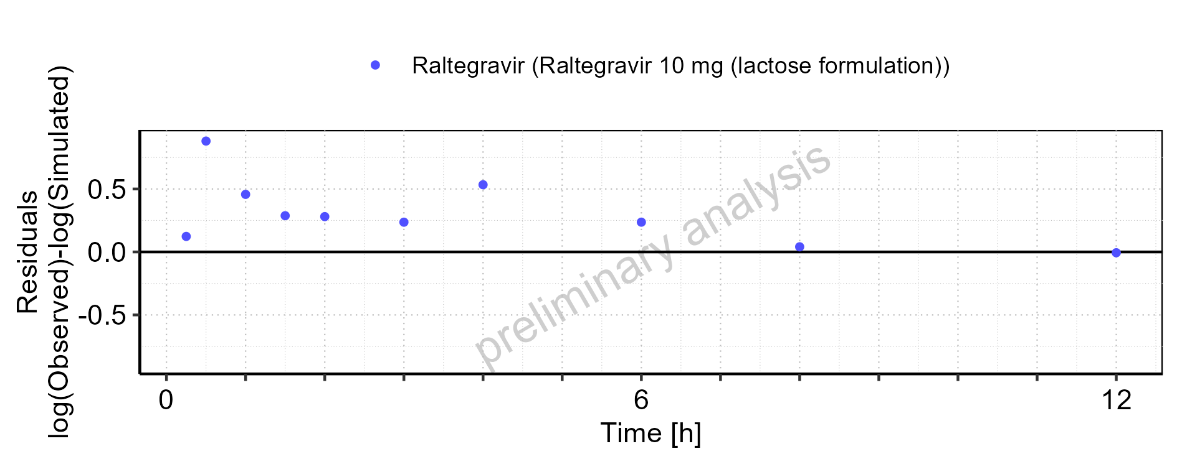

Figure 5-7: Logarithmic residuals distribution (stacked) for Raltegravir 10 mg (lactose formulation). Data source: Data/Raltegravir_PK.txt .

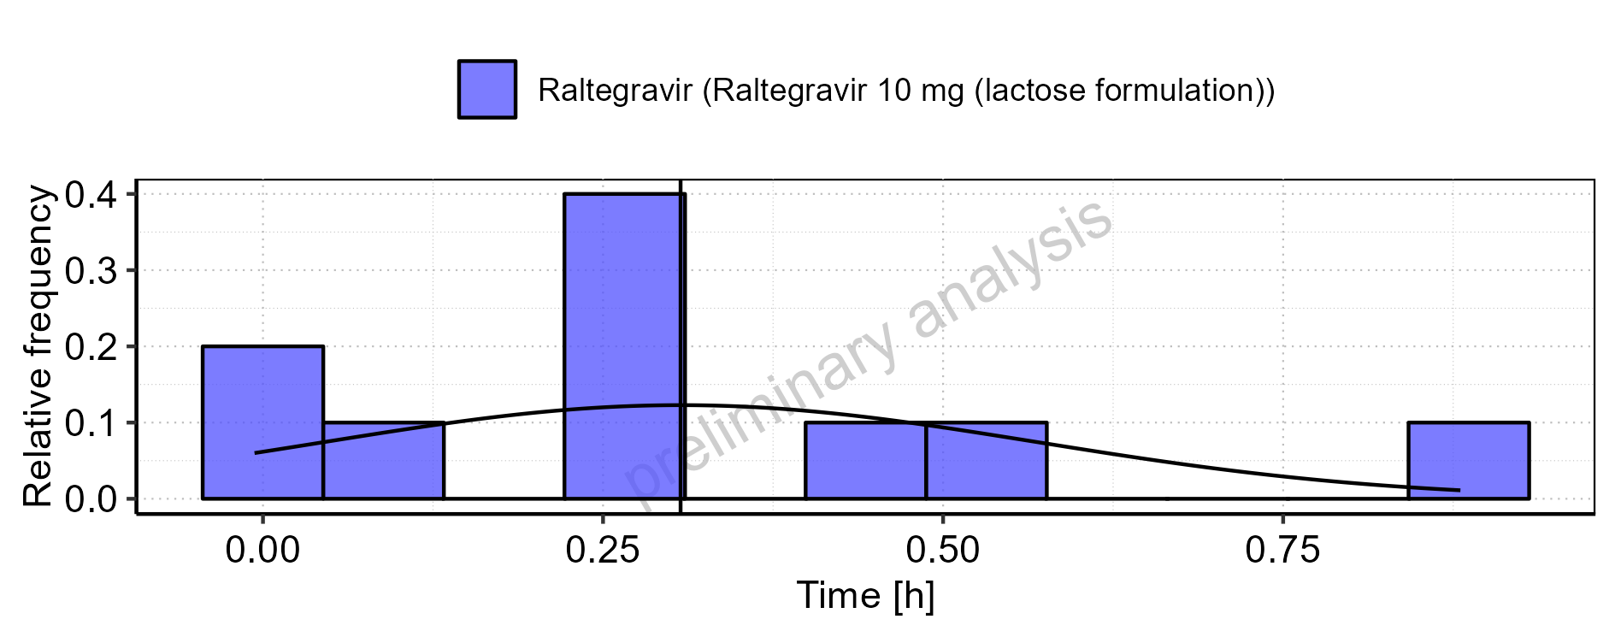

Figure 5-8: Logarithmic residuals for Raltegravir 10 mg (lactose formulation) as quantile-quantile plot. Data source: Data/Raltegravir_PK.txt .

## Time profiles and residual plots for Raltegravir 25 mg (lactose formulation)

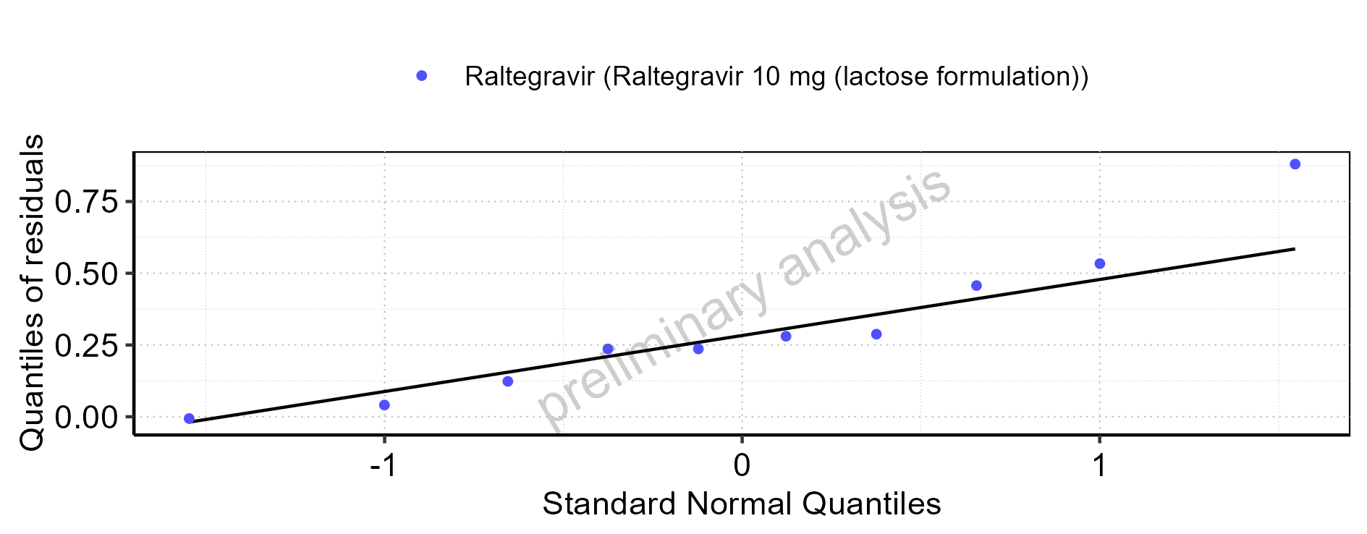

Figure 5-9: Time profiles for Raltegravir 25 mg (lactose formulation). Data source: Data/Raltegravir_PK.txt .. Time profiles are plotted in a linear scale.

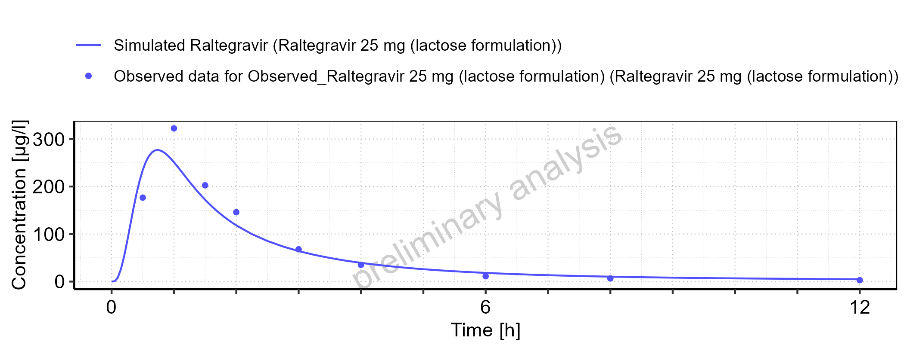

Figure 5-10: Time profiles for Raltegravir 25 mg (lactose formulation). Data source: Data/Raltegravir_PK.txt .. Time profiles are plotted in a logarithmic scale.

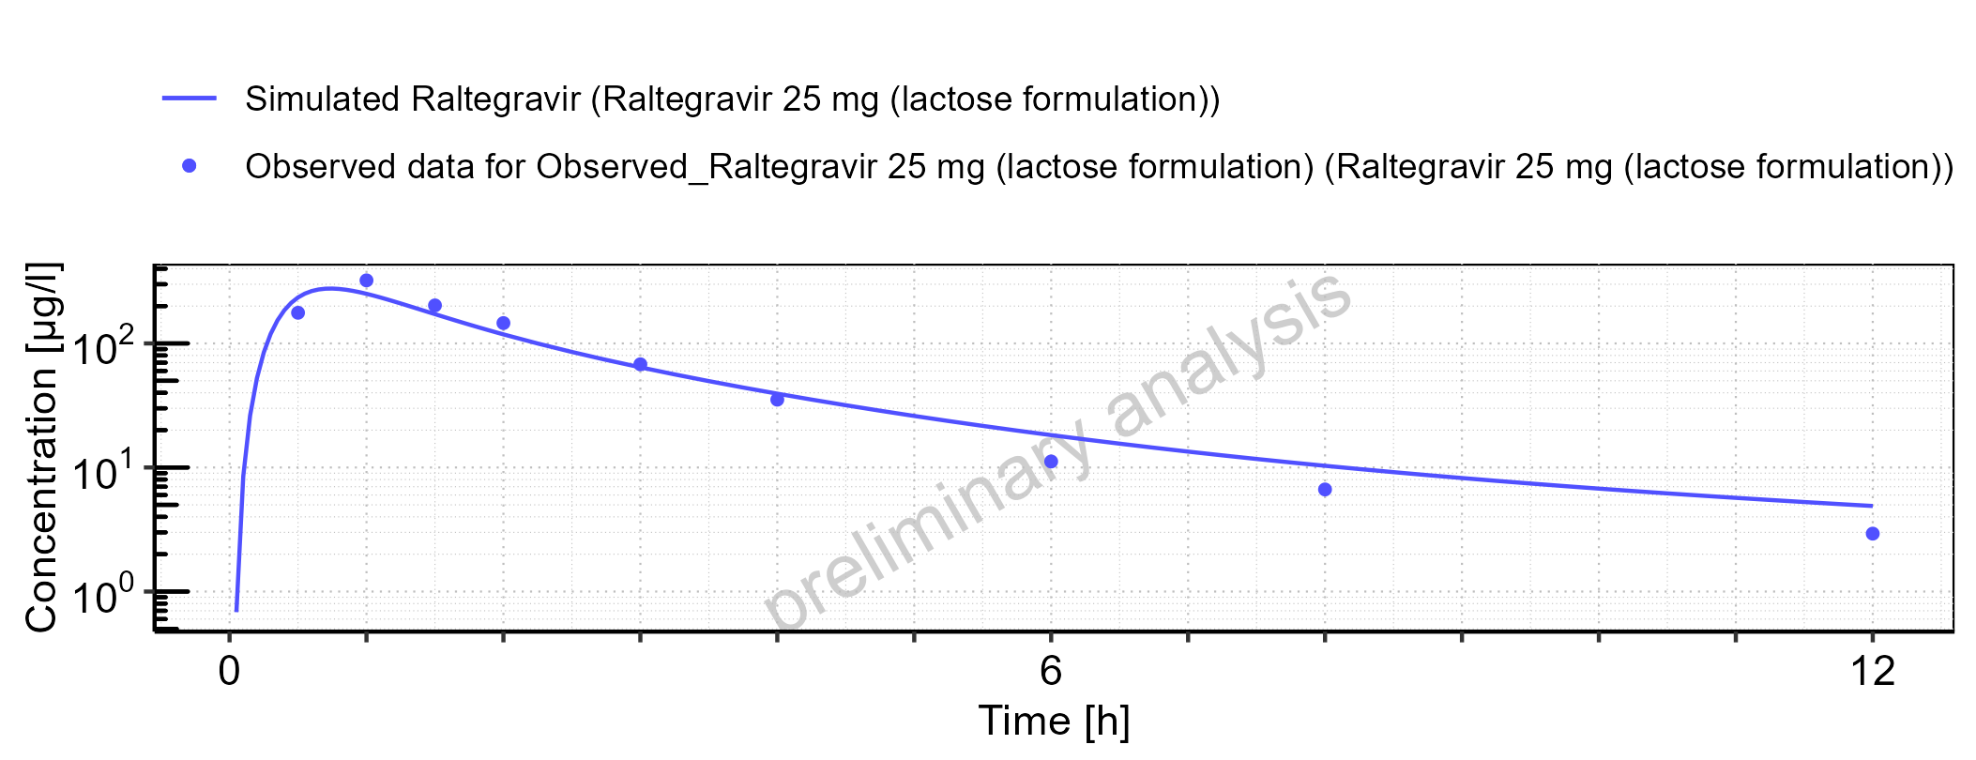

Figure 5-11: Predicted vs observed for Raltegravir 25 mg (lactose formulation). Data source: Data/Raltegravir_PK.txt .. Predictions and observations are plotted in a linear scale.

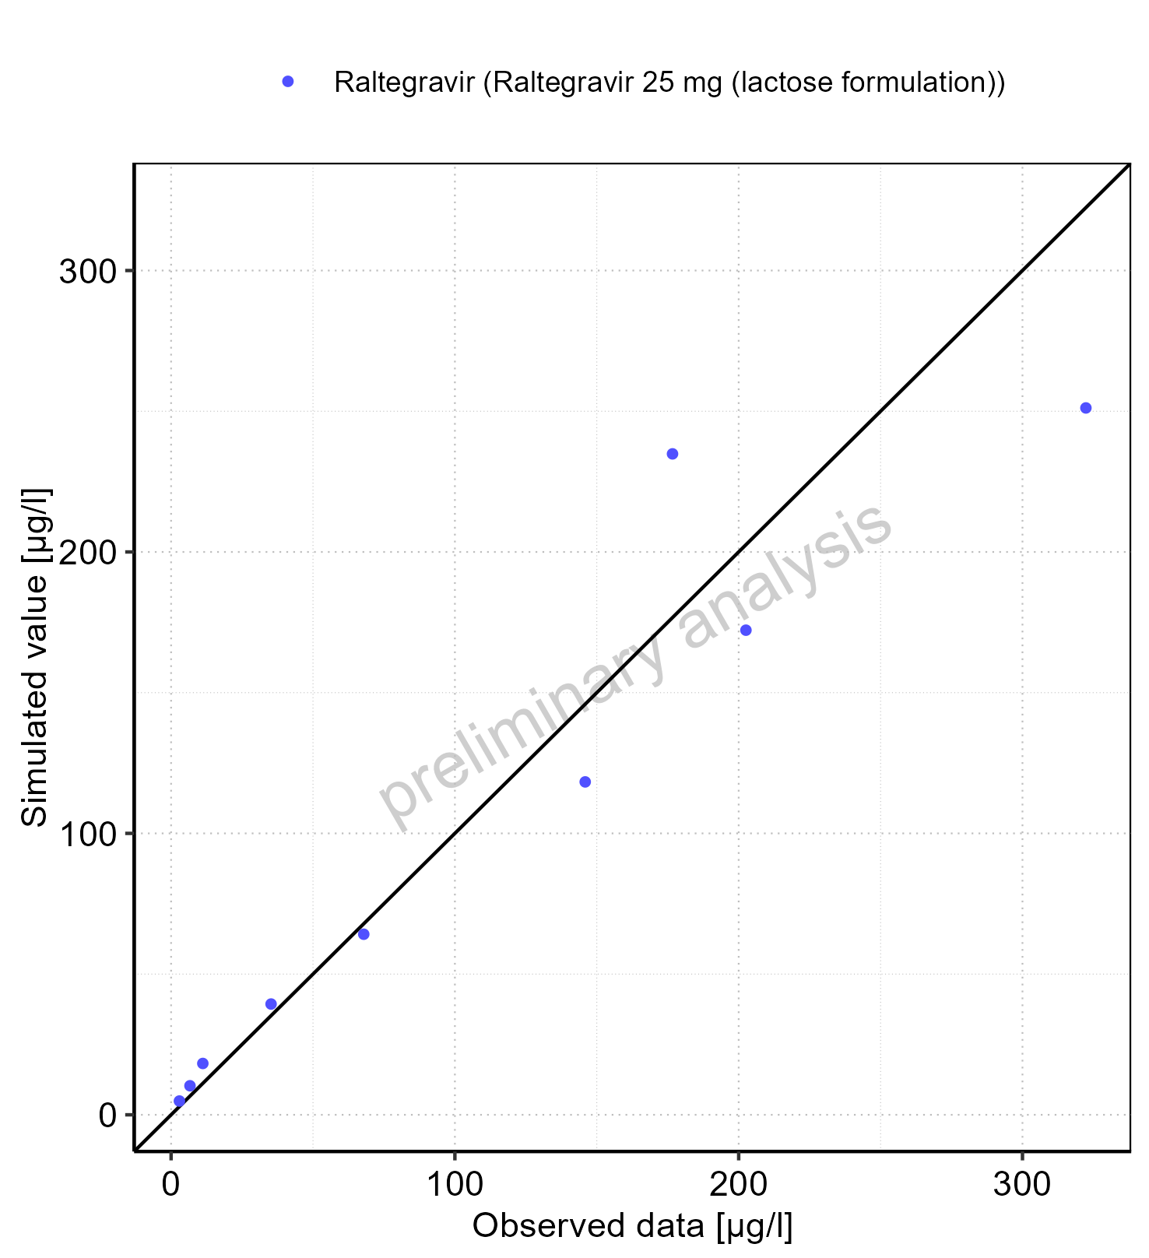

Figure 5-12: Predicted vs observed for Raltegravir 25 mg (lactose formulation). Data source: Data/Raltegravir_PK.txt .. Predictions and observations are plotted in a logarithmic scale.

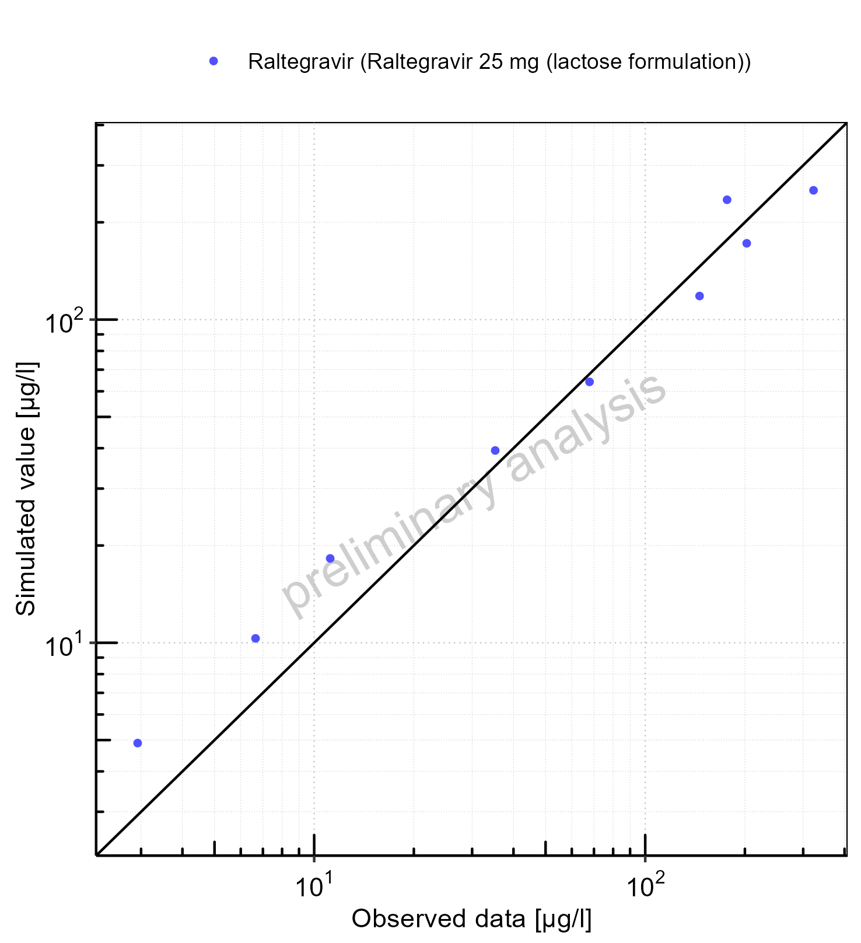

Figure 5-13: Logarithmic residuals vs predicted values for Raltegravir 25 mg (lactose formulation). Data source: Data/Raltegravir_PK.txt .

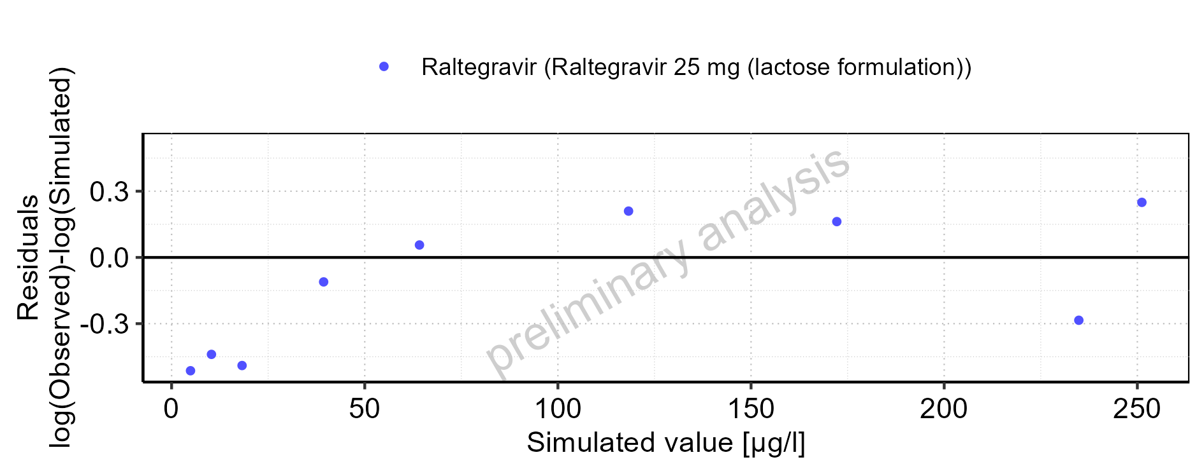

Figure 5-14: Logarithmic residuals vs time values for Raltegravir 25 mg (lactose formulation). Data source: Data/Raltegravir_PK.txt .

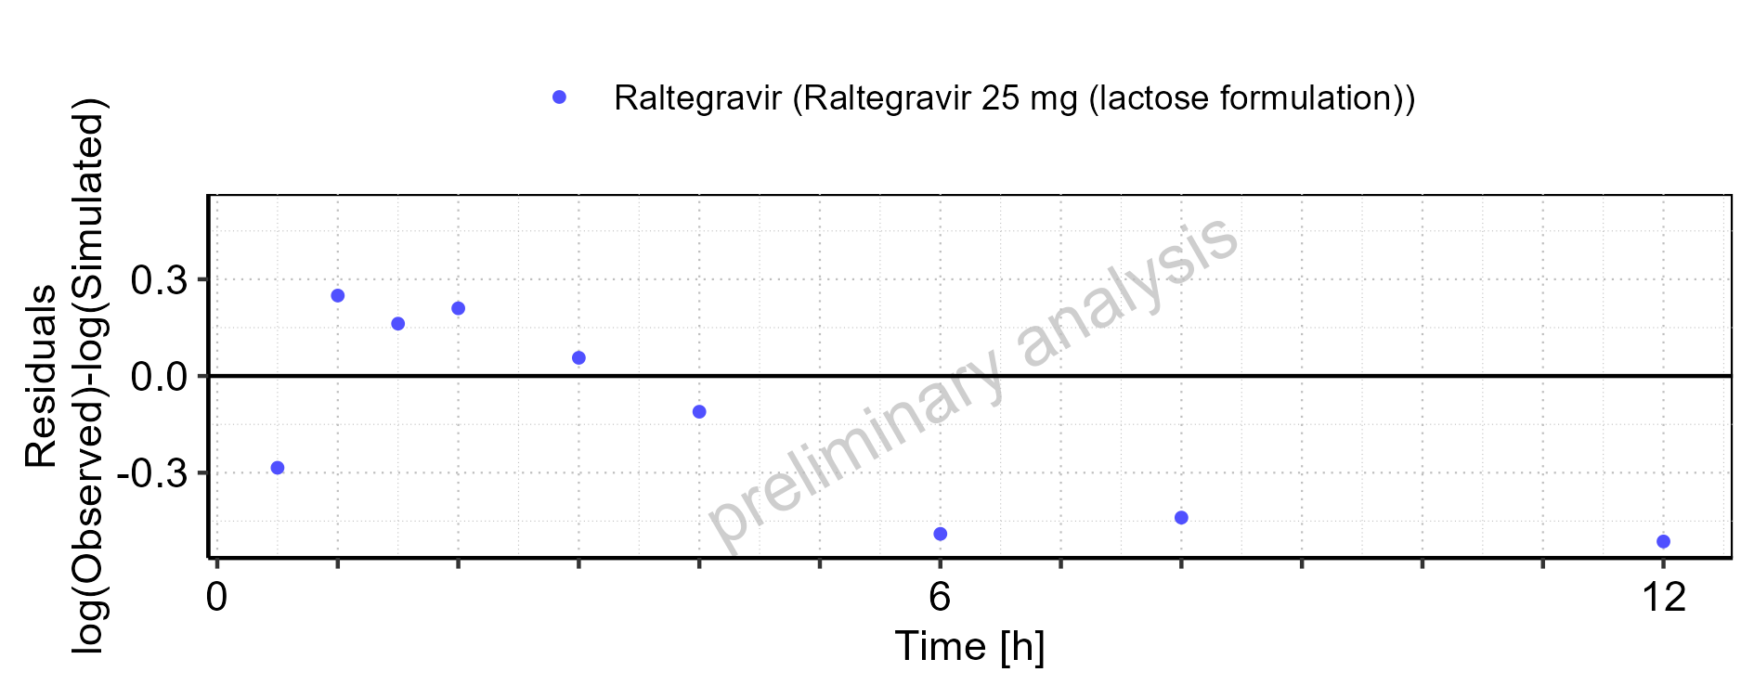

Figure 5-15: Logarithmic residuals distribution (stacked) for Raltegravir 25 mg (lactose formulation). Data source: Data/Raltegravir_PK.txt .

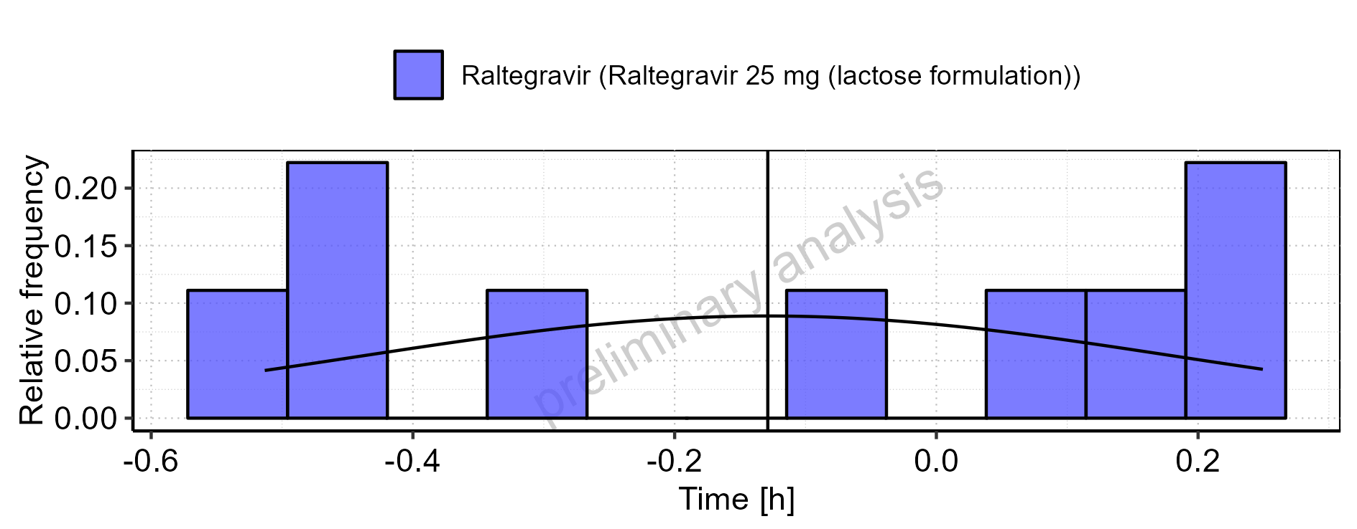

Figure 5-16: Logarithmic residuals for Raltegravir 25 mg (lactose formulation) as quantile-quantile plot. Data source: Data/Raltegravir_PK.txt .

## Time profiles and residual plots for Raltegravir 100 mg filmcoated tablet md

### For total simulation time range

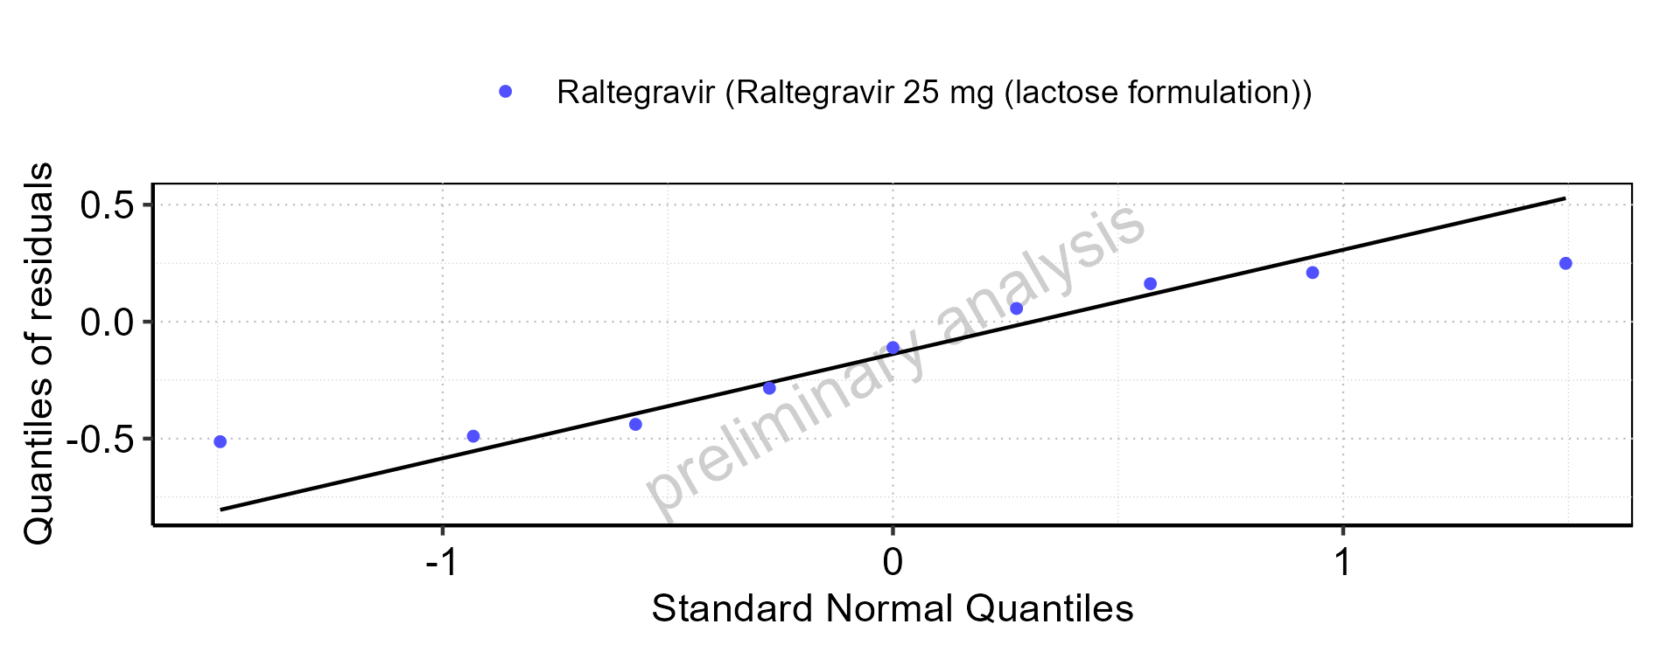

Figure 5-17: Time profiles for Raltegravir 100 mg filmcoated tablet md. Data source: Data/Raltegravir_PK.txt .. Time profiles are plotted in a linear scale.

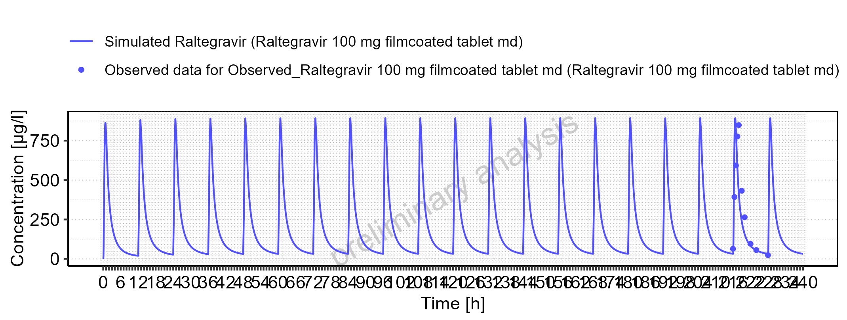

Figure 5-18: Time profiles for Raltegravir 100 mg filmcoated tablet md. Data source: Data/Raltegravir_PK.txt .. Time profiles are plotted in a logarithmic scale.

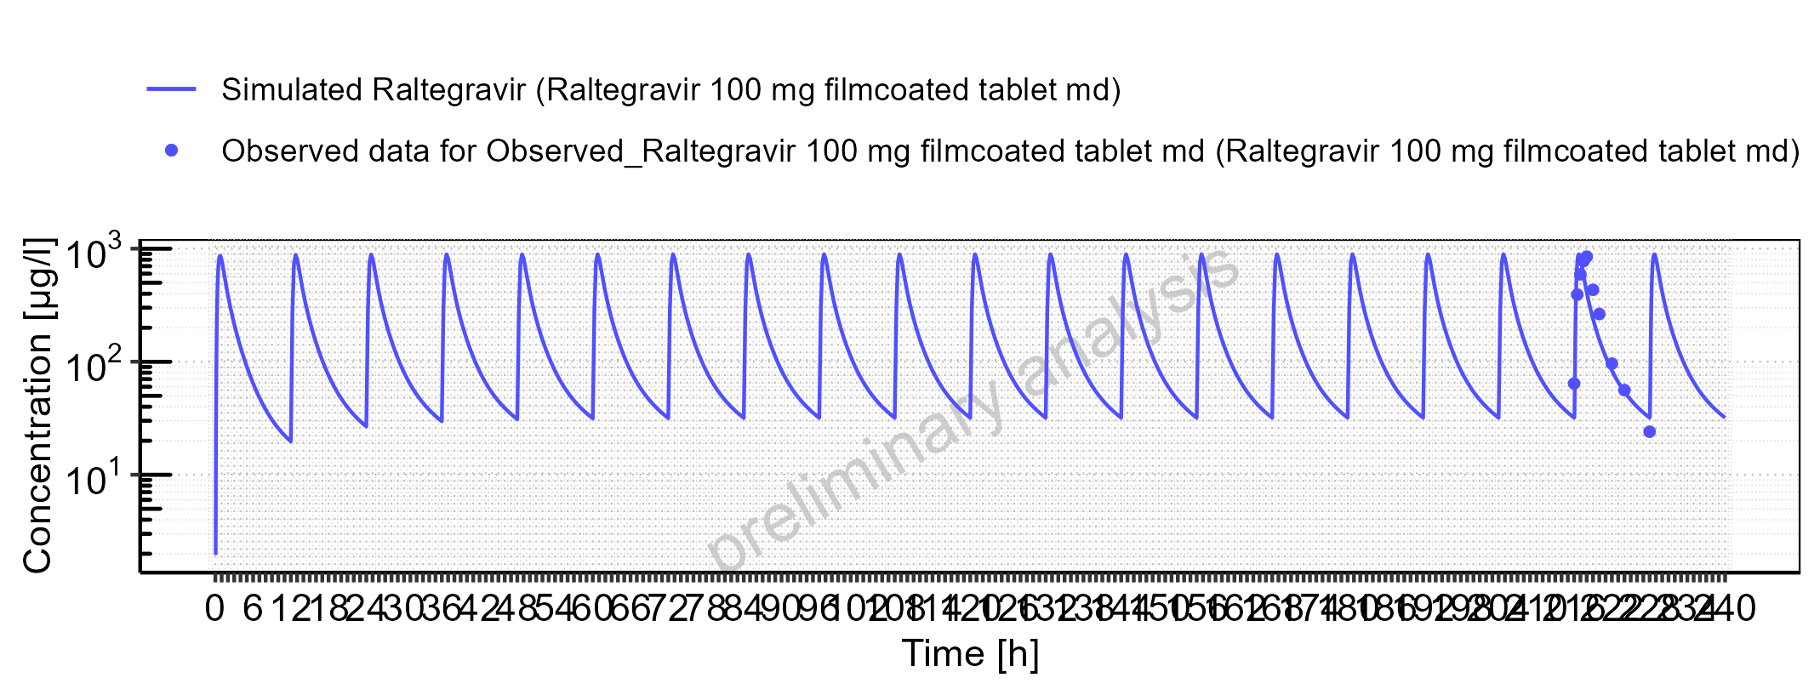

Figure 5-19: Predicted vs observed for Raltegravir 100 mg filmcoated tablet md. Data source: Data/Raltegravir_PK.txt .. Predictions and observations are plotted in a linear scale.

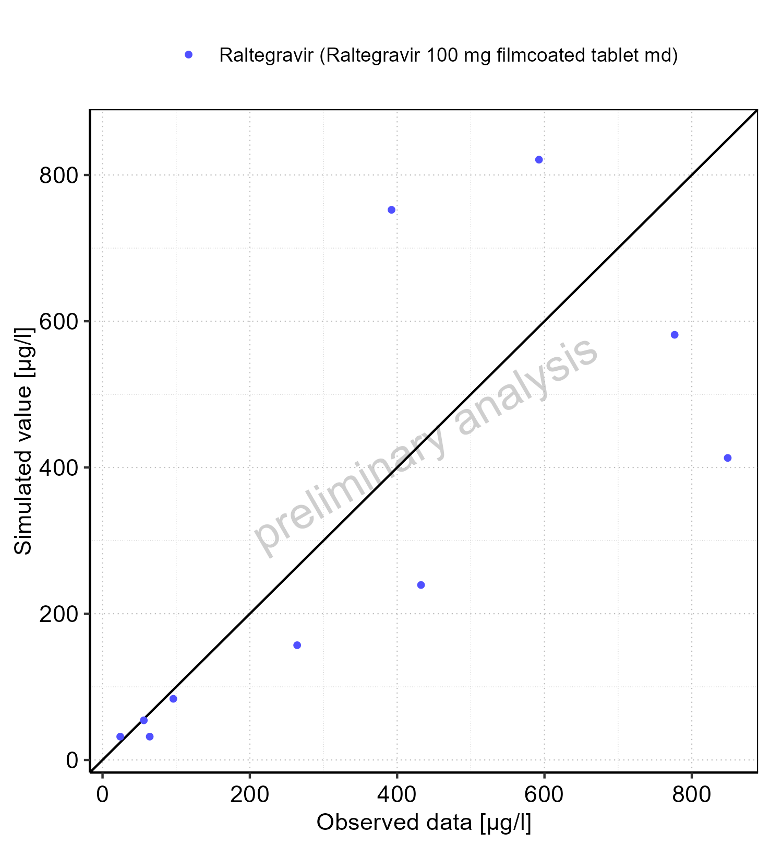

Figure 5-20: Predicted vs observed for Raltegravir 100 mg filmcoated tablet md. Data source: Data/Raltegravir_PK.txt .. Predictions and observations are plotted in a logarithmic scale.

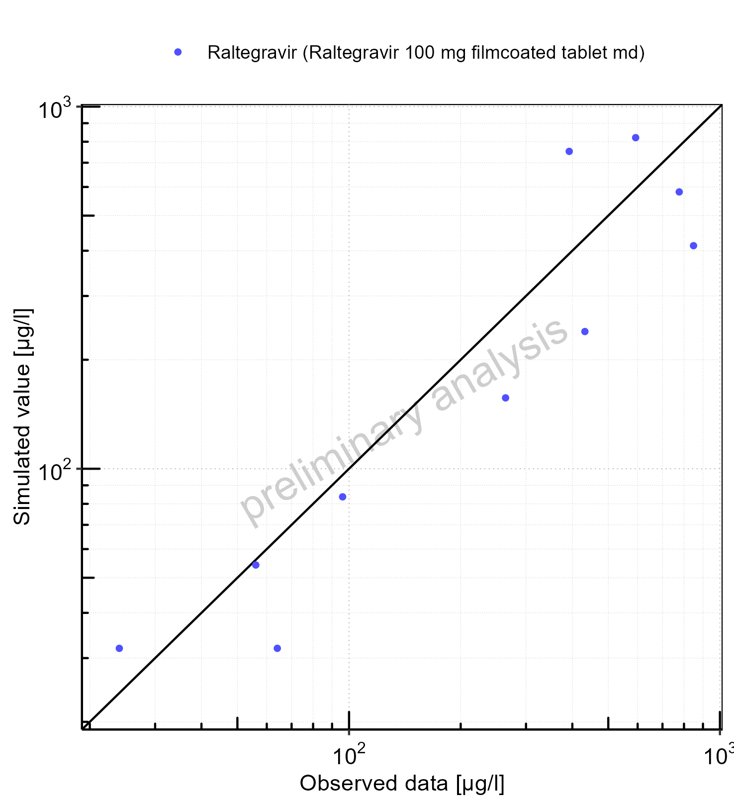

Figure 5-21: Logarithmic residuals vs predicted values for Raltegravir 100 mg filmcoated tablet md. Data source: Data/Raltegravir_PK.txt .

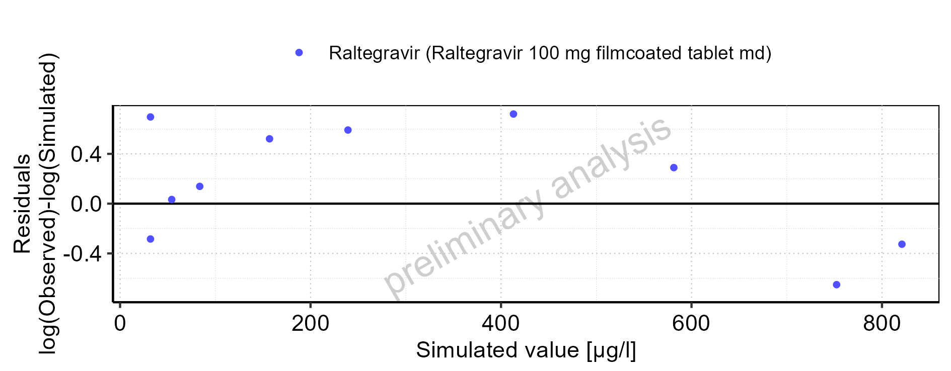

Figure 5-22: Logarithmic residuals vs time values for Raltegravir 100 mg filmcoated tablet md. Data source: Data/Raltegravir_PK.txt .

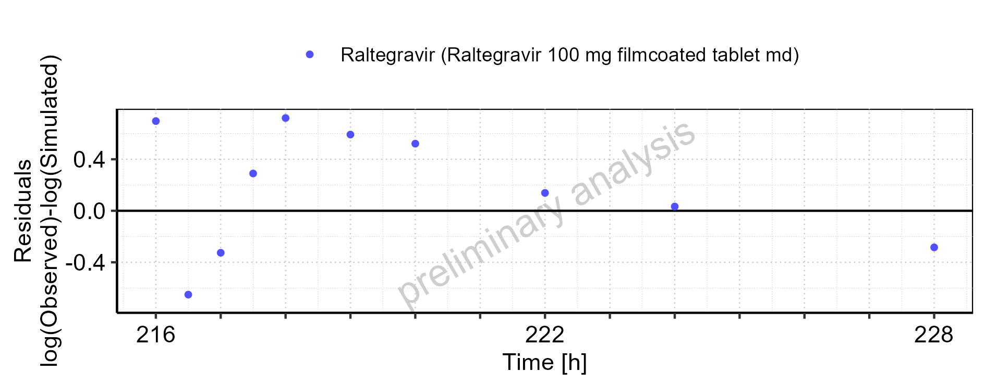

Figure 5-23: Logarithmic residuals distribution (stacked) for Raltegravir 100 mg filmcoated tablet md. Data source: Data/Raltegravir_PK.txt .

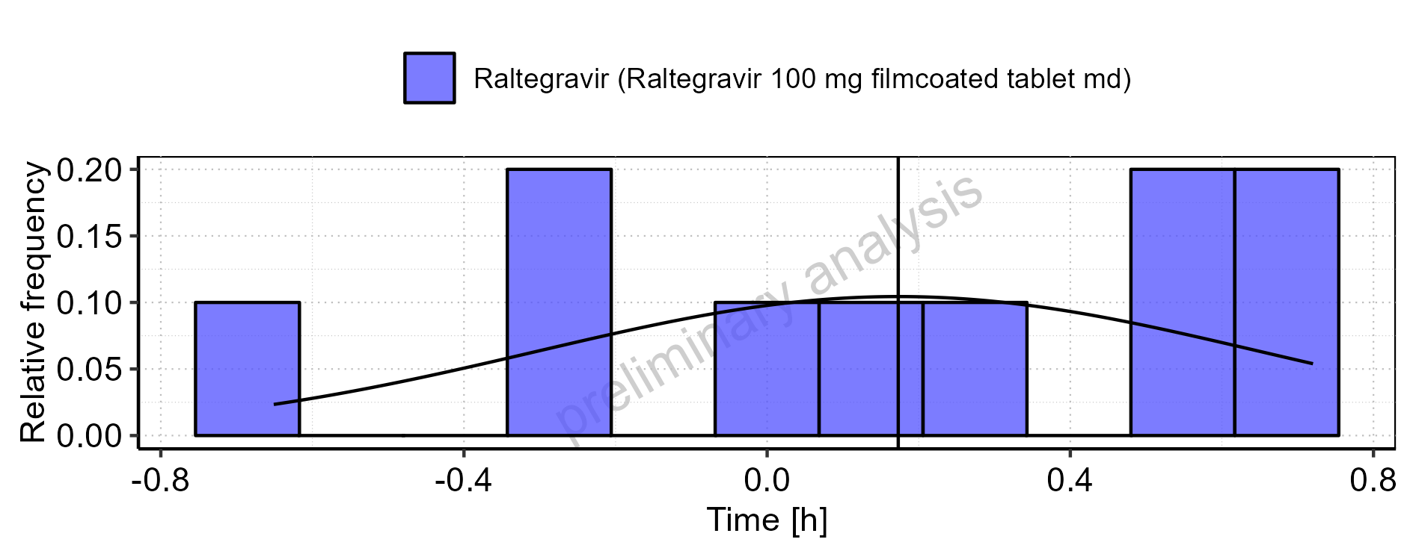

Figure 5-24: Logarithmic residuals for Raltegravir 100 mg filmcoated tablet md as quantile-quantile plot. Data source: Data/Raltegravir_PK.txt .

### For first application range

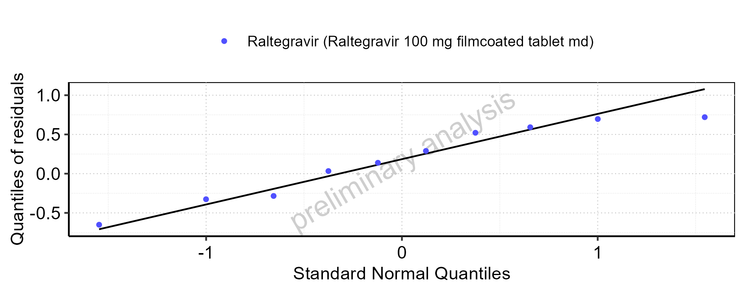

Figure 5-25: Time profiles for Raltegravir 100 mg filmcoated tablet md. Data source: Data/Raltegravir_PK.txt .. Time profiles are plotted in a linear scale.

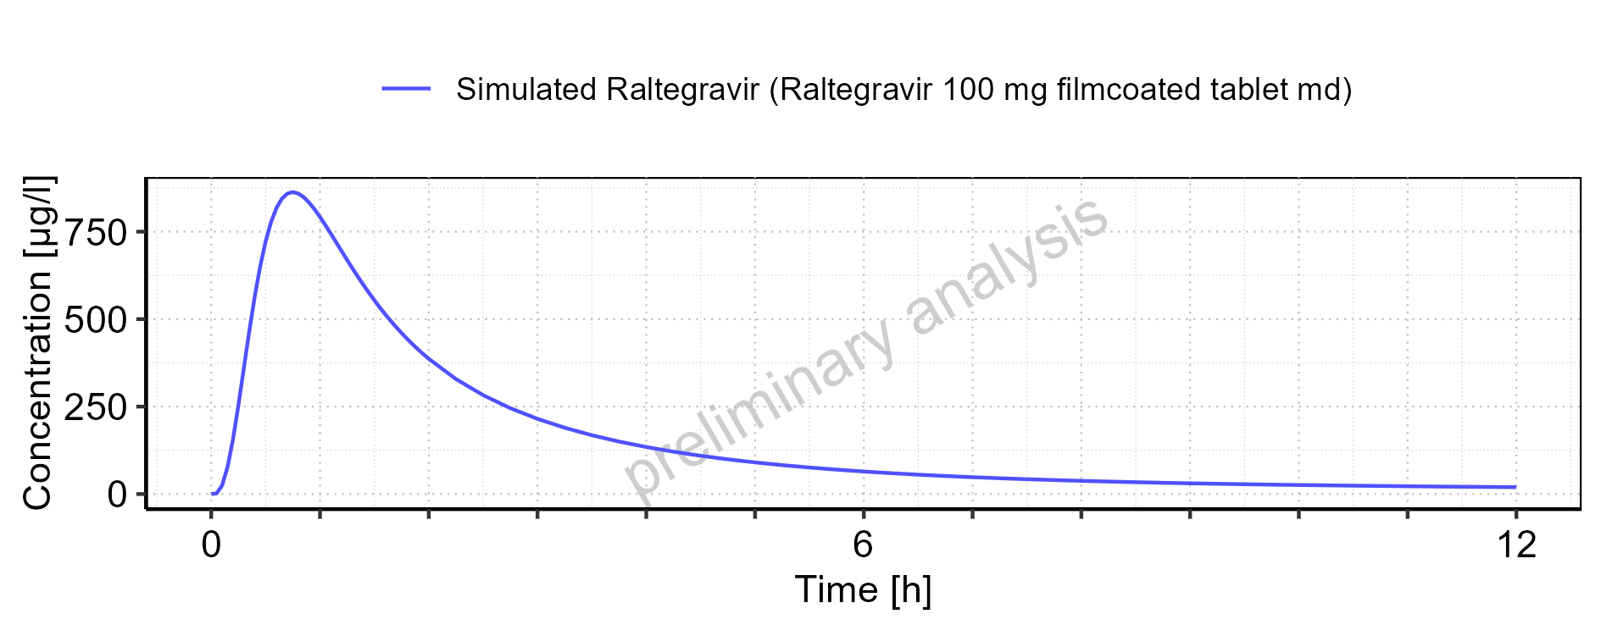

Figure 5-26: Time profiles for Raltegravir 100 mg filmcoated tablet md. Data source: Data/Raltegravir_PK.txt .. Time profiles are plotted in a logarithmic scale.

### For last application range

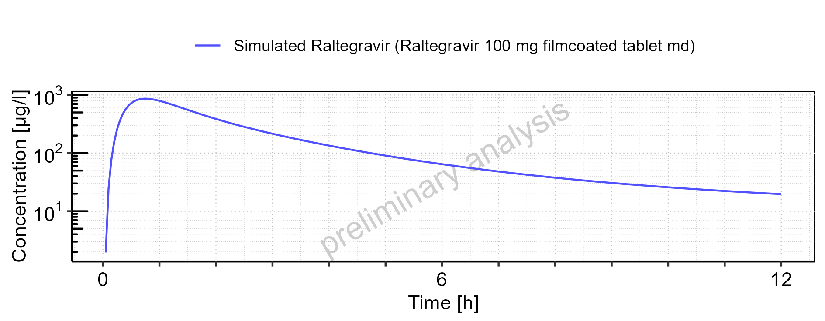

Figure 5-27: Time profiles for Raltegravir 100 mg filmcoated tablet md. Data source: Data/Raltegravir_PK.txt .. Time profiles are plotted in a linear scale.

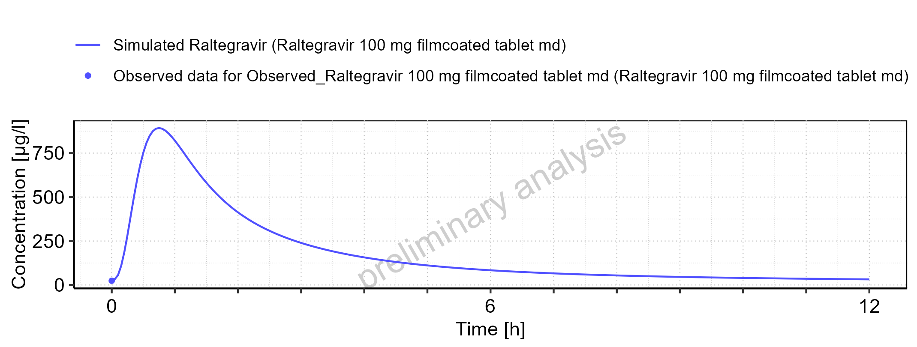

Figure 5-28: Time profiles for Raltegravir 100 mg filmcoated tablet md. Data source: Data/Raltegravir_PK.txt .. Time profiles are plotted in a logarithmic scale.

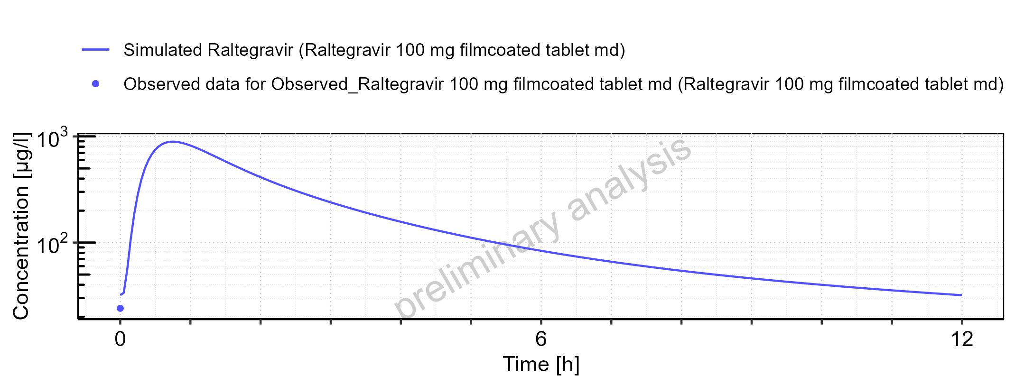

Figure 5-29: Predicted vs observed for Raltegravir 100 mg filmcoated tablet md. Data source: Data/Raltegravir_PK.txt .. Predictions and observations are plotted in a linear scale.

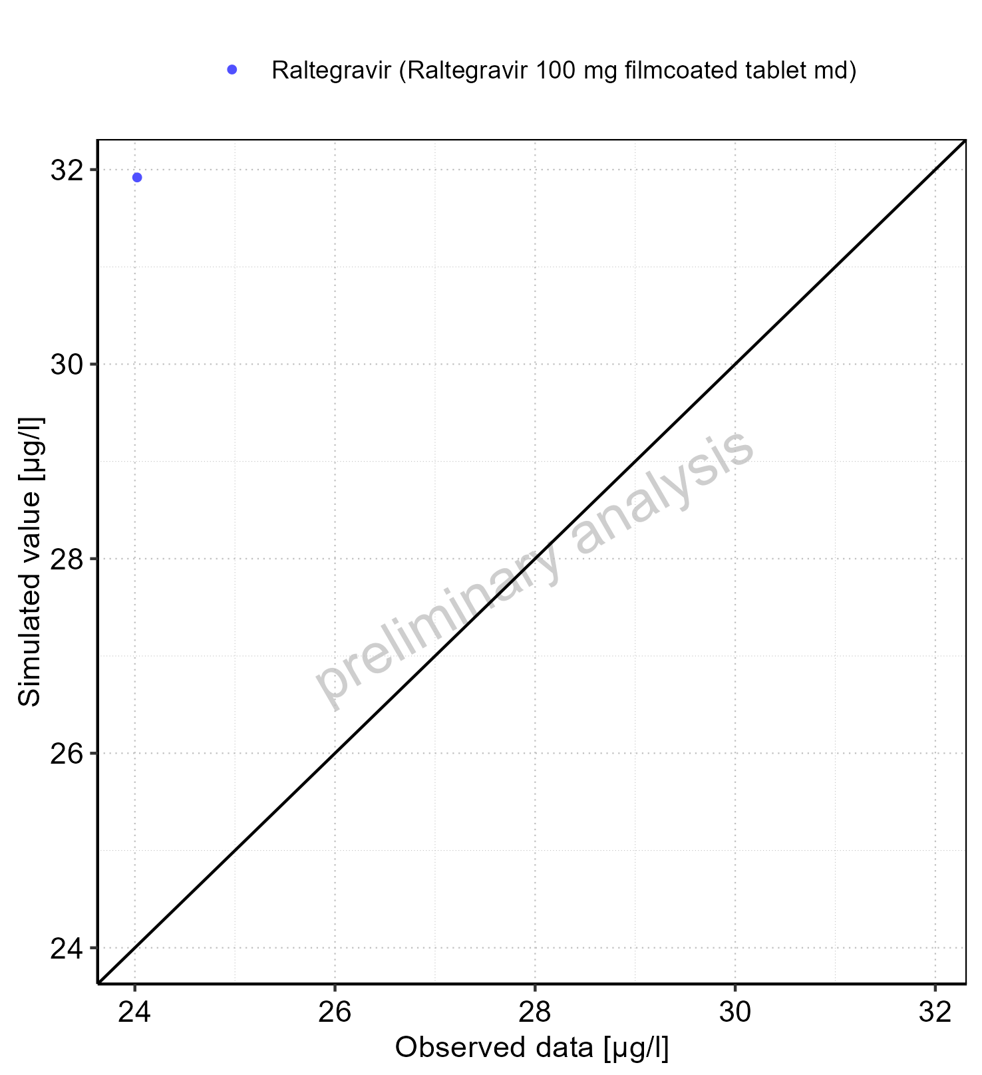

Figure 5-30: Predicted vs observed for Raltegravir 100 mg filmcoated tablet md. Data source: Data/Raltegravir_PK.txt .. Predictions and observations are plotted in a logarithmic scale.

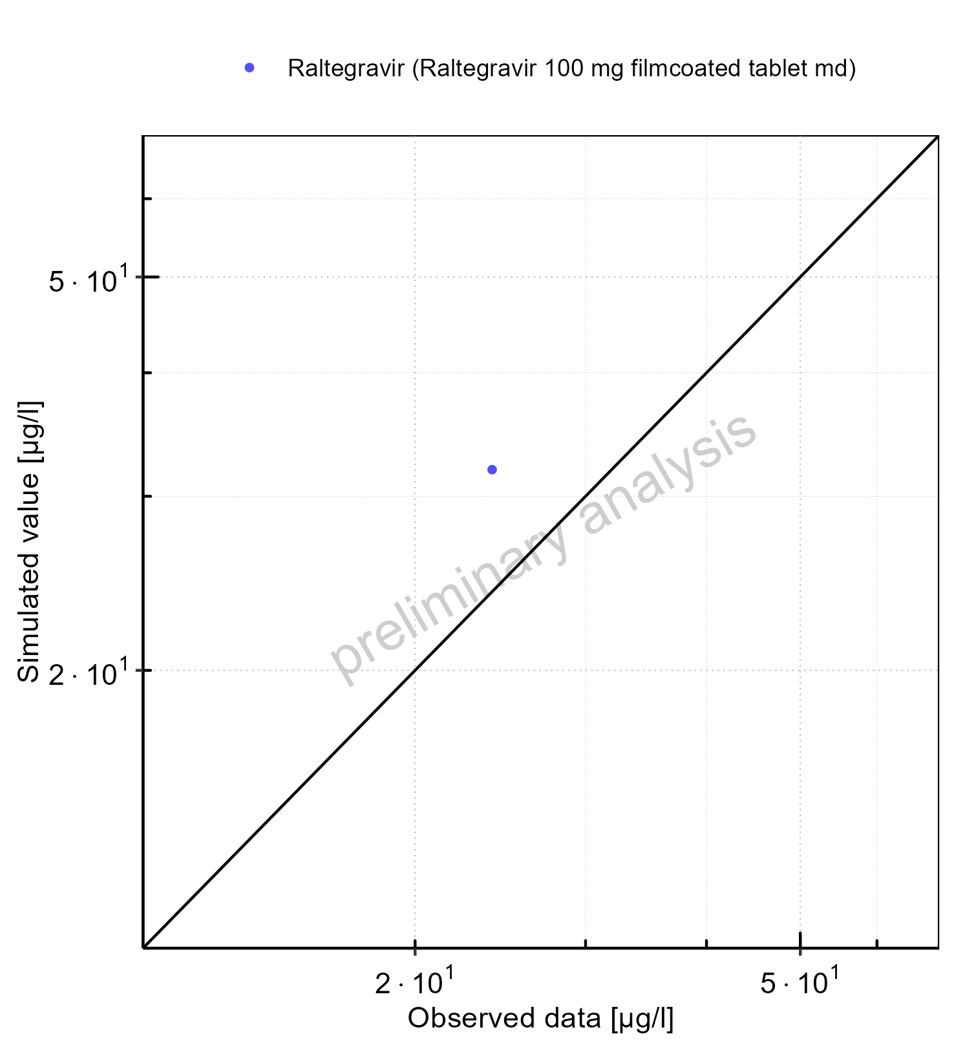

Figure 5-31: Logarithmic residuals vs predicted values for Raltegravir 100 mg filmcoated tablet md. Data source: Data/Raltegravir_PK.txt .

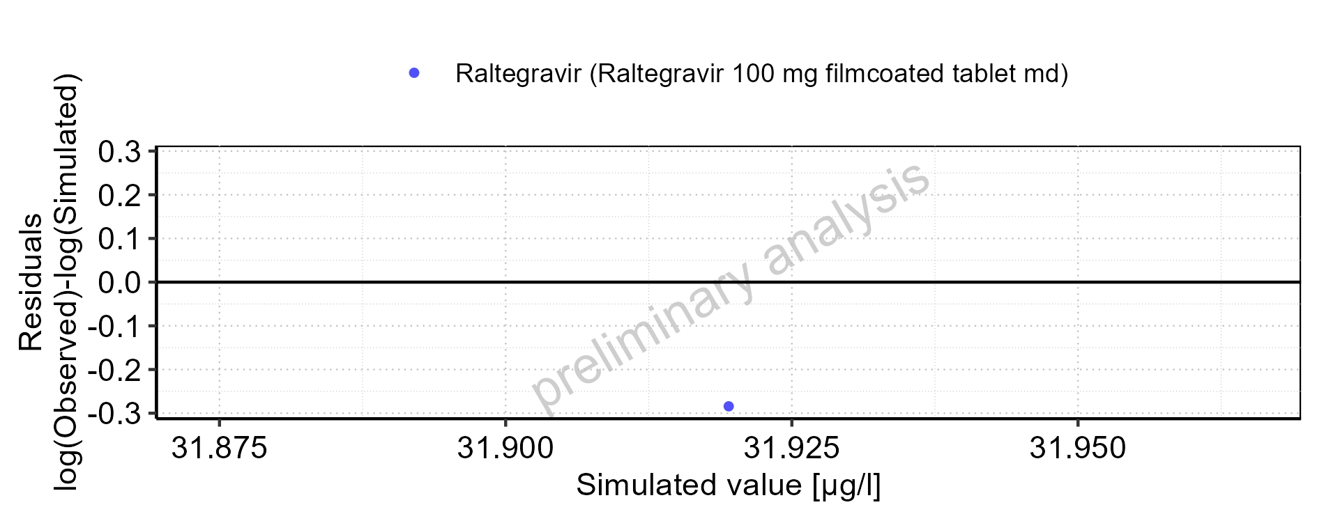

Figure 5-32: Logarithmic residuals vs time values for Raltegravir 100 mg filmcoated tablet md. Data source: Data/Raltegravir_PK.txt .

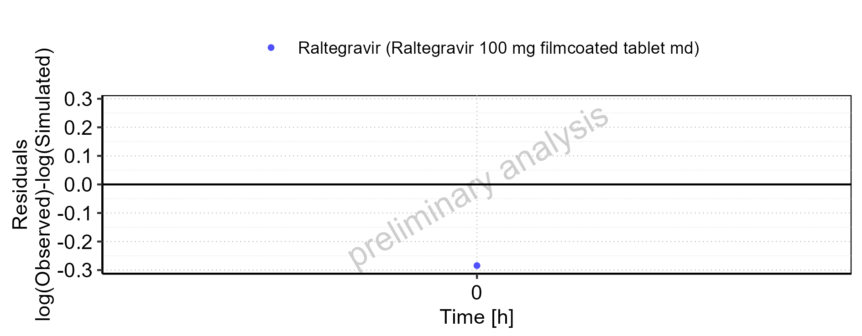

Figure 5-33: Logarithmic residuals distribution (stacked) for Raltegravir 100 mg filmcoated tablet md. Data source: Data/Raltegravir_PK.txt .

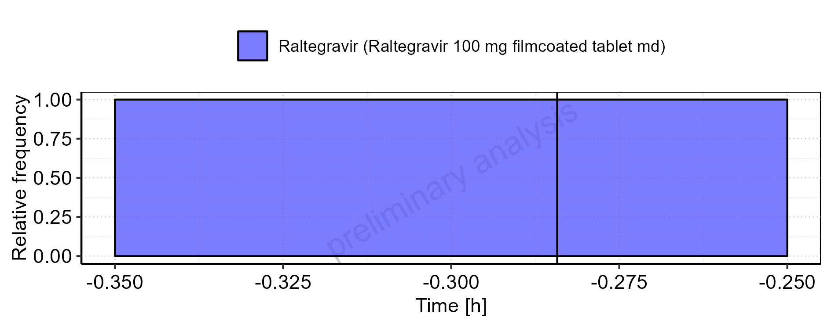

Figure 5-34: Logarithmic residuals for Raltegravir 100 mg filmcoated tablet md as quantile-quantile plot. Data source: Data/Raltegravir_PK.txt .

## Residuals across all simulations

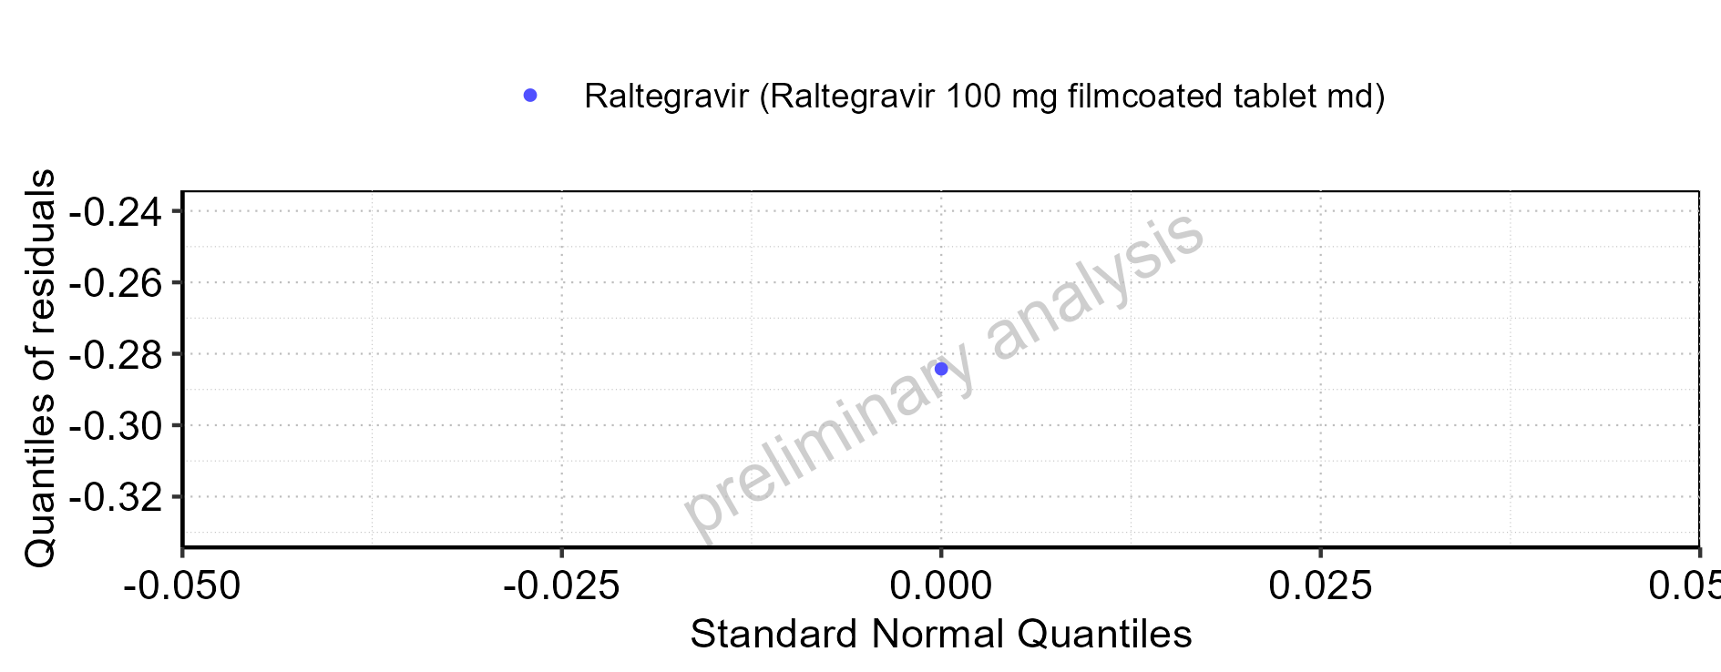

Figure 5-35: Predicted vs observed for Raltegravir across Raltegravir 10 mg (lactose formulation), Raltegravir 25 mg (lactose formulation), Raltegravir 100 mg filmcoated tablet md. Predictions and observations are plotted in a linear scale.

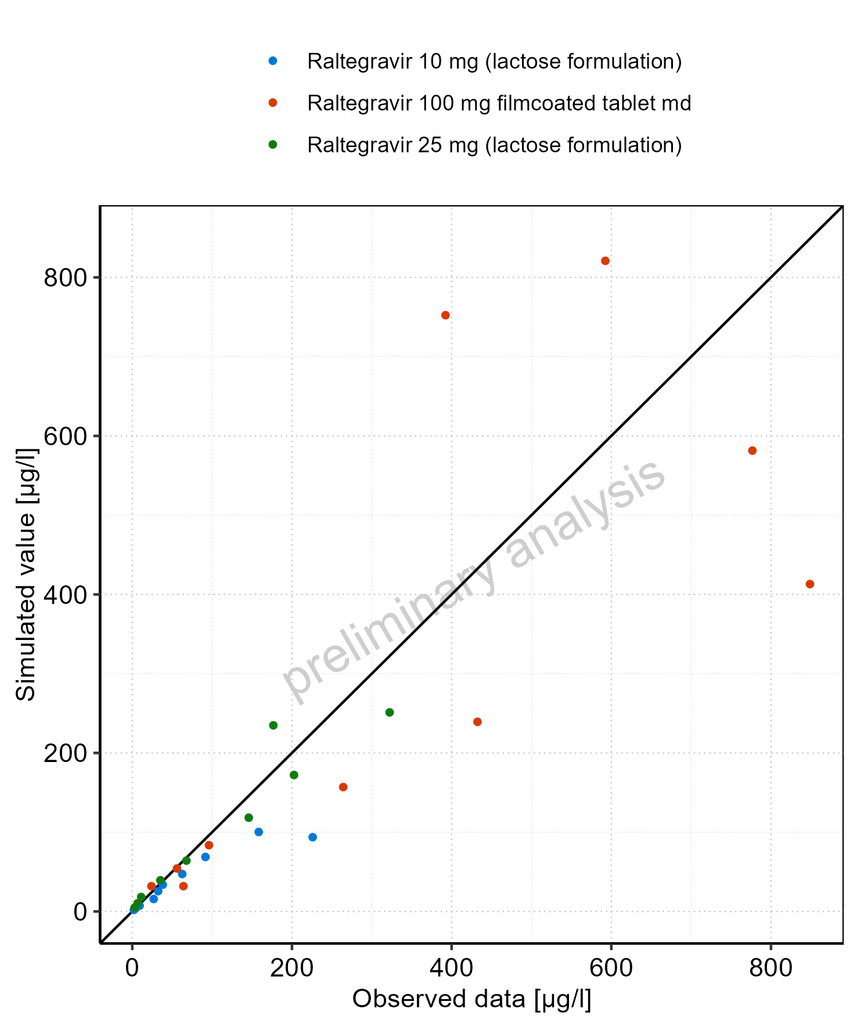

Figure 5-36: Predicted vs observed for Raltegravir across Raltegravir 10 mg (lactose formulation), Raltegravir 25 mg (lactose formulation), Raltegravir 100 mg filmcoated tablet md. Predictions and observations are plotted in a logarithmic scale.

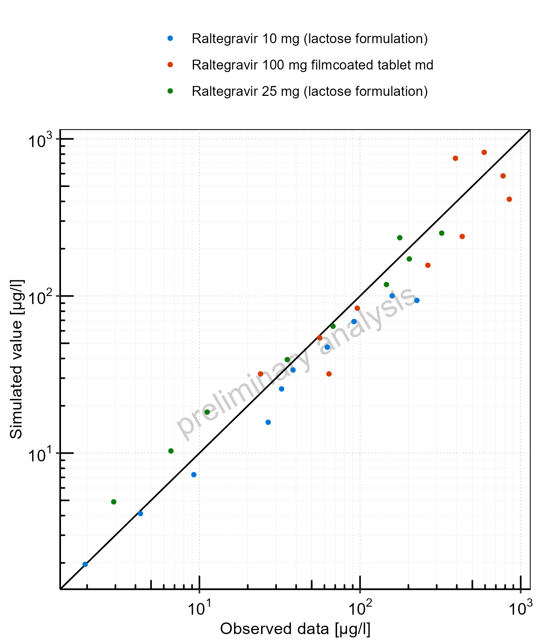

Figure 5-37: Logarithmic residuals vs predicted values for Raltegravir across Raltegravir 10 mg (lactose formulation), Raltegravir 25 mg (lactose formulation), Raltegravir 100 mg filmcoated tablet md

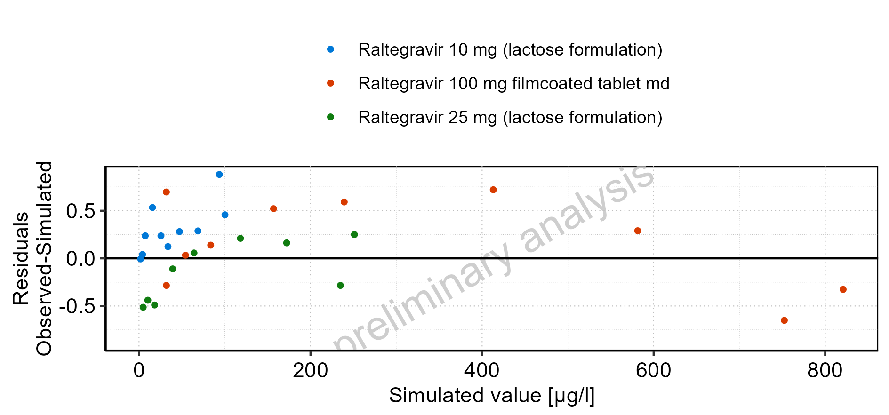

Figure 5-38: Logarithmic residuals vs time values for Raltegravir across Raltegravir 10 mg (lactose formulation), Raltegravir 25 mg (lactose formulation), Raltegravir 100 mg filmcoated tablet md

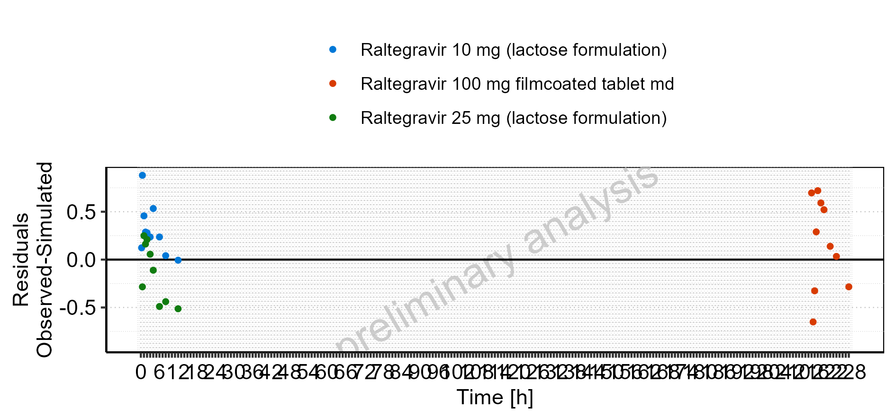

Figure 5-39: Logarithmic residuals distribution (stacked) for Raltegravir across Raltegravir 10 mg (lactose formulation), Raltegravir 25 mg (lactose formulation), Raltegravir 100 mg filmcoated tablet md

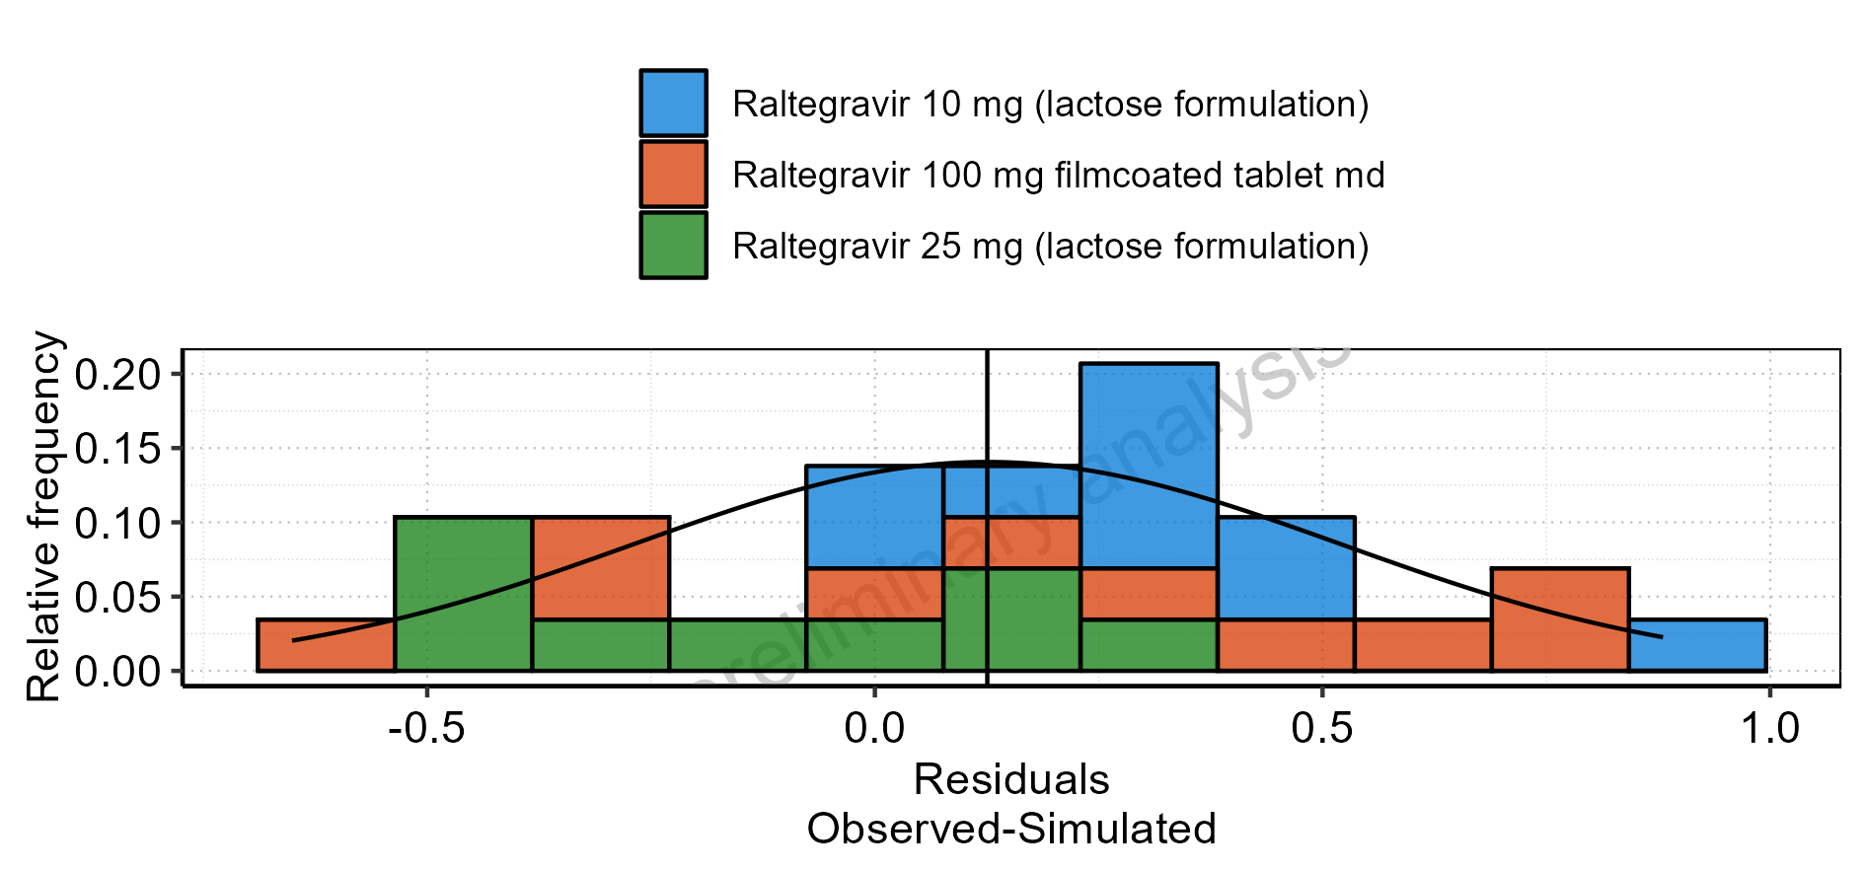

Figure 5-40: Logarithmic residuals for Raltegravir across Raltegravir 10 mg (lactose formulation), Raltegravir 25 mg (lactose formulation), Raltegravir 100 mg filmcoated tablet md as quantile-quantile plot